Comments – discussion by email about the OCG Service Level Agreement Draft for GLOSS

**(comments chronological inverse order – latest first)**

TURPIN – 4 July

Thank you for taking the time to read the letter carefully.

To answer your points:

Cruise: You're absolutely right—cruise information doesn’t apply to GLOSS (just as with HF radar, FVON, or OceanGliders). It’s not required to obtain a Passport ID for GLOSS, so there’s no blocking issue here.

Roles and Responsibilities: These are outlined in the document linked to the letter, but in short:

* Under the baseline service, the network agrees to provide access to data and essential metadata via a central node, and to designate one or two points of contact to liaise with OceanOPS.
* OceanOPS commits to integrating this information into the GOOS monitoring system. This includes delivering monthly indicators and maps, and ensuring regular updates to keep GLOSS activity visible and current.

Informally, the baseline is meant to ensure that GLOSS activity is properly reflected in the GOOS system with minimal effort. In the first year, we will work to organize data and metadata sharing using existing structures as much as possible, and then maintain regular updates based on that structure.

On the SLA: Thanks for checking with IOC. Just a note: OceanOPS is an IOC agency (shared with WMO), and IOC/GOOS has actively supported this SLA initiative under GOOS-OCG. The Letter of Agreement is not legally binding—it’s simply meant to clarify expectations and ensure the monitoring and support are aligned with the level of engagement. It has been identify by GOOS-OCG that such clarification was needed.

I'm confident everything will move forward smoothly, and I’m happy to provide any further clarification if needed.

BEGONA – 3 July

I add Liz Bradshaw to this discussion loop about the LoA content.

She is having a look now to the GOOS passport. We wonder if we should reflect more details here about this metadata granularity and specific requirements for GLOSS. For example, Liz points out to some of the metadata listed in the document, such as "associated cruise", for which GLOSS cannot contribute. Do these vocabs used allow "not used" or a blank etc.

We may be more specific or add a text to consider these particular concerns.

Another important aspect for us would be to clarify who must do what (even for the baseline service). It would be better to define this well at the beginning, so both teams can organize the work more efficiently. If possible, we should anticipate some of these issues and see if we can close the text with the Steering Committee next week.

I also requested Bernardo to get a legal green light from IOC. I understand this shouldn't be an issue, but I understand this is the correct way to proceed with this kind of agreements. He will tell us how to proceed.

BEGONA – 2 july

I would like some of the main doubts to be solved before the meeting next week.

Liz: it seems we share doubts and concerns. With respect to the funding, we will not pay any amount to OceanOPS, as we will go for the Baseline Service, which is free. If we think this is not clear we can modify the text.

I think these are the priorities with respect to this document:

* We need a legal advice from UNESCO/IOC. I will request an informal advice of our legal department in Puertos del Estado, but this will not be signed by Puertos del Estado, so I am not sure what they will respond and when. I hope this could clarify any doubt about the format and formal doubts we have. I don't have problem to sign as chair, but we need input from IOC
* About the program: I think the program must be GLOSS; do you have in mind including all data centres?  I think this should refer to the network, but we could add mention to data centres if needed somewhere
* Notice that they will be able to provide a new unique ID in their system, but we will not lose our own IDs (this was never the intention)
* We are of course in time to adapt the GOOS passport and metadata requirements to our needs (see Mathieu email below). I think we have done so a couple of months ago, could we reflect this in the agreement, or just leave the text more open to adapt to future discussion?
* Important: who does what? for this, I need more information about on-going activities for unique data flow and ERRDAP information between data centres. We should be able to tell them where to go and collect this info, can you update on this point?  We should identify the best approach (less work) for us and come up with a proposal. Are we in the position of doing this? Where should we redirect them for an access to the minimum metadata for OceaOPS?  Could this be VLIZ for now?
* And more important: which stations will we share? They are now providing an incredible spatial coverage of stations in Peru and Chile and only GLOSS Core Network in the rest of the world (a very limited number of stations in Europe). We need to define a criterion ourselves, about how we want GLOSS to be displayed outside and in this context. This is what is now GLOSS for OceanOPS. I don't know the source of these data and the selection criteria:

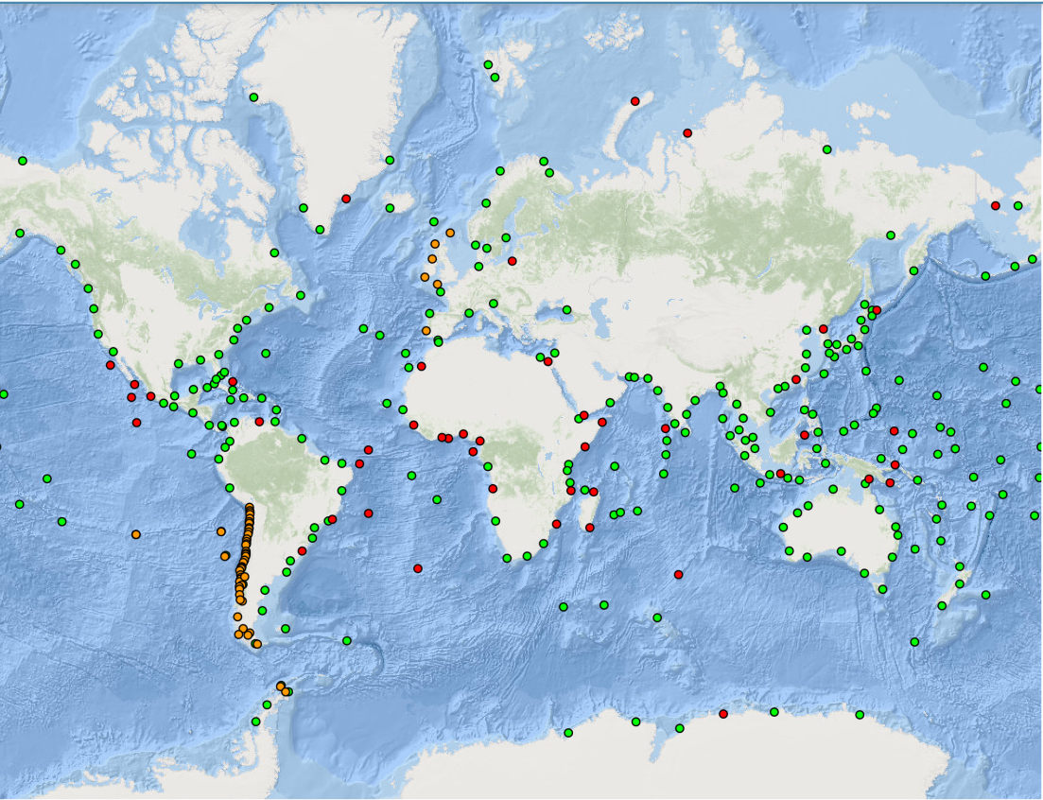

2 July - LIZ

I have read the document and left some comments. In principle, I don't see any big issues with the service being proposed, but there are lots of details that would need to be established before signing.

I am confused by the agreement as it states it is not contractually binding but also places clauses and dates within the document.

I will need to go over the metadata passport again because we cannot provide all the information listed in annex 3, but it may be that the vocabularies used allow for a "not applicable".

TURPIN – 1 July

Just a quick note regarding the "unique identifier." We're not asking GLOSS to switch from its current method of uniquely identifying stations to the GOOS approach.

Instead, we're suggesting the addition of another identifier—one that is guaranteed to be unique within the GOOS system and delivered by OceanOPS—which can be included in the dataset alongside the standard GLOSS ID you are currently using.

Unique identifiers are unique within the system that assigns them.  
When you want to link or integrate different systems—like GLOSS and GOOS in this case—a good practice is to include the unique identifiers from the other system in your own records. This is a standard procedure across GOOS networks. And this is what we are doing also in our database.

Just a quick comment on this aspect, as there's sometimes some confusion around this point.

BELBEOCH – 1 July

Dear Begona

Baseline is the minimum common denominator of all services levels including unique ids.

We have a unique identifier defined for fixed platforms ready to be used by gloss.

We need now to have a discussion on the minimum metadata  and on the granularity level (the GOOS passeport) and we can amend/adapt to tide gauges as needed.

BEGONA – 1 July

before proceeding to review the text with the whole Steering Committee, I would appreciate if you could clarify the following points:

* In the Baseline service, you include in the requirements a "Unique ID", which we don't have for GLOSS yet. However, this is not a requirement for the Standard and Advanced services, is this because you understand this is obvious and already solved in these cases?
* If we don't have this Unique IDs, a pending action for us, should we interpret we could have this service from you if we choose the Baseline service? I am worried about this point.
* Finally, we need to check internally that we can provide all the metadata you mention in the Baseline service. I have shared with our Data management representative in the OCG, to check this part of the document