 | 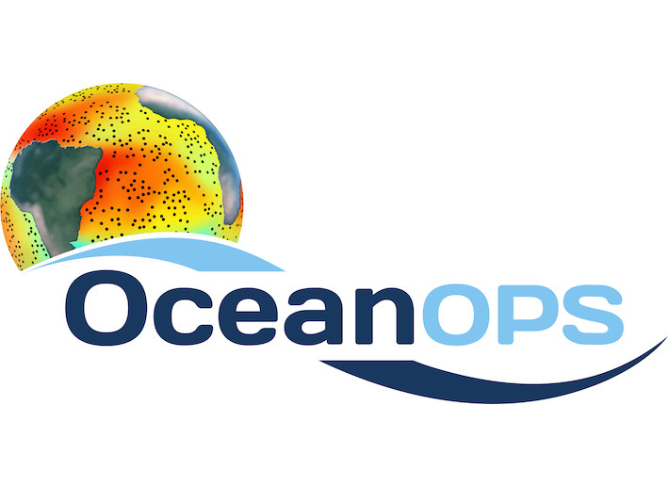

LETTER OF AGREEMENT
(herein referred to as the “Agreement”)

between

OceanOPS

and

Global Sea Level Observing System

(also referred to as “Party” individually and “Parties” collectively)

2026

Preamble
The World Meteorological Organization (WMO) and Intergovernmental Oceanographic Commission (IOC) in-situ Ocean Observations Programme Support centre (OceanOPS) has a central role in monitoring the in-situ ocean observing systems and its constituent networks and maintains an integrated metadata database across all the GOOS observing networks, covering a range of platform types (floats, drifters, ships etc.). OceanOPS is managed under the umbrella of WMO and IOC; its staff are employed by WMO and based in Brest, France. OceanOPS delivers a range of services to the various GOOS observing networks, with its services falling into three main categories (i) baseline, (ii) standard and (iii) advanced services.

The Baseline Services are largely automated cross-cutting services applicable to all endorsed OCG networks and are underpinned by the core funding provided by IOC/UNESCO and WMO to OceanOPS and non-network specific contributions from some Members, including the host country.

The Standard Service builds on the Baseline Service and comes as a package of services that include more advanced levels of tailored services that can be provided to those networks who provide funding into OceanOPS. Minimal technical coordination will be provided to ensure standard services delivery. A Standard Plus option enables the networks to secure services of a dedicated technical coordinator.

The Advanced Services built on top of the standard services package, are network-specific and may include more advanced monitoring and reporting, data and metadata management, operational and technical support. They include further dedicated network support from the technical coordinators in OceanOPS. The level of the direct services and dedicated network support being agreed with each network reflects the level of financial support provided to OceanOPS by the network.

Details of the specific services on offer are given in the ‘Outline of OceanOPS services for GOOS Networks’.

Under the terms of this Agreement, it is hereby agreed that:
- OceanOPS shall provide Global Sea Level Observing System with a baseline service, as detailed in the ‘Outline of OceanOPS services for the Networks’ (see Annex 1) for the period from 1st of January 2026 to 31 December 2026. Priority activities are detailed in Annex 2.

- The Global Sea Level Observing System shall (i) provide access to at least the minimum platform metadata as required by OceanOPS (see Annex 3) in order to deliver the outlined services, (ii) provide a focal point for OceanOPS to liaise with, (iii) will promptly report any issues on the service provided to the Head of OceanOPS [Mathieu Belbeoch: mbelbeoch@ocean-ops.org, MBelbeoch@wmo.int.

Where the agreed service level is Standard, Standard Plus or Advanced, the provision of that service is contingent on the commensurate level of funding provided to OceanOPS by the Network. In the event of a shortfall in funding then the service may be reduced by OceanOPS based on capacity.

Conditions
The intention of this Letter of Agreement (LoA) shall not be contractually binding and the signing of this LoA will not create any obligation or right enforceable in law or equity by or against either Party (i.e. OceanOPS and the various Network contributors). The following paragraphs provide more details on this intention for specific issues.

- This LoA does not change the legal status of liability.
- Nothing in this LoA or any contract deriving therefrom will prevent the Parties from carrying out any work, or providing advice or information on any subject including the type of work described under the scope of this agreement, to any other person or organisation. Nor will it prevent the Parties from exploiting their expertise as they see fit provided the execution of this LoA and any contract deriving therefrom is not affected by the carrying out of such work.
- Nothing in this LoA will be construed as constituting a partnership or a joint venture or any such relationship between the Parties hereto and sets out all the provisions mutually accepted between the Parties.
- The Parties agree that should the services required, or the services provided, change then the Party making the change shall notify the other Party promptly of such a change.

Termination
Either of the Parties may withdraw from this LoA subject to six months prior written notice to the other Party. All commitments and financial obligations under this agreement will continue to the date of termination.

Dispute Procedure
The Parties will endeavour in good faith to resolve any disputes in the first instance at operational level. In the event that the dispute cannot be resolved, the matter will be referred to the OceanOPS Management Board [Albert Fischer: afischer@wmo.int].

Review
This LoA will be reviewed annually, with the first review to take place no later than 12 months from the effective date.

The foregoing represents the understanding reached between the Parties upon the matters referred to therein.

Signed by
Mathieu Belbeoch, head of OceanOPS | <NAME>, Chair(s) of the Global Sea Level Observing System
For and on behalf of OceanOPS | For and on behalf of the Global Sea Level Observing System
Date: __________________ | Date: ___________________

ANNEXES

ANNEX 1: SERVICE LEVEL AGREEMENT OVERVIEW
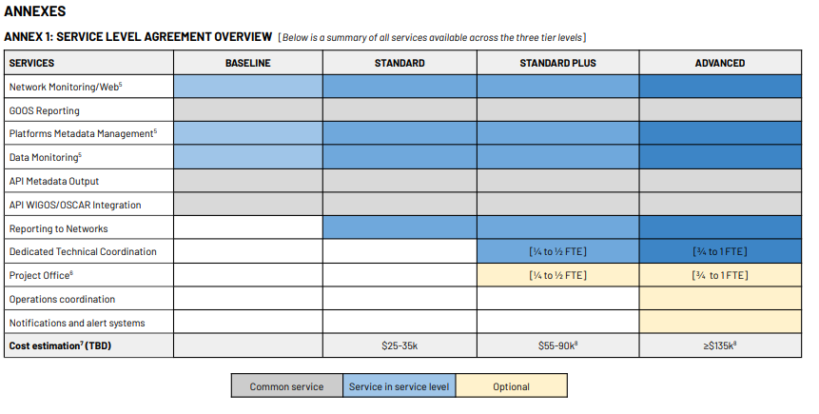

Link to detailed SLA documentation: UNESCO IOC GOOS

ANNEX 2: PRIORITIES FOR 2026
In 2026, GLOSS and OceanOPS will focus their cooperation on the following activities:
- Reviewing priority metadata for GLOSS monitoring
- Centralizing and ingesting metadata from the GLOSS program into the OceanOPS database
- Providing basic maps and statistics to report contributions to GOOS
- Developing basic tools for online monitoring (web services)
- Delivering GLOSS metadata through an API

ANNEX 3: MINIMUM PLATFORM METADATA
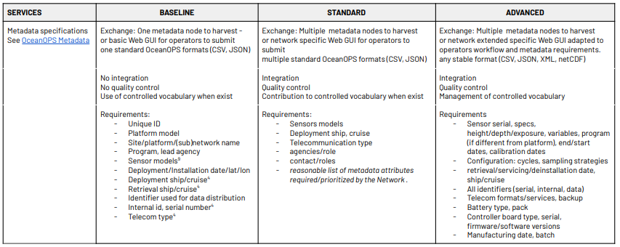
Link to detailed SLA documentation: UNESCO IOC GOOS

