|  |
| --- |
| INFORMATION  **Progress report on the third edition of the *Global Ocean Science Report (GOSR)***  This information paper is intended to provide IOC Member States with a short update on activities coordinated by the Secretariat associated with planning and producing the third edition of the *Global Ocean Science Report*. |

### **Background**

Based on two decisions of its Executive Council in 2014 (EC-XLVII/6.2) and its Assembly in 2015 (IOC-XXVIII/5.1), the Intergovernmental Oceanographic Commission of UNESCO undertook to prepare and publish the *Global Ocean Science Report*, a UNESCO Flagship Report, aiming at covering a five-year period. The first edition of the *Global Ocean Science Report* (GOSR) was published in 2017 and assessed for the first time the status and trends in ocean science capacity around the world and was followed by a second edition published in 2020.

The GOSR is a resource for policymakers, academics and other stakeholders seeking to harness the potential of ocean science to address global challenges by informing strategic decisions related to funding for ocean science, pointing to opportunities for scientific collaborations and fostering partnerships aimed at developing further capacity in ocean science. Importantly, the GOSR is utilized to monitor progress against indicator 14.a.1 of Sustainable Development Goal 14: ‘Proportion of total research budget allocated to research in the field of marine technology’ and therefore represents Member State reporting on this indicator.

The GOSR plays a central role in driving a transformative process aimed at providing the necessary capacities in ocean science in the context of the United Nations Decade of Ocean Science for Sustainable Development (2021–2030), the 2030 Agenda as a whole, and Sustainable Development Goal (SDG) 14 (Life below water), in particular. It is intended to serve as a benchmark to assess progress in capacity development in ocean science.

The content of the GOSR is primarily based on three main elements:

1. Submission by Member States of responses to a questionnaire asking for details on the investment in ocean science, infrastructure associated with ocean observing and data management, priority thematic areas of ocean science being conducted in their country and the level of collaboration and connectivity with regional and global ocean science networks.
2. A bibliometric analysis of scientific outputs across the period of the focus of each report
3. Expert input into the writing process associated with developing the report.

### **The Editorial Board for the third edition of the *Global Ocean Science Report***

Following the process of the first and second editions of the GOSR, members of the Editorial Board for the third edition were identified by all sections of the IOC Secretariat, taking into account expertise, geographical and gender balance. Several of the experts who guided the production of the report agreed to continue as members of the Board. The 13 external experts comprising the GOSR Editorial Board represent 11 countries as well as the European Marine Board and the OECD. In addition, colleagues of the Ocean Decade Coordination Unit and the Ocean Observation Section are supporting the Editorial Board and the Ocean Science Section in the preparation of the report.

The membership of the Editorial Board for the third edition of the GOSR is detailed in Annex 1.

### **Progress in developing the third edition of the *Global Ocean Science Report***

Due to the vacancy and delays in installing a Head of Section for the Ocean Science Section (OSS) and the workloads of OSS staff associated with programmatic delivery, the planning for the third edition of the GOSR did not commence until January 2025. Since January 2025, progress on the third edition of the GOSR has focused on:

* Confirming the Terms of Reference for the Editorial Board (provided in Annex 2).
* Developing a timeline for the preparation and delivery of the report (provided in Annex 3).
* Identifying a title and developing an outline for the report, including chapter headings and sub-headings (provided in Annex 4).
* Updating the Member State questionnaire (provided in [IOC Circular Letter 3035](https://oceanexpert.org/document/36049)) and facilitating online access to and submission of the questionnaire.
* Issuing a call for Member States to nominate national focal points for the submission of the Member State questionnaire ([CL-3035](https://oceanexpert.org/document/36049)).
* Providing information sessions on the third edition of the GOSR and Member State questionnaire (recordings and the related presentation can be requested to the Secretariat).
* Reviewing and updating graphical outputs associated with the bibliometric analysis and contracting services for the bibliometric analysis.
* Undertaking a thematic, geographic and gender distribution assessment of scientific conferences and workshops.
* Identifying potential authors and reviewers for the chapters of the report.
* Developing guidelines for writing teams and reviewers.

The above activities have been facilitated through monthly meetings of the Editorial Board throughout 2025 and an in-person meeting of the Editorial Board held in May 2025.

As of 1 June 2025, a total of 36 Member States have nominated focal points for the submission of the Member State questionnaire (Figure 1). Additional Member States are encouraged to nominate focal points and contribute to the report to ensure that the report includes information relevant to their country and region and the report delivers against the original objectives agreed upon by Member States as per the IOC Executive Council decision EC-XLVII/6.2 in 2014 and the IOC Assembly decision IOC-XXVIII/5.1 in 2015.

### **Next steps**

The Secretariat is currently finalising contact details of potential authors and reviewers with the Editorial Board, following which authors and reviewers will be invited to contribute to writing teams for each chapter. Feedback from the Editorial Board is being incorporated into the assessment of scientific conferences and workshops and the assessment finalised. The preliminary outputs from the bibliometric analysis will be available in June, following which the Editorial Board will provide feedback to the contractor and the analysis finalised and delivered in July 2025. As part of providing clear guidance to writing teams, the Editorial Board will be developing an annotated version of the outline for the report. This will ensure that essential components and relevant issues are covered by each writing team and not overlooked.

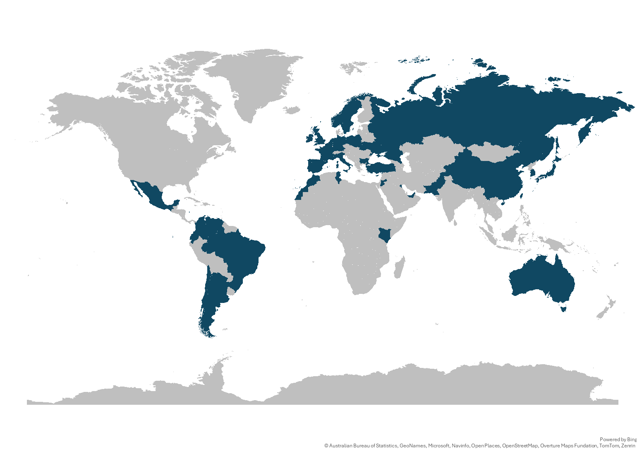

Figure 1. Countries that have nominated focal points for submission of the Member State questionnaire as of 1 June 2025.

Given the current budgetary situation, there are currently insufficient funds available to progress a number of elements associated with the editorial process and finalisation (including translation) of the report within 2025. Most of these activities have been scheduled into the first half of 2026. As soon as the prioritisation of funds available to the IOC is completed and in association, an updated timeline has been developed by the Editorial Board, Member States will be informed of any updates to the submission dates of the questionnaire.

An assessment of the lessons learned from the third cycle of the GOSR process will be undertaken by the Secretariat in the first half of 2026 with input from the Editorial Board. This will include developing a set of guidelines for planning of editions of the GOSR to ensure that adequate leads times and planning of budgets (including identification of risks and relevant responses) can be incorporated into future editions of the report.

### **Annex 1: Membership of the Editorial Board for the third edition of the *Global Ocean Science Report***

|  |  |
| --- | --- |
| **Name** | **Institution** |
| Jan Mees* | Flanders Marine Institute, Belgium |
| Jacqueline Uku* | Kenyan Marine and Fisheries Institute, Kenya |
| Kentaro Ando | Japan Agency for Marine-Earth Science and Technology |
| Ronaldo Christofoletti | Instituto do Mar, Universidade Federal de São Paulo, Brasil |
| Minhan Dai | Xiamen University, China |
| Sheila Heymans | European Marine Board, Belgium |
| Claire Jolly | OECD, France |
| Kwame Koranteng | Food and Agriculture Organization, Ghana |
| Youn-ho Lee | Korea Institute of Ocean Science and Technology, Korea |
| Leonard Nurse | University of the West Indies, Barbados |
| Rohan Pathirage | UNESCO Institute of Statistics, Canada |
| Susan Roberts | The National Academies of Sciences, Engineering, and Medicine, USA |
| Paula Cristina Sierra Correa | Instituto de Investigaciones Marinas y Costeras José Benito Vives de Andreis, Columbia |

*Co-chairs

### **Annex 2: Terms of Reference for the Editorial Board for the third edition of the *Global Ocean Science Report***

In pursuance to Decision IOC-XXIX/5.1, adopted by the IOC Assembly at its 29th session in 2017, and Decision IOC/EC-LI/4.3 adopted by the IOC Executive Council in 2018, the Global Ocean Science Report Editorial Board will guide the production of the *Global Ocean Science Report* (GOSR). More specifically, the Editorial Board will:

1. Provide strategic and substantive guidance on the framing of next edition of the GOSR, in order to deliver against the Report’s main goal: assess the status and trends of ocean science capacity around the world; and building on, and taking into account lessons learned in the production of the first and second edition.
2. Decide on the outline and topics covered by the GOSR.
3. Provide guidance on the GOSR questionnaire.
4. Provide guidance to ensure quality assurance and quality control of the contents of the GOSR, by:
   1. Approving the final selection of lead and contributing authors, taking into account the need for discipline, issue area, geographic and gender balance;
   2. Identifying experts to peer-review the publication.
5. Provide guidance on a methodology for assessing the contribution of ocean science to sustainable development and, in particular to assessing the outcomes of tracked changes in ocean science capacities at the national, regional and global level.
6. Provide guidance on communication efforts aimed at promoting the GOSR as a resource for policy-makers, academics and other stakeholders seeking to harness the potential of ocean science to address global challenges.
7. Provide guidance in relation to the launch of the next edition of the GOSR.

### **Annex 3: Timeline for the preparation and delivery of the third edition of the *Global Ocean Science Report***

| **Dates** | **Actions** |
| --- | --- |
| **2025** | |
| **March** | Finalisation of questionnaire including translation (working languages of IOC)  Issue of CL to MS  Finalisation of list of international conferences  Request for disaggregated data on conference participants  Finalisation of bibliometric metrics/keywords  Identification of potential authors  Identification of additional resources |
| **April** | Analysis of international conferences participant lists  Compilation of historic data from previous GOSR questionnaires |
| **May** | MS information session  Editorial Board in person meeting  Bibliometric analysis initiated  Identification of GOSR authors |
| **June** | Finalisation of authors  Identification of reviewers  Deadline for GOSR questionnaire 30 June |
| **July** | Final bibliometric analysis  Analysis of questionnaire data based on requests from authors  Provision of annotated outline of chapters to authors  Drafting of sections  Identification of photos to be used in report |
| **August** | Submission of GOSR report to the UNESCO publication board  Decision on graphics to be included  Analysis of GOSR questionnaire finalized |
| **September** | Drafting process |
| **October** | First order draft of sections 30 October |
| **November** | Review by EB  Feedback of EB provided to authors  Submission of second-order draft of chapters and list of key messages/highlights |
| **December** | Peer-review and review by IOC  Drafting of Executive Summary |
| **2026** | |
| **January** | Lead authors incorporating peer-review  Contracting for design of GOSR cover |
| **February/March** | Production phase (lay out, translation of executive summary into 6 UN languages, printing) |
| **April** | Launch at the Our Ocean Conference |

### **Annex 4: The title and outline for the third edition of the *Global Ocean Science Report***

**Investing in Sustainable Ocean Solutions**

1. **Introduction**
   1. The overall landscape of ocean science in 2025
   * Disciplines
   * Actors
   * Products/applications/use
   1. The importance of tracking on investments in ocean science and related capacity and related outputs

* Introduction to and objectives of the Global Ocean Science Report
* Users of the Global Ocean Science Report

1.3 Progress as measured through the Global Ocean Science Report 2015-2025

* What has changed over the period of the three Global Ocean Science Reports

1.4 Organization of the GOSR 2025

* Chapters
* Additions/Modifications

1. **Definitions, data collection and analysis**

2.1 Preparation of the report

2.2 Definition and classification of ocean science into categories

2.3 Data resources and analysis

2.4 Parameters for normalization

2.5 Visualization

1. **Funding for ocean science**
   1. Mapping sources of funding

* National
  + Government
  + Non-government
* Regional
* International

3.2. Key trends in ocean science funding

3.3 Selected case studies on funding streams

3.4 Future perspectives

1. **Research capacity and infrastructure**

4.1 Mapping of human resources

* Geographic
* Disciplinary
* Professions (Qualifications)
* Gender
* Demography

4.2 Ocean science institutions

* Type
* Number

4.3 Platforms and tools for sustained ocean observation

* Platforms (observing systems)
* Other equipment
* New technologies

4.4 Capacity development and transfer of marine technology

* Training programmes
* Supporting mechanisms for building collaborative efforts

4.5 Future infrastructure and capacity needs, emerging issues

1. **Ocean data and knowledge**
   1. The diversity of ocean data, knowledge and information

* Institutional
* Non-institutional (citizen science)
* Multiple knowledge systems including Indigenous and local community knowledge
  1. Ocean science data management infrastructures
* International
* Regional
* National
  1. Data management strategies and policies
* Frameworks for recognizing, acknowledging and including multiple knowledge systems
  1. Products and applications
* Data products
* Digital twins
* Automated systems and use of AI/ML
  1. Development of data infrastructure and data delivery
     + Data and data product delivery platforms

1. **Ocean science outputs**
   1. Scientific publication outputs

* Total
* Per capita
* Gender/Age
* Discipline/Multi-disciplinary
* Trends in collaboration
  1. Other science outputs
* Grey literature
* Communication outputs

6.3 Impact of COVID-19 on scientific outputs

1. **Uptake and application of ocean science**
   1. Sectors utilizing ocean science outputs

* Navigation and safety at sea (shipping, transport, tourism)
* Early warning systems (fisheries, aquaculture, shipping, transport, tourism, communities)
* Forecasting systems (fisheries, aquaculture)
* Others
  1. Science inputs into planning, management and reporting
* Sector-based regulation
* Planning processes (MSP, SOP, urban development, digital twins)
* Inclusion of the ocean into accounting and disclosure systems

7.3 Contribution of ocean science towards the achievement of the SDGs, in particular SDG14

7.4 Advancing awareness of ocean science and its role to society

* Ocean education and learning
* Citizen science programs
  1. International, regional and national processes utilizing ocean science outputs
* Global, regional and national ocean assessment processes
* Education and environment awareness programs
  1. Improving the use and application of ocean science for sustainability

1. **International, regional and national collaborative efforts supporting ocean science**
   1. International, regional and national processes coordinating and producing ocean science

* The UN Decade of Ocean Science for Sustainable Development and The UN Decade of Ecosystem Restoration
* Regional/national coordination and collaboration mechanisms
* Expansion of international organisations and initiatives
  1. The importance of non-institutional actors in supporting and progressing ocean science
* Intergovernmental organisations (incl. regional)
* Non-Governmental organisations
* Civil society

1. **Vulnerability of ocean science**

* Covid-19 and geopolitical changes
  + Gender
  + Ocean science use
  + Science funding

1. **Opportunities and challenges for transformative ocean science (epilogue)**

* Reflection on the first five years of the Ocean Decade
  + Gender
  + Investment
  + Coordination
  + Vulnerability