Summary. The document outlines the concept of an IOC Data Architecture proposed to optimise connections between existing IOC elements to enhance the access and discovery of IOC data, and strengthen delivery of ocean data for multiple services and applications. This concept proposal contains details on this architecture and how the unique IOC set of data assets can connect and integrate to deliver something much more powerful than the sum of its parts. This proposal was developed for the 33rd session of the IOC Assembly (UNESCO, 25 June–3 July 2025) by the interim IOC Data Architecture Working Group, April 2025.

1. IOC Data Architecture Vision
A harmonised and tightly coordinated suite of IOC data systems delivering open, actionable, and freely available ocean data to all, advancing the ocean’s digital ecosystem.

2. Digital ecosystem / environment
What are the drivers behind this proposal, what are the opportunities, and why now.

External drivers – the environment
- Increasing need for ocean data to support civil society and the private sector in navigating a sustainable future, including climate risk and biodiversity protection, to support nations reporting to UN policy instruments and in developing sustainable ocean management policy and practice.
- Science, commercial and public sector users need:
  - interoperable data, to be able to easily link data across disciplines and repositories, and from local, to regional, and global scales
  - simple access to data from across IOC
  - identified sources of trusted data
  - trusted data that are already structured to support national reporting
- Ocean and socio and/or economic data increasingly need to be combined for new sustainable ocean management services.
- Digital Twins and other future digital harvesting systems will need information about data quality, as well as traditional sectors.

Internal drivers
- Key IOC data systems are now ready to be robustly interlinked, due to broad adoption of open architectures and a federated system approach, across GOOS and IODE (examples that operate federated approach ODIS, WIS2.0, ERDDAP™).
- IOC desire to deliver knowledge products for decision-making, which requires efficient and comprehensive access to appropriate data from multiple sources, and with minimal overhead.
- IOC’s unique position, global expertise and resources provide opportunities to meet demands for data articulated by partners across the UN and other communities.
- Increasing need to provide clear access points, documentation, and policies for all IOC data, data products, and digital services, and to promote greater usage and product/service development using these assets.
- IOC Programmes desire to increase access and use of data, and to enable more effective and sustainable digital value chains, through simplifying a complex internal data landscape under GOOS, IODE and other IOC elements. See for example:
  - Global Ocean Observing System 2030 Strategy (Decision IOC-XXX/7.1.1), which defined Strategic Objective 7 as ‘Ensure GOOS ocean observing data and information are findable, accessible, interoperable, and reusable, with appropriate quality and latency’, and in the Roadmap for the Implementation of the GOOS 2030 Strategy noted as key outcomes – open data access and products based on essential ocean variables (EOVs).
  - Thirteenth GOOS Steering Committee Meeting, April 2024, defined an action to ‘create and adopt a cross GOOS Digital Infrastructure / Ecosystem Strategy in alignment with IODE, Ocean Decade Data Strategy and other partners (see GOOS Report 299).
  - Establishment, by the 31st Session of the IOC Assembly through Annex II to Decision A-31/3.4.2, of the IOC Ocean Data and Information System Project (ODIS), ensuring its long term support as a stand-alone activity.
  - Adoption, of the IOC Strategic Plan for Ocean Data and Information Management (2023–2029), published as IOC Manuals and Guides No. 92, by the IOC Assembly during its 32nd session (A-32/3.4.2), which guides IOC programmes to share and manage their data and information in a coordinated way.
  - That the IODE Committee, at its 27th session, March 2023, instructed its Co-Chairs to ‘engage with the GOOS OCG Data Strategy Implementation Plan to ensure that it is fit for purpose from the ocean data management community standpoint’.
  - The IOC Executive Council at its 57th session requested GOOS to provide a proposal to the IOC Assembly 2025 to evolve GOOS (EC-57/4.1.) and identified ‘Create a functioning Digital Ecosystem to enable end user applications’ as one of 5 key elements of this work.
- Long term desire within GOOS and IODE to reduce the need for ocean data to be submitted more than once into a ‘system’ through an already interconnected system, unique identifiers and minimum standard metadata.
- Need to develop coordinated IOC data implementation response as new opportunities/ challenges are encountered, e.g. new data providers such as commercial and/or citizen science, disruptions to data access or sharing, emergence of digital twins or AI/ML services.
- IOC collective contribution to ocean data is not well recognised—while elements of IOC are recognised, IOC as a whole requires a more defined niche to build its digital identity.

3. IOC Data Architecture
What is proposed & what does it enable

The core architectural model for the IOC Data Architecture is that of a data fabric, which is defined as:
A data architecture which uses logical abstraction of distributed data, high degrees of data virtualisation, common asset catalogues, and overarching governance models to promote seamless access to disparate data stored in diverse systems “woven” into the fabric.

Such an architecture interlinks raw data in data stores and networks, with data as a service (DaaS) systems, to technologies that can process and convert them into information forms needed for downstream analysis, such as product and service development for consumers and applications, as visualised in Figure 1.

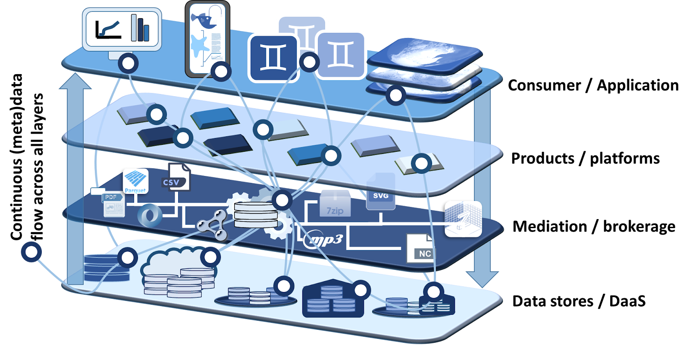

Figure 1: The IOC Data Architecture will adopt a data fabric architectural model, closely resembling that recommended by the Implementation Plan of the UN Decade of Ocean Science of Science for Sustainable Development. Each layer of the fabric, and the data exchanges that stitch them together, must have well-developed data management practices in place to ensure quality and integrity.

This architecture model will enable a more cohesive digital culture across the IOC, allowing its elements to:
- More efficiently and reliably harness the digital value of IOC activities across the value chain
- Federate capacities across IOC and with external organisations, aligning with the UN Ocean Decade Data and Information Strategy
- Ensure open, FAIR and CARE data access through coordinated and persistent implementation of these principles
- Deliver value more globally through consistent standards and metadata
- Enhance the development and maintenance of, and access to, IOC data products and services, including Essential Ocean Variable (EOV) data products, SDG, KMGBF and other indicators, and global data exchange diagnostics and reports
- Provide federated endpoints for metadata discovery/harvesting that will link to actual data that flows on demand. Federated data will always point back to the original source so that version issues are minimized
- The architecture will also enhance IOCs ability to set global standards, common norms and frameworks in ocean data and information
The following basic schema for an IOC Data Architecture, embedding key IOC components into a holistic data fabric ecosystem, is proposed.The IOC’s key digital assets will be positioned across this architecture as follows:
- IODE’s ODIS will provide an active metadata and orchestration layer to “stitch” the fabric together and coordinate data discovery and mobilisation, both within IOC and with other systems federated through ODIS.
- GOOS Observation Coordination Group ERDDAPTM server which provides metadata and data access and will act as a data mediator/broker for data and metadata, federating data across many organisations and supporting numerous downstream services, products and platforms.
- IODE’s OBIS provides data storage, data brokerage, applications and products, dedicated to biological and ecological data. OBIS is an example of a thematic resource that enhances the architecture within a domain and across multiple organisations.
- IOC-WMO OceanOPS operational centre will embed in the mediation/brokerage layer, providing and harvesting operational metadata and delivering operational services to GOOS and others.
- IODE data centres (NODCs and ADUs) will share their asset catalogues via the active metadata layer coordinated via ODIS, allowing IOC to identify opportunities to further enhance and optimise the architecture.
- IOC/OSS Programmes, GOOS Expert Panels, and OBIS projects, will harvest data from across all GOOS/IODE data sources / stores and develop data products and services for delivery of information to policy and decision makers, including SDG indicators, as well as KMGBF and other indicators.
- Essential Ocean Variables will be core elements within the system, with trusted GOOS EOV data sources identified through a GOOS "flag", and standard metadata for provenance, licensing, and uncertainty estimates.
- Marine Spatial and Sustainable Ocean Planning entities will have comprehensive access to Essential Ocean Variable data sources from across IOC programmes and regions, enabling rapid assessment of data adequacy, analysis, and combination with other data sources, for example socio economic.
- IOC Tsunami Programme provides metadata to ODIS as an addition to its existing data channels.

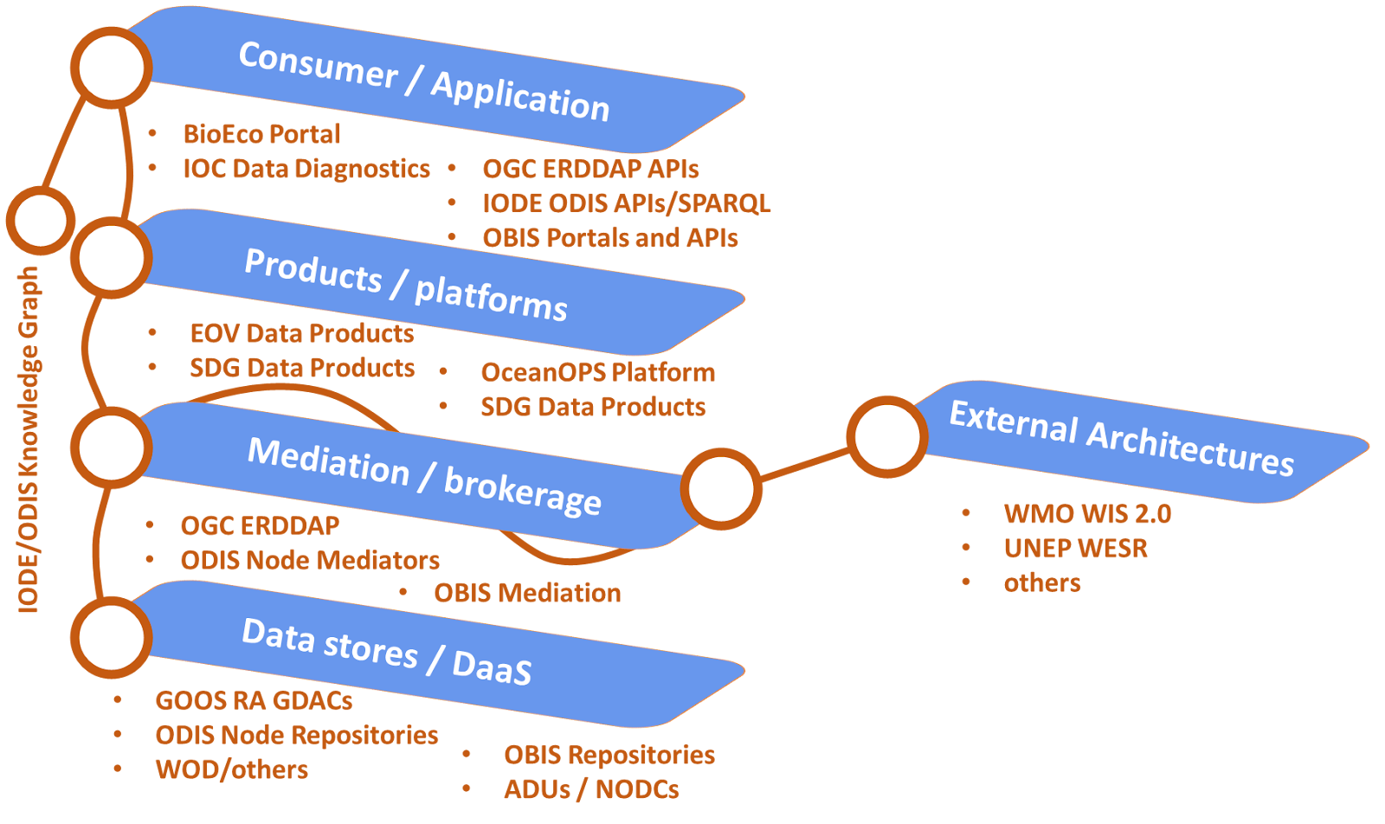
Figure 2: Illustrative schematic of selected IOC digital assets and partner systems positioned across the proposed IOC Data Architecture (data fabric), with some relevant external connections. Key to acronyms: IODE Ocean Data Information System (ODIS), IODE Ocean Biodiversity Information System (OBIS), GOOS OceanOPS (WMO-IOC Joint Operational Centre Ocean Observing), OCG ERDDAPTM (core ERDDAP™, consolidated access across all GOOS Observation Coordination Group (OCG) Network metadata), World Ocean Database (WOD), GOOS Regional Alliances (GOOS RAs), Global Data Assembly Centres (GDACs), GOOS Biological and Ecological EOV based observing communities., World Meteorological Organization Information System 2.0 (WIS2.0).

What does this greater connectivity do/enable?
In a relatively simple manner, using existing assets combined with a standard set of advanced technology, this architecture model creates an integrated IOC ‘data system’ that can simplify IOCs work moving forward and underpin data availability in a very real sense. An IOC Data Architecture will supercharge the production of data knowledge products, such as an oxygen atlas, or ocean carbon assessment; it is a platform for the future, powering complex and compound products, such as digital twins and AI applications not yet fully understood. The architecture will also cement IOCs leading role as setting global ocean information system standards and being a hub for ocean data. Finally, expanded use of ocean data will support funding for the core IOC infrastructure elements. The IOC Data Architecture, underpinned by IODE and GOOS, will develop broader connections with key communities towards a federated digital data ecosystem, in which IOC assets are a core component and are interoperable with other data assets. This powers both global solutions and the IOC mission.
Below are some specific examples of what the IOC Data Architecture will give users across science, private and public sector:
- Multiple use and (re)direction of data to multiple consumers, while reducing the need for multiple submissions of data and metadata to separate repositories, e.g. ocean carbon data from EOVs to SDG Indicators, and harvesting of open and coastal ocean oxygen data from different measurement platforms with qualified uncertainty.
- Harvesting of EOV data appropriate for national reporting across disciplines, e.g. to meet Convention on Biodiversity (CBD) biodiversity reporting.
- Creation of products and services across all discipline, including from GOOS certified EOV data, and using this trusted source data with confidence, e.g. for ocean oxygen deoxygenation indicator.
- Automating access to fuel models and operational services, including:
  - EOV (and Essential Climate Variable-ECV) and data across all GOOS ocean observing networks
  - other data variables within the IOC mandate, e.g. HABs, etc.
- Connecting ocean data with other discipline datasets for compound, cross discipline products and understanding, e.g. capturing the interplay between shipping corridors and marine life for sustainable ocean planning.
- Easy contribution of ocean data to the system by entities external to IOC through following system metadata standards (e.g. provenance, licence, etc), with due recognition/attribution in downstream products.
- Interface—at scale—IOC’s core digital capacities with other existing architectures and infrastructures (e.g. WMO’s WIS 2.0, UNEP’s WESR) to simplify data flow and access across domains, e.g. weather and earth system forecasting.
- Bridge digital divides and help mature digital ecosystems globally through digital capacity transfer, for example ODIS technology transfer between Member States in IOC regions.

4. Stakeholders—who are we building this for?
As an open data architecture delivering data at various stages of processing, the IOC Data Architecture will serve a vast range of stakeholders, including policy and decision makers, blue economy actors and ocean planners. However, specific consumers of IOC data served through the architecture are already known and will be engaged to co-create/co-shape implementation. These include:
Primary stakeholders: IOC Member States, IOC and its programmatic communities (including ocean observing and data communities, research communities, ocean forecasting and modelling communities), WMO, UNEP, FAO and other members of the UN Oceans community, Digital Twins.
Other beneficiaries: private sector (data contribution and use), non professional users, other UN and other international organisations, general public.
The open architecture approach should ensure that stakeholders we are not yet aware of will also benefit and a regular review process will ensure that the architecture remains relevant.

5. Why is this unique to the IOC?
The IOC Data architecture leverages and expands IOCs existing position in the ocean digital ecosystem, harnessing its inherent strengths to meet the needs of Member States and to advise decision making. The IOC has:
- A set of well established assets that the architecture connects to deliver something much more powerful than the sum of its parts.
- A clear role in the ocean community as the global coordinator, specifically of ocean science, observations and data, it would be very hard to create this outside of the IOC.
- The global mechanisms to consult ocean, data, and other communities to get the implementation right.
- Expertise, coordination, motivated communities, and decades of collective experience, to support this development for the benefit of society.
- A defining role in the UN Ocean Decade’s Data and Information Strategy.

6. Implementation
The concept and potential benefits of this unifying and forward looking IOC Data Architecture have been outlined above. The ambition and the potential of the platform to solve a number of needs across IOC and the broader ocean community was discussed at length during the First IODE/GOOS Data Workshop in September 2024 (IOC Workshop Report 311), with many useful ideas identified. However to go from concept to reality will require careful planning, development, testing, in a phased approach. Developing and implementing an IOC Data Architecture through well defined phases was one of the recommendations from the Workshop, starting with the development of a clear implementation plan and set of minimum viable products (MVPs) to test the concepts and demonstrate successful implementation at each step. A set of implementation steps for an IOC Data Architecture can be envisioned as follows:
- Plan, consult, test, advocate: consult with primary stakeholders to enhance the concept, develop a detailed plan for a Phase 1 implementation, setting goals, identifying existing assets and resource needs. Communicate to Member States on the plan, costs and benefits, and create early MVPs to prove concepts.
- Implement Phase 1: this would create the core infrastructure connections, governance, a set of minimum demonstrator MVPs, and initiate capacity development. This should deliver a core defined capability for IOC, it should also outline and seek to minimise the maintenance costs of such a core infrastructure and define elements for Phase 2 with IOC and primary stakeholders.
- Implement Phase 2: this would build on the core infrastructure, extending the delivery of IOC services, capacity development aspects, and include support for ignition or connection to new data sources both across the IOC ocean community and/or with citizen science and private sector (TBD). Again a set of MVPs would be the outcome, as well as measure of community engagements and use. The cost of maintenance of any IOC products and services developed is also important to define, such that Member States can identify efficiency gained through such core service provision.
- Implement Phase 3: As required, based on Member State support, learning from successful implementation to date, and ongoing technological development in the ocean digital ecosystem with regard to technology, users, and community needs.
Each implementation phase will have clear deliverables, timeline, and resource needs identified, and for each phase the eliverables/outcomes will be reported to the IOC governing body (Assembly/Executive Council) for feedback and approval.

Initial work post IODE/GOOS Data Workshop
The IODE and GOOS representatives at the Workshop noted that many elements of the proposed IOC Data Architecture already exist and are already converging, what the Workshop achieved was to identify and develop a common goal and to outline an approach forward to optimise connections between existing elements—the IOC Data architecture—that would strengthen delivery of ocean data. The Workshop established an interim IOC Data Architecture Working Group to develop a concept proposal to provide to the IOC Assembly in June 2025 (as outlined in this document).
In addition, the interim Working Group received initial feedback from the GOOS and IODE governing bodies; the 14th GOOS Steering Committee, in February 2025, welcomed the results of the IODE-GOOS Data Workshop and the proposal to develop an IOC Data Architecture, the IODE Committee at its 28th Session, in March 2025, also welcomed the development of the IOC Data Architecture as an important collaboration within IOC to position the IOC in its leadership role to support Member States in achieving the high-level objectives under the IOC Medium Term Strategy. In addition, the IODE Committee welcomed the alignment of the proposed IOC Data Architecture with the core digital architecture of the UN Ocean Decade, and requested that the role of NODCs and ADUs be recognized in the emerging IOC data architecture.
The interim IOC Data Architecture Working Group consists of members from:
- IODE Ocean Data Information System
- IODE Ocean Biodiversity Information System / GOOS BioEco Panel
- GOOS Observations Coordination Group
- WMO-IOC Operational Centre OceanOPS
- GOOS Management Team
- IOC Ocean Science Section
- GOOS Biogeochemistry Panel
- IODE Management
- Ocean Decade Coordination Office for Ocean Observing and Ocean Data Sharing, and the Collaborative Centre for Ocean Prediction, and corporate Data Group
- IOC Working Group on Sustainable Ocean Planning and Management
With additional experts invited as required.

IOC Assembly in 2025
Draft Decision A-33/3.4.3 proposes that the IOC Assembly at its 33rd session:
- Endorses the IOC Data Architecture concept as outlined in [this document].
- Approves the Terms of Reference of the intersessional Working Group on the development of the IOC Data Architecture, as outlined in the annex to the decision A-33/3.4.3 defines the Intersessional Working Group on the development of the IOC Data Architecture Terms of Reference, as below].
- Requests the IOC Data Architecture working group of experts to deliver a detailed implementation plan and minimum viable product demonstrators for the consideration of the 59th IOC Executive Council in June 2026.
The Intersessional Working Group on the development of the IOC Data Architecture Terms of Reference are:
Taking into account the tasks as outlined in the IODE-GOOS Data Workshop report¹ and feedback from the Fourteenth GOOS Steering Committee and IODE-28, the IOC Data Architecture working group of experts will undertake the following set of synthesised tasks.
Tasks:
- Consult with a range of stakeholders on the proposal concept and integrate the feedback into a revised document.
- Develop a detailed implementation plan for Phase 1 of an IOC data architecture to be submitted to the 59th IOC Executive Council in June 2026.
- Develop a limited set of minimal viable product demonstrators, that are feasible for implementation within a year and that will demonstrate the value of an integrated IOC Data Architecture to the 59th IOC Executive Council in June 2026.
- Communicate with, and seek feedback from, stakeholders, including Member States, on the implementation plan for an IOC Data Architecture prior to the 59th session of the IOC Executive Council.
(1) The tasks defined at the IODE-GOOS Data Workshop are available in the final report (IOC Workshop Report 311), Section 13., subsection 13.1, under point 2., establish and start the work of the IOC Data Architecture Working Group.

7. Next steps & timeline 2025–2026
Following feedback from the IOC Assembly, an Intersessional Working Group on the development of the IOC Data Architecture, with support from IODE and GOOS, will undertake and oversee the 4 tasks outlined above. The consultation (i) should be completed and the draft plan (ii) available by end 2025, to support communication (iv) in early 2026. The minimal viable product demonstrators (iii) will be defined by the Intersessional Working Group post IOC Assembly, and its members will work with the community in developing these for the IOC Executive Council in June 2026. The IOC Data Architecture Phase 1 Implementation Plan will be completed for submission and decision at the 59th session of the IOC Executive Council in 2026.
(i) Consultation: July–December 2025:
Engage with relevant internal and external stakeholder groups, including GOOS Observation Coordination Group, Regional Alliances, and IODE/OBIS nodes, IOC Member State representatives and sub-commissions, WMO and other important external stakeholders (Primary stakeholders).
(ii) Draft Phase 1 Plan: July 2025–January 2026 / Final Phase 1 Plan: April 2026
Leveraging the consultation, the Intersessional Working Group on the development of the IOC Data Architecture, will develop detailed plan for Phase 1, including the following: Vision, governance, technical structure, unique IOC offer, how plan to address capacity, initial MVP deliverables, consider in situ and model data, resource required, including technical resources e.g. computing power, and addressing digital equity and data availability, and risk assessment, timeline and budget.
(iii) MVP work: July 2025–May 2026
Select and develop a limited number of demonstrator minimum viable products (MVPs) that demonstrate data flows, potential data products, broker services, and test architecture and broker services are robust, this could include the following sub tasks:
- Map the data flows for potential demonstrator minimum viable products (MVPs)—what to govern and what to implement—look at optimisation/eliminating redundancy and feasibility for immediate or Phase 1 development.
- Develop small number of demonstrator MVPs e.g. ocean deoxygenation indicator, tracking data flow and interactions, demonstrating cross discipline (physics to biology) EOV data access.
- Assess and develop initial ‘rules’ of coordination and responsibilities for ODIS broker services and data flows, and feed outcomes into planning.
- Showcase initial demonstrator MVPs at IOC Executive Council 2026.
(iv) Communications: January 2025–April 2026
Communicate on the IOC Data Architecture Phase 1 Implementation to gain feedback before decision on implementation at IOC Executive Council 2026.

8. Risk and mitigation
There are some risks to the IOC in pursuing this course of action and these can be summarised, with mitigation steps, as follows :
Risk | Mitigation
IOC data elements are overwhelmed with this extra workload | First step is to elucidate a detailed Phase 1 implementation plan encompassing the roles of the different IOC data elements and what they will require in terms of resource. Implementation will not initiate at scale unless the resources identified in the plan are made available.  The architecture should simplify and reduce work across IOC as implemented
IOC data architecture assumptions are not correct/feasible, and/or it will not meet the needs of its stakeholders | Minimum viable product demonstrators will test and demonstrate potential gains  Consultation post IOC Assembly will will support co-design of Phase 1 Implementation (also Phase 2 and 3)
IOC does not implement and becomes less relevant, for member states needs in the ocean digital ecosystem | IOC acts swiftly, and in agile phases, to connect IOC elements and implement an IOC Data architecture
IOC will not achieve its ambition with regard to services as the internal infrastructure will make such endeavours costly due to inefficiencies associated with having no technical underpinning for cross-IOC delivery | IOC steps up and looks at what it will take to connect IOC elements and implement an IOC Data architecture, with a view to what future services it will support
Phase 1 implementation plan is too costly and/or funding is not available | There will be some cost implications of the IOC data architecture, however it can also provide cost savings and offers quantifiable benefits. In the implementation plan the benefits will be clearly weighed against investment and maintenance costs.  Implementation is built on open source technology, existing IOC elements and existing convergence, therefore it should be a cost efficient mechanism to add value to the IOC enterprise.

The general agreement across the IOC data elements suggest that it is feasible to both implement and to gain benefits envisioned for the IOC, its community, and Member States from an integrated IOC data architecture. There is relatively low risk associated with the IOC Assembly decision to invest time and some limited regular budget funds (IODE/GOOS) to create a detailed implementation plan. The detailed plan, delivered in early 2026 ahead of the next IOC Assembly in 2027 will require careful scrutiny.

Annex 1: List of Acronyms
ADUs : Associate Data Unit
AI/ML services : Artificial Intelligence / Machine Learning
CARE : Collective Benefit, Authority to Control, Responsibility, and Ethics
CBD : Convention on Biological Diversity
DaaS : Data as a Service
DCO-ODS : Decade Coordination Office - Ocean Data Sharing
ECVs : Essential Climate Variables
EOVs : Essential Ocean Variables
ERDDAP : Environmental Research Division Data Access Program
FAIR : Findable, Accessible, Interoperable, and Reusable
FAO : Food and Agricultural Organization
GDACs : Global Data Assembly Centres
GLODAP : Global Ocean Data Analysis Project
GOOS : Global Ocean Observing System
HABs : Harmful Algal Blooms
IODE : International Oceanographic Data and Information Exchange
KMGBF : Kunming-Montreal Global Biodiversity Framework
MVPs : Minimum Viable Products
NODCs : National Oceanographic Data Centres
OCG : Observation Coordination Group
OBIS : Ocean Biodiversity Information System
ODIS : Ocean Data and Information System
ODISCat : ODIS “Catalogue of Sources”
OSS : Ocean Sciences Section
RAs : Regional Alliances
SDG : Sustainable Development Goals
SOPs : Standard Operating Procedures
UNEPs WESR : United Nations Environment Programme - World Environment Situation Room
WMO : World Meteorological Organization
WIS2.0 : World Meteorological Organization Information System 2.0
WOD : World Ocean Database
Intergovernmental Oceanographic Commission (IOC)
United Nations Educational, Scientific and Cultural Organization
7, Place de Fontenoy
75 732 Paris 07 SP, France
http://ioc.unesco.org

