# **Context**

Africa’s ocean spaces support diverse and rich ecosystems, vital to the livelihoods, food security, culture, and economies of coastal populations. The region is home to globally significant biodiversity hotspots, including coral reefs, seagrass beds, mangroves, and deep-sea habitats. Yet, these ecosystems are under increasing pressure due to pollution, overexploitation, habitat degradation, climate change, and limited regulatory enforcement. Global and regional frameworks—including the Convention on Biological Diversity (CBD), the Sustainable Development Goals (SDGs), the Kunming-Montreal Global Biodiversity Framework, and the new Agreement on Biodiversity Beyond National Jurisdiction (BBNJ)—call for urgent action to assess, conserve, and sustainably manage marine biodiversity.  
  
While African countries have made strides in ocean science and ecosystem monitoring, much of the data is fragmented, assessments are not regularly updated, and capacity for ecosystem-based planning remains low. However, Africa is not starting from a vacuum. Several national and regional institutions possess research capacity, taxonomic expertise, and experience in marine assessments. With coordinated support, these can be elevated to regional centers of excellence. This working group is expected to chart a pathway to strengthen the science-policy interface for biodiversity conservation, integrate African priorities into global biodiversity frameworks, and support decision-making through robust assessments.

# Purpose

To support the development of a science-based, action-oriented work plan for ocean science, biodiversity, and ecosystem assessments that contributes to sustainability and resilience in Africa’s marine environment.

# 1. Theme Overview

This theme encompasses scientific research and monitoring efforts to understand marine ecosystems, their services, and stressors. It promotes actions to assess, conserve, and sustainably use biodiversity, while advancing ocean literacy, heritage conservation, and climate resilience through applied science and local knowledge. It is also essential to prepare African countries for implementation of the BBNJ treaty, SDG indicators, and national biodiversity strategies.

# 2. Sub-Themes to Cover

* Marine pollution and ecosystem health → Understanding sources, impacts, and priority interventions.
* Climate change impacts and blue carbon ecosystems → Including mangroves, seagrasses, and saltmarshes.
* Ocean biodiversity conservation and protected areas → Strengthening science to support MPAs and OECMs.
* BBNJ treaty and biodiversity frameworks → Regional coordination for negotiation, implementation, and monitoring.
* Harmful algal blooms (HABs) and biological risks → Enhancing surveillance and response systems.
* Ecosystem assessments and State of the Ocean reporting → Establishing baselines and data sharing practices.

# 3. Guiding Questions

* What are the priority biodiversity knowledge gaps in African coastal and marine areas?
* How can assessments support national action on MPAs, pollution, and restoration?
* What scientific and technical support is needed for BBNJ implementation in Africa?
* How can local knowledge, cultural values, and underwater heritage be integrated into biodiversity planning?
* Which institutions can lead regional research or support capacity building?

# 4. Proposed Activities for 2026–2027

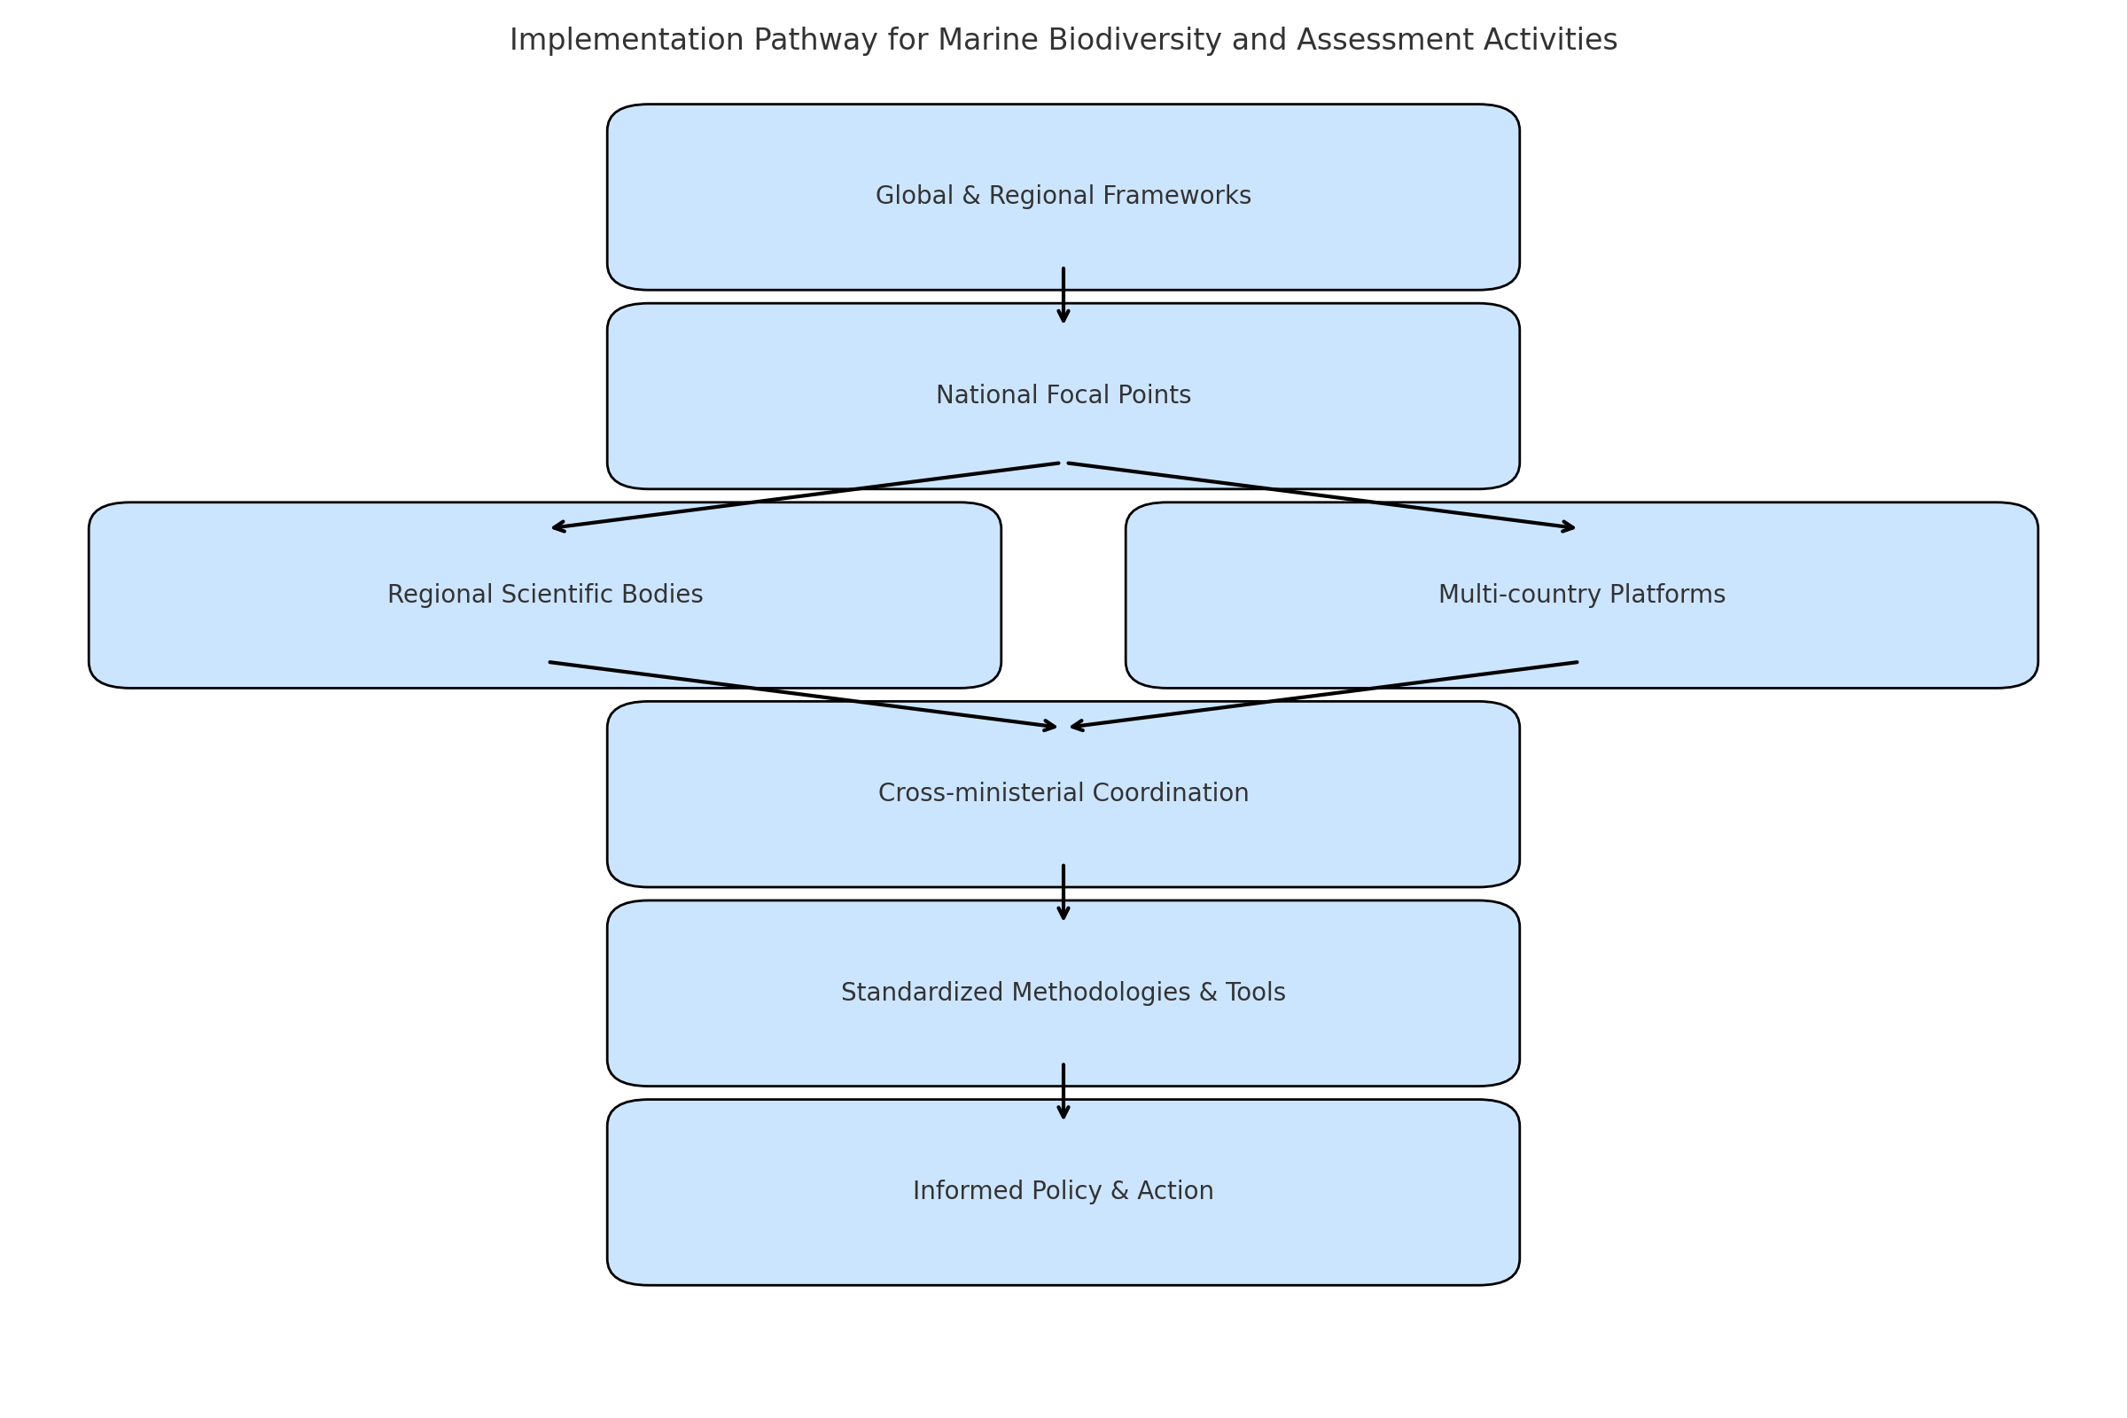

*Figure 1: Suggested implementation pathway for regional biodiversity and ecosystem assessment activities.*

These activities should also support the implementation of relevant global and regional frameworks, including the CBD Kunming-Montreal Global Biodiversity Framework, the BBNJ Agreement, the African Union Action Plan on Biodiversity, the IOC Criteria and Guidelines on the Transfer of Marine Technology, and the Decade of Ocean Science. Alignment with these processes will help ensure coherence, attract funding, and foster cross-regional collaboration. The working group is encouraged to explore implementation pathways that leverage national focal points, existing regional scientific bodies, and multi-country platforms to coordinate data flows, standardize methodologies, and provide technical backstopping for policy alignment. Where applicable, countries should be supported in establishing or strengthening cross-ministerial mechanisms to facilitate coherent implementation of these frameworks across environment, fisheries, culture, and education sectors.

## Research & Monitoring

* Design and implement a comprehensive regional survey to assess the status and trends in marine pollution and ecosystem health, including the identification of pollution hotspots, drivers of degradation, and ecosystem stressors, with a view to informing national and regional management interventions.
* Establish long-term ecological monitoring sites in representative marine habitats.
* Develop a harmonized biodiversity database for Africa’s coastal and marine species.

## Capacity Building

* Training on ecosystem assessment methodologies, indicator development, and SDG 14 reporting.
* Technical workshops on blue carbon mapping and valuation.
* Training programme on BBNJ treaty science and implications for African countries.

## Policy and Technical Support

* Develop regional guidance for mainstreaming biodiversity into coastal development and spatial planning.
* Produce technical briefs for decision-makers on HABs, invasive species, and ecosystem tipping points.

## Tools & Communication

* Develop a digital atlas of African MPAs and OECMs with biodiversity indicators.
* Promote citizen science for biodiversity observation and habitat monitoring.
* Integrate marine biodiversity and underwater cultural heritage in school curricula and awareness campaigns.

## Pilot Actions & Projects

* Launch a pilot project on restoring degraded blue carbon ecosystems (e.g., mangrove rehabilitation).
* Support a multi-country State of the Ocean report with harmonized methodology and national inputs.

# 5. Coordination with Other WGs

* Collaborate with WG 5.2.1 on environmental monitoring for biodiversity.
* Align with WG 5.2.3 on biodiversity data sharing and digital platforms.
* Coordinate with WG 5.2.4 on training and funding opportunities.

# 6. Monitoring & Evaluation Considerations

* Number of ecosystem assessments completed and published.
* Area of blue carbon ecosystems mapped or restored.
* Number of professionals trained on biodiversity monitoring and BBNJ.
* Integration of biodiversity data into regional and global databases (e.g., ODIS, OBIS).

# 7. Expected Outputs from the WG

* + List of priority assessments, research areas, and capacity gaps.
  + Recommendations for incorporating biodiversity in IOCAFRICA’s strategic plan.
  + Proposed partnerships with global biodiversity networks and Decade programmes.
  + Plan for regional BBNJ capacity development and support tools.
  + Awareness-raising initiatives linking science, heritage, and culture.