|  |  |
| --- | --- |
| **Intergovernmental Oceanographic Commission** | |
| **Technical Series** | **135** |



**User’s Guide for**

**Pacific Tsunami Warning Center Procedures and Products for the Tsunami and other Coastal Hazards Warning System for the Caribbean and Adjacent Regions (CARIBE-EWS)**

**April 2025**

**UNESCO**

|  |  |
| --- | --- |
| **Intergovernmental Oceanographic Commission** | |
| **Technical Series** | **135** |

**User’s Guide for**

**Pacific Tsunami Warning Center Procedures and Products for the Tsunami and other Coastal Hazards Warning System for the Caribbean and Adjacent Regions (CARIBE-EWS)**

**May 2025**

**UNESCO**

IOC Technical Series, 135

Paris, October 2017

English only

Official tsunami warning messages are sent out by governmental authorities through the designated national authorities. UNESCO does not warrant, guarantee, or make any representations regarding the timeliness, currency, correctness, accuracy, reliability, or other aspect of the characteristics or use of the information available through the Tsunami and Other Coastal Hazards Warning System for the Caribbean and Adjacent Regions (CARIBE-EWS).

The designations employed and the presentation of the material in this publication do not imply the expression of any opinion whatsoever on the part

of the Secretariats of UNESCO and IOC concerning the legal status of any country or territory, or its authorities, or concerning the delimitation of the frontiers of any country or territory.

For bibliographic purposes, this document should be cited as follows:

*User’s Guide for Pacific Tsunami Warning Center Procedures and Products for the Tsunami and other Coastal Hazards Warning System for the Caribbean and Adjacent Regions (CARIBE-EWS).* IOC Technical Series No 135. UNESCO/IOC 2017 (English.)

Guide prepared by: Pacific Tsunami Warning Center

~~International Tsunami Information Center~~

~~PTWS Task Team on Enhanced Products~~

Published in 2017

by United Nations Educational, Scientific and Cultural Organization

7, Place de Fontenoy, 75352 Paris 07 SP

 UNESCO 2017

Printed in France

(IOC/2017/TS/135)

# TABLE OF CONTENTS

TABLE OF CONTENTS i

Change Log iv

I. DOCUMENT PURPOSE 1

II. BACKGROUND 1

III. OVERVIEW 1

IV. PTWC CAPABILITIES AND PROCEDURES 2

A. General Timeline of events for PTWC Processes and CARIBE-EWS Products 2

B. Supporting Seismic Data 4

C. Supporting Sea Level Data 5

D. Criteria for PTWC Initial Text Products for the CARIBE-EWS. 7

V. RIFT FORECAST MODEL DESCRIPTION AND LIMITATIONS 8

A. RIFT Description 8

B. RIFT Limitations 9

VI. DESCRIPTION OF PRODUCTS 10

A. Text Products 10

i. Headers 10

ii. Headline 10

iii. Target Area 10

iv. Updates 10

v. Tsunami Threat Forecast 10

vi. Evaluation 10

vii. Recommended Actions 10

viii. Estimated Times of Arrival 10

ix. Potential Impacts 10

x. Tsunami Observations 10

xi. Preliminary Earthquake Parameters 11

xii. Next Update and Additional Information 11

B. Graphical Products 11

i. Forecast Polygon Map 11

ii. Forecast Polygon Table 11

iii. Energy Forecast Map 11

iv. Coastal Forecast Map 11

v. Coastal Forecast KMZ File 11

VII. PROCEDURES FOR ACTING ON PRODUCTS 13

VIII. CONTACT POINTS 14

APPENDIX I. EXAMPLE PTWC PRODUCTS FOR CARIBBEAN EARTHQUAKES 15

A. Tsunami Information Statement – Initial and usually only product 15

i. Text Product Only 15

B. Initial Tsunami Threat Product with the Potential Threat Area 17

i. Text Product 17

C. Second Threat Product with a Tsunami Forecast 21

i. Text Product 21

ii. Forecast Polygons Map 26

iii. Table of Forecast Statistics 27

iv. Energy Forecast Map 29

v. Coastal Forecast Map 30

D. Third or Later Threat Product with Sea Level Readings 31

i. Text Product 31

E. Final Threat Product - Threat Ended 36

i. Text Product 36

APPENDIX II. EXAMPLE PTWC PRODUCTS FOR ATLANTIC EARTHQUAKES 38

A. Tsunami Information Statement – No Tsunami Threat 38

i. Text Product Only 38

B. First Product - Tsunami Information Statement – Still Evaluating 40

i. Text Product 40

C. Later Product - Initial Tsunami Threat with Tsunami Forecast 42

i. Text Product 42

ii. Forecast Polygons Map 47

iii. Table of Forecast Statistics 48

iv. Energy Forecast Map 50

v. Coastal Forecast Map - Atlantic 51

vi. Coastal Forecast Map – Caribbean 52

E. Later Threat Product with Gauge Readings 53

i. Text Product 53

F. Final Threat Product 59

i. Text Message 59

APPENDIX III. Countries and Territories as Named in PTWC CARIBE-EWS Products 61

APPENDIX IV. UNESCO CARIBE-EWS Member States 62

APPENDIX V. List of Forecast Polygons 63

APPENDIX VI. Estimated Tsunami Arrival Time Points Named in PTWC Products 65

APPENDIX VII. IOC Technical Series 68

# Change Log

|  |  |  |
| --- | --- | --- |
| Date | Description | Made By |
| October 2017 | Original Version |  |
| April 20, 2024 | Added this Change Log | C. McCreery / PTWC |
| April 29, 2024 | Made minor edits to the Overview | C. McCreery / PTWC |
| July 14, 2024 | Reviewed and updated entire document where necessary. Made numerous format changes to text products including changes from all upper-case text to mixed case, and organizing ETAs and observations by country. | C. McCreery / PTWC |
| September 12, 2024 | Changed document title to reflect that these are no longer the enhanced products but the regular products. Incorporated content from the 2006 Communication Plan making that Plan now obsolete. Modified all sections to make them up to date with current procedures and products. | C. McCreery / PTWC |
| May 1, 2025 | Included the expanded Coastal Forecast Map – Caribbean for Atlantic Events. Added language to indicate the forecast applies to the entire duration of the event. Added language to evaluation statements to reinforce that they are only for CARIBE-EWS coasts. | C. McCreery / PTWC |

# DOCUMENT PURPOSE

This purpose of this document is to provide a description of the procedures and products of the Pacific Tsunami Warning Center (PTWC) in its function as a Tsunami Service Provider (TSP) for the Tsunami and Other Hazards Warning and Mitigation System for the Caribbean and Adjacent Seas (CARIBE-EWS), a subsidiary body of UNESCO’s Intergovernmental Oceanographic Commission (IOC). Products issued by PTWC to countries and territories around the Caribbean in support of its TSP mission have evolved over time as supporting data, analysis methods, computational capabilities, and communications have all improved and user’s needs have evolved. This User’s Guide describes the current procedures and products issued to designated national authorities of the Member States of the CARIBE-EWS in support of their own tsunami response procedures and corresponding actions. Text products from PTWC are also publicly available. All products are for information only. National authorities are responsible for determining the level of tsunami alert within each Member State. This document replaces previous versions as well as the Communication Plan for the Interim Tsunami Advisory Information Service to the Caribbean Sea and Adjacent Regions - 19 December 2007 Version.

# BACKGROUND

PTWC was established in 1949 as a tsunami warning center for the U.S. State of Hawaii following the unwarned April 1, 1946 tsunami from the Aleutian Islands that killed 159 persons in Hawaii. It became a warning center for the entire Pacific in 1965 following the May 22, 1960 Chile tsunami from a magnitude 9.5 earthquake that spread across the entire Pacific and killed 139 people in Japan, striking there almost a day after it was generated. In 2005, following the December 26, 2004 tsunami in the Indian Ocean that killed 230,000 people, PTWC took the responsibility of serving as an interim TSP for both the Indian Ocean and the Caribbean. PTWC service for the Indian Ocean ended in 2013 following the establishment of capable Tsunami Service Providers (TSPs) in Indonesia, Australia and India. In 2016, the Intergovernmental Coordination Group for the CARIBE-EWS recommended that the PTWC be considered as a CARIBE-EWS TSP for the Caribbean and Adjacent Regions, removing the interim nature of its services. The product suite issued by PTWC for the CARIBE-EWS for potential and actual tsunami events includes text and graphical products. Text products provide concise and general information about the earthquake, the tsunami threat, expected first wave arrival times, expected maximum tsunami amplitudes at pre-determined tsunami warning points, and measurements of tsunami waves at available sea level gauges. The graphical products provide more detailed information regarding the expected directionality of the tsunami and expected amplitudes along all coasts.

# OVERVIEW

To provide information as quickly as possible on a potential tsunami threat following a large earthquake, initial tsunami guidance in PTWC products is based solely on the preliminary assessment of the earthquake, without a numerical tsunami forecast. This information is usually issued within 5-10 minutes. A forecast is only produced after the earthquake mechanism is determined – about 20-30 minutes after the earthquake. This mechanism drives the forecast model. The forecast is further constrained, if necessary, by any readings of the tsunami on coastal or deep-ocean sea level gauges. In general, products continue to be issued until no further coasts in the region are threatened and readings on most gauges have fallen below threat levels and are not expected to increase.

It is important to note the limitations with respect to the PTWC products. The science of forecasting tsunamis in real time is still developing. A good forecast depends upon knowing how the seafloor was deformed by the earthquake to initiate the tsunami. This cannot be measured directly and must be inferred from the seismic analyses or from sea level readings. Another limitation is being able to observe the tsunami prior to impact —not only to confirm and measure the waves but to help constrain the forecast. For the nearest coasts where the tsunami is usually largest, there will likely be no readings before impact. A third limitation is in forecasting how the tsunami will interact with the coast. In most cases a general approximation must be used that does not take into account local effects that may increase or decrease amplitudes. Numerical simulation of inundations is computationally intensive and requires accurate and finely gridded coastal bathymetry and topography. Even when coastal inundation models are available, capturing coastal resonances, trapped wave energy, and multiple wave interactions after even a few wave cycles is difficult. For all these reasons, the forecast model information provided in the products should be viewed as a general approximation of the tsunami and its impacts, taking into consideration limitations generally described here and explained further in this document.

PTWC products may also be issued in response to tsunami waves generated by sources other than earthquakes. Procedures for such events are still in development and may be ad-hoc depending on the situation.

# PTWC CAPABILITIES AND PROCEDURES

The product suite is tied closely to PTWC’s scientific and technical capabilities and procedures. This section of the User’s Guide provides an overview of those capabilities and procedures and how they will drive the products. The overview is presented in terms of a timeline of events that occur in PTWC’s processing of an actual or potential tsunami. Times indicated are only approximate, but are typical.

## General Timeline of events for PTWC Processes and CARIBE-EWS Products

|  |  |
| --- | --- |
| **Typical**  **Elapsed Time** | **Event** |
| 00h00m | A large earthquake occurs in the Caribbean or Atlantic region. |
| 00h00m  to  00h02m | Vibrations from the earthquake reach nearby seismic stations monitored by PTWC (Figures 1 and 2), triggering event alarms. PTWC duty analysts respond to the operations centre and begin to analyze the event. |
| 00h02m  to  00h07m | Using a combination of automatic and interactive analyses, duty analysts complete their preliminary determination of the earthquake epicenter, depth, and magnitude. For large events, these parameters also trigger the W-phase Centroid Moment Tensor (WCMT) earthquake fault parameter analysis. |
| 00h05m  to  00h10m | Based only on the preliminary earthquake location, depth, and magnitude, an initial PTWC text product for the CARIBE-EWS is issued according to criteria listed in Table 2. A one-time Information Statement is issued if there is no tsunami threat. An Information Statement is also issued for a potential threat from far away that is still under evaluation. A Threat Message will be immediately issued for earthquakes that pose a potential tsunami threat to CARIBE-EWS coasts in accordance with the Table 2 criteria. |
| 00h15m | The seismic analyses continue as data from additional seismic stations arrive and are processed. If the earthquake parameters change significantly then another text product may be issued using the same Table 2 criteria. |
| 00h20m | The aforementioned WCMT analysis based upon data from broadband seismic stations in the surrounding regions completes. This analysis gives an accurate estimate of the earthquake centroid, depth and magnitude, and an estimate of the  earthquake’s mechanism —the strike angle of the fault, the dip angle of the fault, and the direction and amount of slip along the fault. These parameters are used to estimate the seafloor deformation that is the tsunami source. PTWC’s RIFT tsunami forecast model is then initiated based on the CMT parameters. For Caribbean earthquakes the run completes in about 2-3 minutes. For Atlantic events, the run completes in about 7-9 minutes. |
| 00h20m  to  00h30m | For events with any RIFT forecast amplitudes above 0.3 m on CARIBE-EWS coasts, then a Threat Message is issued along with accompanying maps, a table of forecast statistics, and a coastal forecast amplitudes kmz file that cover the entire Caribbean region and adjacent seas of the CARIBE-EWS. If the forecast indicates no amplitudes above 0.3 m and data from the nearest sea-level gauges are consistent with that forecast, then a final Threat Message is issued. |

|  |  |
| --- | --- |
| **Elapsed Time** | **Event** |
| 00h30m  to  02h00m | If there is a threat, sea-level gauges are monitored for tsunami signals. Within the first 30 minutes to an hour the tsunami may arrive on the nearest one or two coastal gauges and one or two deep-ocean gauges. Tsunami amplitudes are measured and compared, when possible, with forecast amplitudes produced by the models. Model forecasts may be adjusted to be more consistent with observations. Supplemental Threat Messages that include key observations and any revised forecasts are issued at least once an hour. |
| Beyond 2h | The process of refining the earthquake parameters and collecting additional sea- level observations continues, with that information used to constrain the forecast. The tsunami is monitored as it advances. When it is likely that there is no longer a significant tsunami threat then a final Threat Message is issued. |

## Supporting Seismic Data

Data are provided by many cooperating seismic networks. At any time, some stations and networks have outages in service due to station or communication issues. However, there is usually sufficient redundancy to ensure that PTWC performance is not significantly affected.

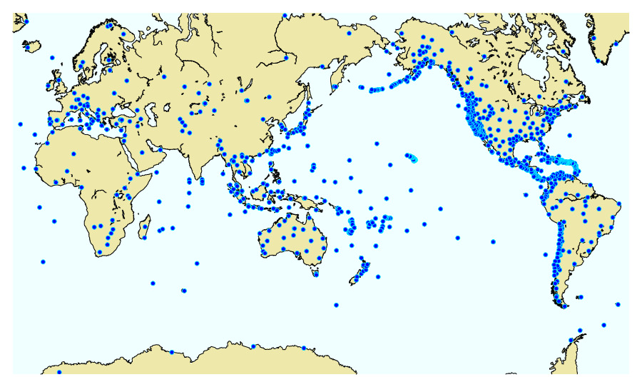Figure 1. Seismic stations worldwide with data transmitted to PTWC in real time (2024).

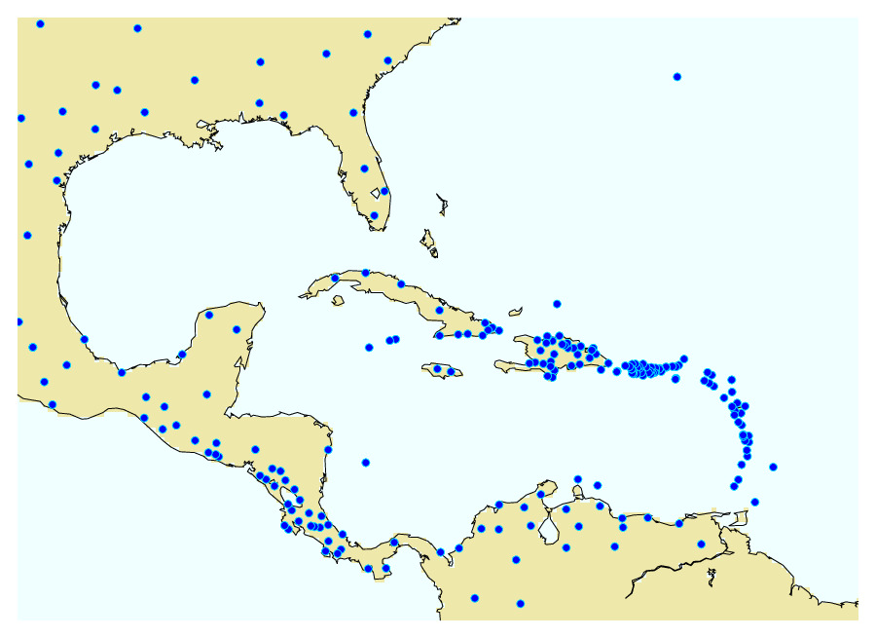Figure 2. Caribbean region seismic stations with data transmitted to PTWC in real time (2024).

## Supporting Sea Level Data

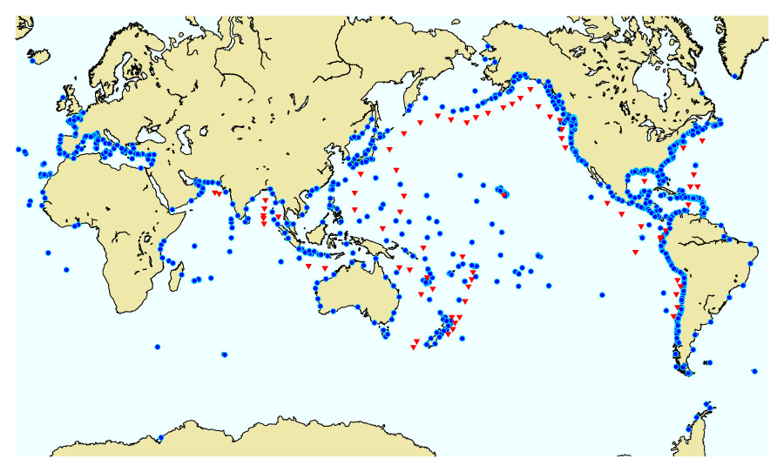Sea level data are provided by many cooperating sea level networks. At any time, some stations and networks have outages in service due to station or communication issues. There is a certain level of redundancy but gaps and outages can affect PTWC performance in detecting, monitoring, and measuring tsunami waves in a timely manner.

Figure 3. Sea level stations worldwide with data transmitted to PTWC in near real time. Blue dots are coastal stations; red triangles are deep-ocean tsunameters. (2024)

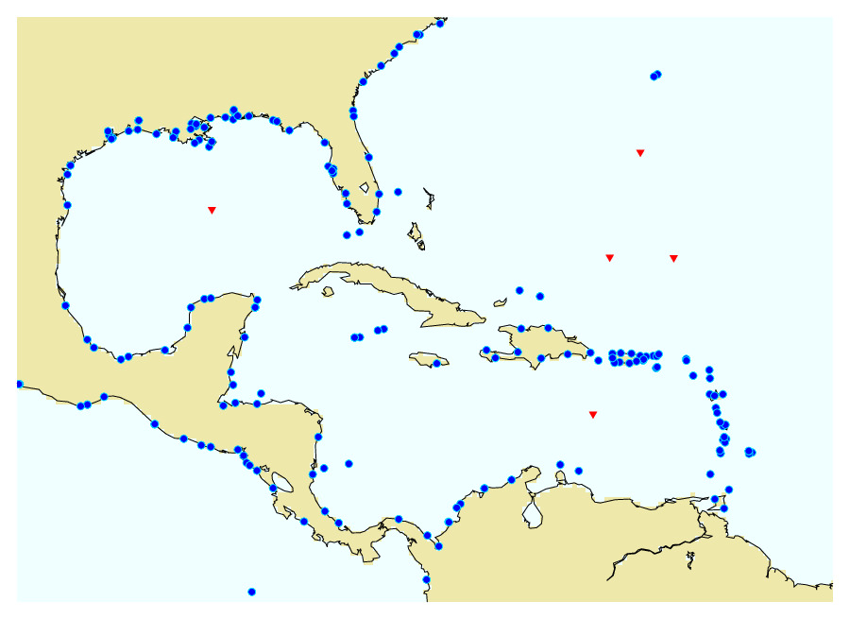Figure 4. Caribbean region sea level stations with data transmitted to PTWC in near real time. Blue dots are coastal stations; red triangles are deep-ocean tsunameters. (2024)

## Criteria for PTWC Initial Text Products for the CARIBE-EWS.

|  |  |  |  |  |  |
| --- | --- | --- | --- | --- | --- |
|  | **Earthquake** | | | **Product** | |
| Region | Location | Depth | Magnitude (Mw) | Type | Tsunami Threat |
| Caribbean | under the sea or very near the coast | any | < 6.0 | none | none |
| 6.0 – 7.0 | Information Statement | None - earthquake is too small |
| well inland | ≥ 6.0 | Information Statement | None - earthquake is too far inland |
| Atlantic | under the sea or very near the coast | any | < 6.5 | none | none |
| 6.5 – 7.0 | Information Statement | None - earthquake is too small |
| well inland | ≥ 6.5 | Information Statement | None - earthquake is too far inland |
| Caribbean or  Atlantic | under the sea or very near the coast | ≥ 100 km | ≥ 7.1 | Information Statement | None - earthquake is too deep |
| < 100 km | 7.1 - 7.5 | Threat Message | Potential threat to coasts within 300 km |
| 7.6 – 7.8 | Threat Message | Potential threat to coasts within 1000 km |
| ≥ 7.9 | Threat Message | Potential threat to coasts with ETA ≤ 3hours |
| Atlantic | under the sea or very near the coast | < 100 km | ≥ 7.9 | Information Statement | Potential threat but no coasts with ETA ≤ 3 hours.  Evaluation continues |

# RIFT FORECAST MODEL DESCRIPTION AND LIMITATIONS

## RIFT Description

RIFT (Real-time Forecast of Tsunamis) is a tsunami forecast model based on the linear shallow water equations. Studies of its accuracy for a wide variety of sources and coasts are still underway. However, based upon its general success in forecasting impacts from several recent tsunamis, including the February 2010 Chile tsunami and the March 2011 Japan tsunami, and its unique capability to use estimates of the earthquake fault geometry as the primary source constraint and to produce comprehensive forecast for all coasts in real time, RIFT forms the basis for the new products being produced for the PTWS.

Definitions: z2p=maximum absolute value of RIFT zero to peak wave amplitude

z2t=maximum absolute value of RIFT zero to trough wave amplitude

***RIFT Deep-Ocean Maximum Tsunami Wave Amplitude Map***

At each model grid point in the ocean, RIFT produces a time series of the sea level fluctuations caused by the passing tsunami waves. Shown on the map is the maximum amplitude of those fluctuations, Amax, defined by:

Amax = 0.5 * (z2p + z2t) in meters

These are the maximum deep-ocean tsunami amplitudes. Maximum coastal amplitudes can be much larger.

***RIFT Coastal Maximum Tsunami Wave Amplitude Map***

For each model grid point near the coast, the tsunami amplitude at the coast can be estimated based upon Green's Law.

Green’s Law: Acoast = Aoffshore * ( Doffshore / Dcoast )¼ where

Acoast is the tsunami amplitude at the coast

Aoffshore is the tsunami amplitude at the offshore grid point

Dcoast is the depth of the ocean at the coast

Doffshore is the depth of the ocean at the offshore grid point

The offshore grid point used for computing the coastal amplitude is the closest one with an ocean depth appropriate for the assumed tsunami wavelength that varies with depth and the model grid spacing. For the grid spacings at which RIFT is run - 30 arc-sec, 1 arc-min, 2 arc-min or 4 arc-min – the appropriate offshore ocean depth can vary from about 15 m to 1000 m. The coastal ocean depth is set to be 1 m.

If the distance from the coastal point to the offshore point is greater than 100 km, then no forecast is made for the coastal point. There is no confidence in the quality of the coastal forecast if Green's Law is applied over distances > 100 km. As a consequence, there might not be a forecast for coasts with wide continental shelves at 4-arc- min. resolution. In those cases, a RIFT run at finer than 4 arc-min resolution is required to produce a Green's Law coastal forecast.

## RIFT Limitations

The tsunami forecast produced by the RIFT model has uncertainty due to many factors. This uncertainty should to be considered when using the forecast for decision-making.

* Forecast results can vary easily by a factor of two, because of uncertainties in the preliminary magnitude, depth and assumed mechanism of the earthquake. Later results, constrained by the earthquake centroid moment tensor as well as by deep-ocean observations should be more reliable.
* For small islands (e.g., islands generally less than 30 km in diameter), and for islands with fringing or barrier reefs, Green's Law can overestimate the coastal amplitude. In those cases, a forecast amplitude value between the offshore and Green's Law amplitude may be more appropriate.
* For resonant harbors, the Green's Law amplitude can underestimate the actual wave amplitude. Green's Law amplitude should be interpreted as average wave amplitude at the open coast, not necessarily the maximum amplitude inside a harbor or at a sea-level gauge.
* The RIFT forecast coastal amplitude is not necessarily indicative of the inundation depth -how deep the water is on the land - which is also a function of the tsunami period and the local topography. A 30-meter coastal amplitude from Green's Law does not mean the inundation depth will reach 30 meters. But it does indicate a very major tsunami impact.
* In the near field, the Green’s law amplitude does not necessarily consider wave propagation and dissipation. Thus, a coastal amplitude of 20-30 meters can be misleading, it should also simply be interpreted as a major tsunami.
* The forecast is sensitive to the earthquake magnitude. A difference of 0.2 in the earthquake magnitude results in factor of two in the tsunami wave amplitude.
* The forecast is sensitive to the earthquake depth. A fault rupture at 10 km depth will result in a much larger tsunami than a rupture at 60 km depth.
* The forecast is sensitive to the earthquake focal mechanism. For example, two earthquakes of magnitude 7.5 with different focal mechanisms can give vastly different results, easily by a factor of two or more.
* RIFT is forced by an earthquake’s computed centroid moment tensor (CMT) that provides a faulting mechanism and a seismic moment that can, in turn, produce an estimate of the seafloor displacement to initiate a tsunami. Variations in different CMT results can produce a factor of two difference in the RIFT tsunami wave forecast.

***Key Assumptions of Green's Law***

* The coastline in question is linear and exposed to the open ocean.
* Tsunami waves near the coast behave as one-dimensional plane waves.
* There are no significant wave reflections and no dissipation by turbulence.
* The bathymetry varies slowly compared to the wavelength of the tsunami waves. Thus, for steep bathymetry, the Green's Law forecast can overestimate the tsunami wave amplitudes.
* Cliff boundary conditions are used. In other words, the coast is assumed to be a vertical wall.

# DESCRIPTION OF PRODUCTS

## Text Products

Text products are organized into the following discreet sections.

### Headers

At the top of each text product are some header lines that include the World Meteorological Organization (WMO) Product ID and issue date/time, an AWIPS ID, a product type line, an issuing office line, and an issuance date/time line. Identifiers are listed in the table below.

|  |  |  |
| --- | --- | --- |
| **Product Type** | **WMO ID** | **AWIPS ID** |
| Tsunami Information Statement | WECA43 PHEB | TIBCAX |
| Tsunami Threat Message | WECA41 PHEB | TSUCAX |

### Headline

Immediately below the header lines is a brief headline, leading and trailing with an ellipsis (…). The headline indicates either an information statement or a tsunami threat message.

### Target Area

Below the headline is a statement indicating the geographic area that the product is intended for. The products are for most of the Caribbean and Adjacent Regions except those parts exclusively covered by other centers. This statement is to help avoid confusion in areas not covered by the product.

### Updates

This section is to report any significant changes to the information in the products. Typically this might be a change in the earthquake magnitude, and update to the forecast, and new or revised sea level observations.

### Tsunami Threat Forecast

Within this section are indicated the countries or places with a potential or forecast tsunami threat. For a forecast threat, the levels are tsunami heights of 0.3-1 meter, 1-3 meters, and greater than 3 meters above the normal tide level.

### Evaluation

The evaluation section always includes a narrative statement describing the key earthquake parameters. It may also include one or two short statements about the tsunami threat.

### Recommended Actions

This section gives brief statements about recommended actions. Since the product is intended primarily for government agencies and not the public, the recommended actions are left very general to avoid conflicting with actions directed by the local authoritative government agencies.

### Estimated Times of Arrival

Within this section are listed, in table form, estimated first tsunami wave arrival times for specific points within or near areas identified with a tsunami threat of at least 0.3 meters above the tide. These times should only be viewed as approximate. For a long-duration event, estimated arrival times more than an hour in the past are removed from the list.

### Potential Impacts

This section contains brief statements about tsunami behavior and the hazard presented by each level of threat.

### Tsunami Observations

Within this section are readings of the maximum tsunami amplitude observed so far on coastal and/or deep-ocean sea-level gauges.

### Preliminary Earthquake Parameters

The earthquake parameters, the origin time, epicenter coordinates, depth, magnitude, and descriptive location are provided here in bulleted form.

### Next Update and Additional Information

This final section indicates when the next product, if any, can be expected. It is usually within an hour. It also tells where additional information about the event may be found.

## Graphical Products

### Forecast Polygon Map

The forecast polygon map provides a quick and general view of the tsunami threat. All coastal areas of the Caribbean covered by the product are enclosed within a set of polygons. Some countries or places are covered by a single polygon and some by multiple polygons. Each polygon is given a color depending upon its maximum level of threat. Some polygons are uncolored because either 1) the forecast model domain did not include those areas, or 2) the forecast model could not make a forecast because its resolution was insufficient in areas of shallow water.

### Forecast Polygon Table

The forecast polygon table shows, for each polygon with a threat, the maximum, mean, and median forecast coastal tsunami height as well as the maximum, mean, and median offshore tsunami height. Offshore heights are translated to coastal heights using Green’s Law. For places like islands that have dimensions much smaller than the tsunami wavelength, Green’s Law overestimates and the offshore height may be more appropriate. In all cases, height is measured relative to the tide level. Also provided are the standard deviation of the values, the total number of forecast points within each polygon, and a descriptive name for each polygon.

### Energy Forecast Map

The energy map shows the maximum tsunami amplitude at each place in the deep ocean. It shows how the tsunami is directed away from the earthquake, how it is focused and defocused by the shape of the seafloor, and how it diminishes by spreading. It is useful for understanding why some areas may be more threatened because they are in a “beam” of directed tsunami energy.

### Coastal Forecast Map

This map shows the individual coastal forecast points colored according to the forecast tsunami height at each point. It provides significantly more spatial detail than the polygons. This can be useful for identifying when only part of a coast within a polygon is under threat. The accuracy of individual points, however, is less than points as a group.

### Coastal Forecast KMZ File

Also provided with each forecast is a kmz file containing the individual tsunami forecast height values for each coastal grid point. When combined with a program like GoogleEarth, the user can drill down into the forecast to examine individual forecast points. Again, however, the accuracy of individual points is less than points as a group, and may not be appropriate for some coastal configurations.

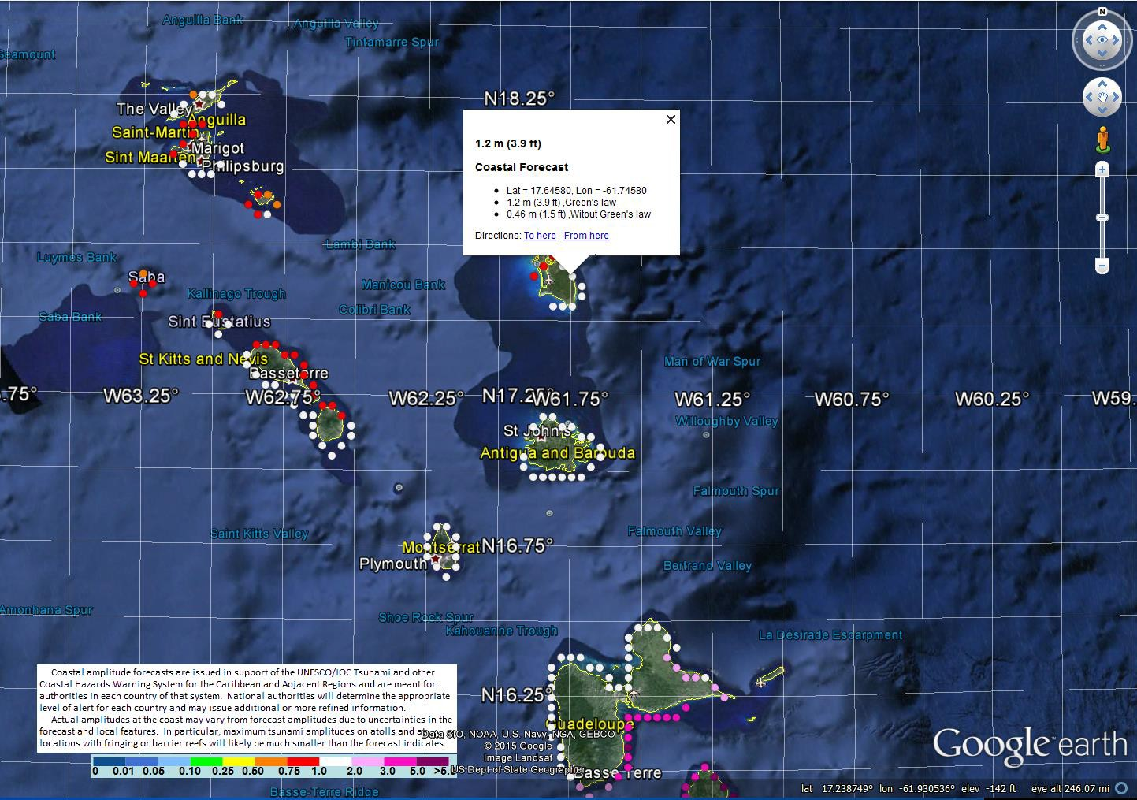

Figure 5. GoogleEarth screenshot of sample RIFT coastal tsunami forecast points around some of the Leeward Islands. By mousing over and clicking on a forecast point, the metadata for the point is shown.

# PROCEDURES FOR ACTING ON PRODUCTS

It is the responsibility of each Member State and its corresponding warning authority to decide how it will utilize PTWC TSP products sent to its Tsunami Warning Focal Point (TWFP) and National Tsunami Warning Center (NTWC). Standard operating procedures should be established and practiced for quickly recognizing when PTWC products are received, understanding the products, gathering any other necessary information, making decisions regarding actions to be taken, and then executing the actions to save lives, protect property, and otherwise reduce adverse impacts.

A decision tree regarding initial actions might include branches based upon the following factors:

* Does the PTWC product indicate no threat or a potential or a confirmed tsunami?
* What are the parameters of the earthquake or other source?
* When is the expected arrival time of the initial tsunami wave?
* How much time remains before the initial tsunami wave?
* What is the forecast amplitude of the tsunami impact?
* What is the amplitude of the tsunami in other places it has already impacted?
* What will the state of the tides be when the tsunami arrives?
* Are other local factors such as weather, time of day, or traffic relevant?

Initial response actions could include the following:

* No action is required.
* Wait for more definitive information from PTWC as the situation evolves.
* Notify disaster management agencies and other core partners including the media.
* Issue and disseminate evacuation orders and instructions to the public at risk.

Follow-up actions – If a tsunami is generated and a tsunami alert is issued, the decision tree regarding additional actions could include the following:

* Is there still a tsunami threat?
* What is the forecast or observed amplitude of the tsunami within the country or territory.
* What tsunami amplitudes are being observed elsewhere.
* Potential actions – upgrade, downgrade, or cancel the tsunami alert.

A significant challenge associated with these procedures is the decision-making about evacuations, particularly since evacuations can be very costly and disruptive and there is a significant probability of false alarms owing to the current lack of adequate sea level data from the source region. Procedures can include pre-determined decisions, such as automatically notifying the media and public for nearby events when time is very limited.

# CONTACT POINTS

Each Member State’s contact information for their TWFP and NTWC is maintained by the IOC, and Member States need to keep that information up to date through the IOC process. It is important for Member States to have these official designated agencies to receive PTWC products, and a to have a single authoritative agency to issue tsunami alerts. Confusion could result if conflicting information is disseminated to the public from multiple authorities.

**Need to include information here about the IOC process for updating the contact information.**

# APPENDIX I. EXAMPLE PTWC PRODUCTS FOR CARIBBEAN EARTHQUAKES

## Tsunami Information Statement – Initial and usually only product

### Text Product Only

ZCZC

WECA43 PHEB 030152

TIBCAX

Tsunami Information Statement Number 1

NWS Pacific Tsunami Warning Center Honolulu HI

0152 UTC Fri May 3 2024

...TSUNAMI INFORMATION STATEMENT...

**** NOTICE **** NOTICE **** NOTICE **** NOTICE **** NOTICE *****

This statement is issued for information only in support of the

UNESCO/IOC Tsunami and Other Coastal Hazards Warning System for

the Caribbean and Adjacent Regions and is meant for national

authorities in each country of that system.

National authorities will determine the appropriate level of

alert for each country and may issue additional or more refined

information.

**** NOTICE **** NOTICE **** NOTICE **** NOTICE **** NOTICE *****

PRELIMINARY EARTHQUAKE PARAMETERS

---------------------------------

* Magnitude 6.7

* Origin Time 0146 UTC May 3 2024

* Coordinates 10.3 North 78.5 West

* Depth 10 km / 6 miles

* Location North Of Panama

EVALUATION

----------

* An earthquake with a preliminary magnitude of 6.7 occurred

north of Panama at 0146 UTC on Friday May 3 2024.

* Based on all available data... there is no significant

tsunami threat from this earthquake to coasts of the

Caribbean and adjacent regions covered by this international

product. However... there is a very small possibility of

tsunami waves along coasts located nearest the epicenter.

RECOMMENDED ACTIONS

-------------------

* No action is required.

NEXT UPDATE AND ADDITIONAL INFORMATION

--------------------------------------

* This will be the only statement issued for this event unless

additional data are received or the situation changes.

* Authoritative information about the earthquake from the U.S.

Geological Survey can be found on the internet at

earthquake.usgs.gov.

* Further information about this event may be found at

www.tsunami.gov.

* Coastal regions of the US Gulf Coast... US East Coast... and

the Maritime Provinces of Canada should refer to U.S.

National Tsunami Warning Center messages that can be found

at www.tsunami.gov.

$$

NNNN

## Initial Tsunami Threat Product with the Potential Threat Area

### Text Product

ZCZC

WECA41 PHEB 211506

TSUCAX

Tsunami Message Number 1

NWS Pacific Tsunami Warning Center Honolulu HI

1506 UTC Thu Mar 21 2024

...TSUNAMI THREAT MESSAGE...

**** NOTICE **** NOTICE **** NOTICE **** NOTICE **** NOTICE *****

This message is issued for information only in support of the

UNESCO/IOC Tsunami and Other Coastal Hazards Warning System for

the Caribbean and Adjacent Regions and is meant for national

authorities in each country of that system.

National authorities will determine the appropriate level of

alert for each country and may issue additional or more refined

information.

**** NOTICE **** NOTICE **** NOTICE **** NOTICE **** NOTICE *****

PRELIMINARY EARTHQUAKE PARAMETERS

---------------------------------

* Magnitude 8.7

* Origin Time 1500 UTC Mar 21 2024

* Coordinates 19.3 North 66.5 West

* Depth 20 km / 12 miles

* Location Puerto Rico Region

EVALUATION

----------

* An earthquake with a preliminary magnitude of 8.7 occurred in

the Puerto Rico region at 1500 UTC on Thursday March 21

2024.

* Based on the preliminary earthquake parameters... widespread

hazardous tsunami waves are possible to coasts of the

Caribbean and adjacent regions covered by this international

product.

TSUNAMI THREAT FORECAST

---------------------------------

* Hazardous tsunami waves from this earthquake are possible

within the next three hours along some coasts of

ANGUILLA... ANTIGUA... ARUBA... BAHAMAS... BARBADOS...

BARBUDA... BERMUDA... BONAIRE... BR VIRGIN IS... CAYMAN

ISLANDS... COLOMBIA... CUBA... CURACAO... DOMINICA...

DOMINICAN REP... GRENADA... GUADELOUPE... HAITI...

JAMAICA... MARTINIQUE... MONTSERRAT... PANAMA... PUERTO

RICO... SABA... SAINT BARTHELEMY... SAINT KITTS... SAINT

LUCIA... SAINT MARTIN... SAINT VINCENT... SAN ANDRES

PROVID... SINT EUSTATIUS... SINT MAARTEN... TRINIDAD

TOBAGO... TURKS N CAICOS... US VIRGIN IS and VENEZUELA

RECOMMENDED ACTIONS

-------------------

* Government agencies responsible for threatened coastal areas

should take action to inform and instruct any coastal

populations at risk in accordance with their own

evaluation... procedures and the level of threat.

* Persons located in threatened coastal areas should stay alert

for information and follow instructions from national and

local authorities.

ESTIMATED TIMES OF ARRIVAL

--------------------------

* Estimated times of arrival -ETA- of the initial tsunami wave

for places within the region identified with a potential

tsunami threat. Actual arrival times may differ and the

initial wave may not be the largest. A tsunami is a series

of waves and the time between waves can be five minutes to

one hour.

LOCATION COORDINATES ETA(UTC)

------------------------------------------------------

PUERTO RICO

San Juan 18.5N 66.1W 1510 03/21

Mayaguez 18.2N 67.2W 1517 03/21

DOMINICAN REP

Cabo Engano 18.6N 68.3W 1532 03/21

Puerto Plata 19.8N 70.7W 1535 03/21

Santo Domingo 18.5N 69.9W 1556 03/21

BR VIRGIN IS

Anegada 18.8N 64.3W 1534 03/21

Roadtown 18.4N 64.6W 1655 03/21

US VIRGIN IS

Christiansted 17.7N 64.7W 1542 03/21

Charlotte Amalie 18.3N 64.9W 1619 03/21

SABA

Saba 17.6N 63.2W 1543 03/21

TURKS N CAICOS

Grand Turk 21.5N 71.1W 1544 03/21

West Caicos 21.7N 72.5W 1601 03/21

SINT MAARTEN

Simpson Baai 18.0N 63.1W 1549 03/21

ANGUILLA

The Valley 18.3N 63.1W 1551 03/21

SINT EUSTATIUS

Sint Eustatius 17.5N 63.0W 1551 03/21

HAITI

Cap Haiten 19.8N 72.2W 1551 03/21

Jacamel 18.1N 72.5W 1617 03/21

Jeremie 18.6N 74.1W 1622 03/21

Port Au Prince 18.5N 72.4W 1715 03/21

SAINT KITTS

Basseterre 17.3N 62.7W 1558 03/21

BAHAMAS

Mayaguana 22.3N 73.0W 1559 03/21

Great Inagua 20.9N 73.7W 1612 03/21

San Salvador 24.1N 74.5W 1615 03/21

Long Island 23.3N 75.1W 1623 03/21

Exuma 23.6N 75.9W 1632 03/21

Cat Island 24.4N 75.5W 1633 03/21

Crooked Island 22.7N 74.1W 1634 03/21

Eleuthera Island 25.2N 76.1W 1639 03/21

Andros Island 25.0N 77.9W 1647 03/21

Nassau 25.1N 77.4W 1659 03/21

Freeport 26.5N 78.8W 1711 03/21

Abaco Island 26.6N 77.1W 1715 03/21

Bimini 25.8N 79.3W 1725 03/21

MONTSERRAT

Plymouth 16.7N 62.2W 1610 03/21

CUBA

Baracoa 20.4N 74.5W 1611 03/21

Santiago D Cuba 19.9N 75.8W 1625 03/21

Gibara 21.1N 76.1W 1628 03/21

Cienfuegos 22.0N 80.5W 1719 03/21

BARBUDA

Palmetto Point 17.6N 61.9W 1611 03/21

SAINT MARTIN

Baie Lucas 18.1N 63.0W 1612 03/21

Baie Grand Case 18.1N 63.1W 1613 03/21

Baie Blanche 18.1N 63.0W 1628 03/21

GUADELOUPE

Basse Terre 16.0N 61.7W 1616 03/21

ANTIGUA

Saint Johns 17.1N 61.9W 1616 03/21

SAINT BARTHELEMY

Saint Barthelemy 17.9N 62.8W 1617 03/21

BONAIRE

Onima 12.3N 68.3W 1619 03/21

DOMINICA

Roseau 15.3N 61.4W 1622 03/21

ARUBA

Oranjestad 12.5N 70.0W 1628 03/21

SAINT LUCIA

Castries 14.0N 61.0W 1629 03/21

MARTINIQUE

Fort De France 14.6N 61.1W 1629 03/21

BARBADOS

Bridgetown 13.1N 59.6W 1638 03/21

SAINT VINCENT

Kingstown 13.1N 61.2W 1644 03/21

VENEZUELA

Maiquetia 10.6N 67.0W 1649 03/21

Cumana 10.5N 64.2W 1713 03/21

CURACAO

Willemstad 12.1N 68.9W 1652 03/21

BERMUDA

Esso Pier 32.4N 64.7W 1655 03/21

CAYMAN ISLANDS

Cayman Brac 19.7N 79.9W 1656 03/21

Grand Cayman 19.3N 81.3W 1713 03/21

COLOMBIA

Santa Marta 11.2N 74.2W 1706 03/21

Cartagena 10.4N 75.6W 1722 03/21

Barranquilla 11.1N 74.9W 1731 03/21

Riohacha 11.6N 72.9W 1735 03/21

Punta Caribana 8.6N 76.9W 1805 03/21

JAMAICA

Montego Bay 18.5N 77.9W 1708 03/21

Kingston 17.9N 76.9W 1724 03/21

GRENADA

Saint Georges 12.0N 61.8W 1709 03/21

TRINIDAD TOBAGO

Pirates Bay 11.3N 60.6W 1722 03/21

PANAMA

Aligandi 9.2N 78.0W 1743 03/21

Puerto Carreto 8.8N 77.6W 1750 03/21

Puerto Obaldia 8.7N 77.4W 1802 03/21

SAN ANDRES PROVID

San Andres 13.4N 81.4W 1749 03/21

Providencia 12.6N 81.7W 1752 03/21

POTENTIAL IMPACTS

-----------------

* A tsunami is a series of waves. The time between wave crests

can vary from 5 minutes to an hour. The hazard may persist

for many hours or longer after the initial wave.

* Impacts can vary significantly from one section of coast to

the next due to local bathymetry and the shape and elevation

of the shoreline.

* Impacts can also vary depending upon the state of the tide at

the time of the maximum tsunami waves.

* Persons caught in the water of a tsunami may drown... be

crushed by debris in the water... or be swept out to sea.

NEXT UPDATE AND ADDITIONAL INFORMATION

--------------------------------------

* The next message will be issued in one hour... or sooner if

the situation warrants.

* Authoritative information about the earthquake from the U.S.

Geological Survey can be found on the internet at

earthquake.usgs.gov.

* Further information about this event may be found at

www.tsunami.gov.

* Coastal regions of the US Gulf Coast... US East Coast... and

the Maritime Provinces of Canada should refer to U.S.

National Tsunami Warning Center messages that can be found

at www.tsunami.gov.

$$

NNNN

## Second Threat Product with a Tsunami Forecast

### Text Product

ZCZC

WECA41 PHEB 211530

TSUCAX

Tsunami Message Number 2

NWS Pacific Tsunami Warning Center Honolulu HI

1530 UTC Thu Mar 21 2024

...TSUNAMI THREAT MESSAGE...

**** NOTICE **** NOTICE **** NOTICE **** NOTICE **** NOTICE *****

This message is issued for information only in support of the

UNESCO/IOC Tsunami and Other Coastal Hazards Warning System for

the Caribbean and Adjacent Regions and is meant for national

authorities in each country of that system.

National authorities will determine the appropriate level of

alert for each country and may issue additional or more refined

information.

**** NOTICE **** NOTICE **** NOTICE **** NOTICE **** NOTICE *****

PRELIMINARY EARTHQUAKE PARAMETERS

---------------------------------

* Magnitude 8.7

* Origin Time 1500 UTC Mar 21 2024

* Coordinates 19.3 North 66.5 West

* Depth 20 km / 12 miles

* Location Puerto Rico Region

EVALUATION

----------

* An earthquake with a preliminary magnitude of 8.7 occurred in

the Puerto Rico region at 1500 UTC on Thursday March 21

2024.

* Tsunami waves have been observed.

* Based on all available data... hazardous tsunami waves are

forecast for some coasts of the Caribbean and adjacent

regions covered by this international product.

TSUNAMI THREAT FORECAST...UPDATED

---------------------------------

The following forecast tsunami amplitudes apply to the entire

duration of the event. It is up to national authorities to

decide on the appropriate levels of alert for their coasts

throughout the event based upon all available information.

* Tsunami waves reaching more than 3 meters above the tide

level are possible along some coasts of

ANGUILLA... BERMUDA... DOMINICAN REPUBLIC... and PUERTO

RICO AND VIRGIN ISLANDS.

* Tsunami waves reaching 1 to 3 meters above the tide level are

possible along some coasts of

ANTIGUA AND BARBUDA... GUADELOUPE... HAITI... SABA AND

SAINT EUSTATIUS... SAINT BARTHELEMY... SAINT KITTS AND

NEVIS... SINT MAARTEN... SAINT MARTIN... and TURKS AND

CAICOS ISLANDS.

* Tsunami waves reaching 0.3 to 1 meters above the tide level

are possible for some coasts of

ARUBA... BAHAMAS... BARBADOS... BONAIRE... COLOMBIA...

COSTA RICA... CUBA... CURACAO... DOMINICA... GRENADA...

GUYANA... JAMAICA... MARTINIQUE... MEXICO... MONTSERRAT...

PANAMA... SAINT LUCIA... SAINT VINCENT AND THE

GRENADINES... SURINAME... TRINIDAD AND TOBAGO... and

VENEZUELA.

* Actual amplitudes at the coast may vary from forecast

amplitudes due to uncertainties in the forecast and local

features. In particular maximum tsunami amplitudes on atolls

or small islands and at locations with fringing or barrier

reefs will likely be much smaller than the forecast

indicates.

* For all other areas covered by this message... there is no

tsunami threat although small sea level changes may occur.

RECOMMENDED ACTIONS

-------------------

* Government agencies responsible for threatened coastal areas

should take action to inform and instruct any coastal

populations at risk in accordance with their own

evaluation... procedures and the level of threat.

* Persons located in threatened coastal areas should stay alert

for information and follow instructions from national and

local authorities.

ESTIMATED TIMES OF ARRIVAL

--------------------------

* Estimated times of arrival -ETA- of the initial tsunami wave

for places within threatened regions are given below. Actual

arrival times may differ and the initial wave may not be the

largest. A tsunami is a series of waves and the time between

waves can be five minutes to one hour.

LOCATION COORDINATES ETA(UTC)

------------------------------------------------------

PUERTO RICO

San Juan 18.5N 66.1W 1510 03/21

Mayaguez 18.2N 67.2W 1517 03/21

DOMINICAN REP

Cabo Engano 18.6N 68.3W 1532 03/21

Puerto Plata 19.8N 70.7W 1535 03/21

Santo Domingo 18.5N 69.9W 1556 03/21

BR VIRGIN IS

Anegada 18.8N 64.3W 1534 03/21

Roadtown 18.4N 64.6W 1655 03/21

US VIRGIN IS

Christiansted 17.7N 64.7W 1542 03/21

Charlotte Amalie 18.3N 64.9W 1619 03/21

SABA

Saba 17.6N 63.2W 1543 03/21

TURKS N CAICOS

Grand Turk 21.5N 71.1W 1544 03/21

West Caicos 21.7N 72.5W 1601 03/21

SINT MAARTEN

Simpson Baai 18.0N 63.1W 1549 03/21

ANGUILLA

The Valley 18.3N 63.1W 1551 03/21

SINT EUSTATIUS

Sint Eustatius 17.5N 63.0W 1551 03/21

HAITI

Cap Haiten 19.8N 72.2W 1551 03/21

Jacamel 18.1N 72.5W 1617 03/21

Jeremie 18.6N 74.1W 1622 03/21

Port Au Prince 18.5N 72.4W 1715 03/21

SAINT KITTS

Basseterre 17.3N 62.7W 1558 03/21

BAHAMAS

Mayaguana 22.3N 73.0W 1559 03/21

Great Inagua 20.9N 73.7W 1612 03/21

San Salvador 24.1N 74.5W 1615 03/21

Long Island 23.3N 75.1W 1623 03/21

Exuma 23.6N 75.9W 1632 03/21

Cat Island 24.4N 75.5W 1633 03/21

Crooked Island 22.7N 74.1W 1634 03/21

Eleuthera Island 25.2N 76.1W 1639 03/21

Andros Island 25.0N 77.9W 1647 03/21

Nassau 25.1N 77.4W 1659 03/21

Freeport 26.5N 78.8W 1711 03/21

Abaco Island 26.6N 77.1W 1715 03/21

Bimini 25.8N 79.3W 1725 03/21

MONTSERRAT

Plymouth 16.7N 62.2W 1610 03/21

CUBA

Baracoa 20.4N 74.5W 1611 03/21

Santiago D Cuba 19.9N 75.8W 1625 03/21

Gibara 21.1N 76.1W 1628 03/21

Cienfuegos 22.0N 80.5W 1719 03/21

Santa Crz D Sur 20.7N 78.0W 1943 03/21

Nueva Gerona 21.9N 82.8W 2120 03/21

BARBUDA

Palmetto Point 17.6N 61.9W 1611 03/21

SAINT MARTIN

Baie Lucas 18.1N 63.0W 1612 03/21

Baie Grand Case 18.1N 63.1W 1613 03/21

Baie Blanche 18.1N 63.0W 1628 03/21

GUADELOUPE

Basse Terre 16.0N 61.7W 1616 03/21

ANTIGUA

Saint Johns 17.1N 61.9W 1616 03/21

SAINT BARTHELEMY

Saint Barthelemy 17.9N 62.8W 1617 03/21

BONAIRE

Onima 12.3N 68.3W 1619 03/21

DOMINICA

Roseau 15.3N 61.4W 1622 03/21

ARUBA

Oranjestad 12.5N 70.0W 1628 03/21

SAINT LUCIA

Castries 14.0N 61.0W 1629 03/21

MARTINIQUE

Fort De France 14.6N 61.1W 1629 03/21

BARBADOS

Bridgetown 13.1N 59.6W 1638 03/21

SAINT VINCENT

Kingstown 13.1N 61.2W 1644 03/21

VENEZUELA

Maiquetia 10.6N 67.0W 1649 03/21

Cumana 10.5N 64.2W 1713 03/21

Punto Fijo 11.7N 70.2W 1853 03/21

Golfo Venezuela 11.4N 71.2W 1953 03/21

Porlamar 10.9N 63.8W 2033 03/21

CURACAO

Willemstad 12.1N 68.9W 1652 03/21

BERMUDA

Esso Pier 32.4N 64.7W 1655 03/21

COLOMBIA

Santa Marta 11.2N 74.2W 1706 03/21

Cartagena 10.4N 75.6W 1722 03/21

Barranquilla 11.1N 74.9W 1731 03/21

Riohacha 11.6N 72.9W 1735 03/21

Punta Caribana 8.6N 76.9W 1805 03/21

JAMAICA

Montego Bay 18.5N 77.9W 1708 03/21

Kingston 17.9N 76.9W 1724 03/21

GRENADA

Saint Georges 12.0N 61.8W 1709 03/21

TRINIDAD TOBAGO

Pirates Bay 11.3N 60.6W 1722 03/21

Port Of Spain 10.6N 61.5W 1823 03/21

PANAMA

Aligandi 9.2N 78.0W 1743 03/21

Puerto Carreto 8.8N 77.6W 1750 03/21

Puerto Obaldia 8.7N 77.4W 1802 03/21

Colon 9.4N 79.9W 1823 03/21

Bocas Del Toro 9.4N 82.2W 1835 03/21

MEXICO

Cozumel 20.5N 87.0W 1810 03/21

COSTA RICA

Puerto Limon 10.0N 83.0W 1821 03/21

GUYANA

Georgetown 6.8N 58.2W 2035 03/21

SURINAME

Paramaribo 5.9N 55.2W 2052 03/21

POTENTIAL IMPACTS

-----------------

* A tsunami is a series of waves. The time between wave crests

can vary from 5 minutes to an hour. The hazard may persist

for many hours or longer after the initial wave.

* Impacts can vary significantly from one section of coast to

the next due to local bathymetry and the shape and elevation

of the shoreline.

* Impacts can also vary depending upon the state of the tide at

the time of the maximum tsunami waves.

* Persons caught in the water of a tsunami may drown... be

crushed by debris in the water... or be swept out to sea.

TSUNAMI OBSERVATIONS

--------------------

* The following are tsunami wave observations from coastal

and/or deep-ocean sea level gauges at the indicated

locations. Tsunami amplitudes are measured with respect to

the normal tide level.

COORDINATES TIME TSUNAMI MS PER

GAUGE LOCATION LAT LON UTC AMPLITUDE TP MIN

---------------------------------------------------------------

PUERTO_RICO

Mayaguez 18.2N 67.2W 1523 7.17M/23.5FT H 12

San Juan 18.5N 66.1W 1520 11.06M/36.3FT C 11

Arecibo 18.5N 66.7W 1514 12.10M/39.7FT H 8

TIME UTC - Time of the reported observation

MS TP - Measurement Type

C is the maximum crest

T is the maximum trough

H is half maximum crest-to-trough

PER MIN - Tsunami wave period in minutes

NEXT UPDATE AND ADDITIONAL INFORMATION

--------------------------------------

* The next message will be issued in one hour... or sooner if

the situation warrants.

* Authoritative information about the earthquake from the U.S.

Geological Survey can be found on the internet at

earthquake.usgs.gov.

* Further information about this event may be found at

www.tsunami.gov.

* Coastal regions of the US Gulf Coast... US East Coast... and

the Maritime Provinces of Canada should refer to U.S.

National Tsunami Warning Center messages that can be found

at www.tsunami.gov.

$$

NNNN

### Forecast Polygons Map

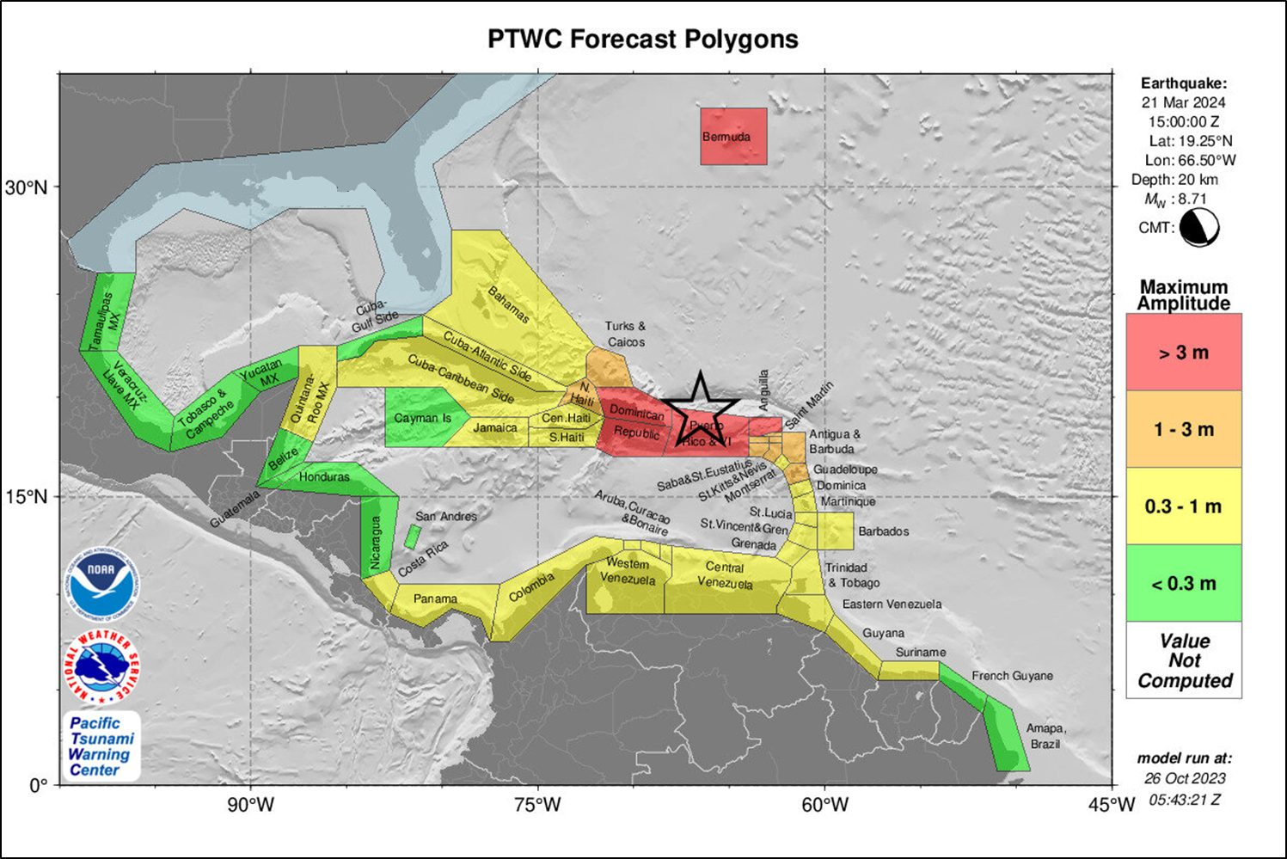

### Table of Forecast Statistics

PTWC TABLE OF FORECAST STATISTICS FOR REGIONAL POLYGONS - RUN ID 20231026054321

(for internal use only - not for distribution)

Earthquake - Origin: 03/21/2024 15:00:00 UTC Coordinates: 19.3N 66.5W Depth: 020km Magnitude: 8.7

This table is issued for information only in support the UNESCO/IOC Tsunami and Other Coastal Hazards

Warning System for the Caribbean and Adjacent Regions and is meant for national authorities in each

country of that system. National authorities will determine the appropriate level of alert for each

country and may issue additional or more refined information.

Actual amplitudes at the coast may vary from forecast amplitudes due to uncertainties in the forecast and

local features. In particular, maximum tsunami amplitudes on small islands will likely be much smaller

than the forecast indicates.

Coastal Forecast (meters) Offshore Forecast (meters) Total

Region_Name Maximum Mean Median STD Maximum Mean Median STD Points

Puerto_Rico_and_Virgin_Islands 7.5 2.60 1.30 2.20 4.2 1.60 1.70 0.98 224

Atlantic_Coast_of_Dominican_Republic 7.0 3.10 2.60 2.00 4.8 1.10 0.79 0.92 157

Bermuda 4.9 4.20 4.40 0.71 2.6 1.30 1.30 0.41 15

Caribbean_Coast_of_Dominican_Republic 3.7 1.20 1.00 0.92 3.0 0.63 0.45 0.55 151

Anguilla 3.2 2.50 2.80 0.68 2.0 1.50 1.50 0.37 8

Turks_and_Caicos_Islands 1.8 1.10 1.00 0.28 1.0 0.43 0.39 0.19 119

Antigua_and_Barbuda 1.8 1.20 1.10 0.38 1.7 0.70 0.71 0.36 32

Saint_Barthelemy 1.7 1.50 1.40 0.13 0.94 0.87 0.87 0.06 6

Saint_Kitts_and_Nevis 1.5 1.10 0.99 0.22 0.68 0.38 0.35 0.14 28

Saint_Martin 1.4 1.30 1.30 0.05 1.6 1.10 1.10 0.22 7

Sint_Maarten 1.4 1.30 1.40 0.06 0.92 0.80 0.80 0.08 5

Saba_and_Saint_Eustatius 1.3 1.00 1.00 0.11 0.42 0.34 0.36 0.07 5

Guadeloupe 1.2 0.82 0.78 0.15 0.81 0.32 0.28 0.14 67

Atlantic_Coast_of_Haiti 1.1 0.80 0.85 0.19 0.71 0.23 0.21 0.11 74

Bahamas 0.99 0.45 0.42 0.20 0.97 0.17 0.14 0.11 1192

Curacao 0.99 0.72 0.67 0.12 0.58 0.26 0.22 0.11 26

Atlantic_Coast_of_Cuba 0.97 0.46 0.50 0.27 0.59 0.13 0.13 0.09 429

Gulf_of_Gonave_Coast_of_Haiti 0.91 0.50 0.46 0.17 0.44 0.14 0.11 0.08 155

Grenada 0.86 0.58 0.65 0.19 0.67 0.25 0.25 0.11 28

Montserrat 0.86 0.78 0.79 0.06 0.25 0.20 0.20 0.02 11

Western_Coast_of_Venezuela 0.85 0.64 0.60 0.13 0.72 0.27 0.23 0.16 236

Aruba 0.83 0.76 0.76 0.04 0.37 0.28 0.27 0.06 13

Caribbean_Coast_of_Colombia 0.81 0.34 0.31 0.17 0.58 0.19 0.15 0.12 315

Bonaire 0.81 0.70 0.69 0.06 0.50 0.29 0.25 0.10 15

Atlantic_Coast_of_Venezuela 0.80 0.57 0.57 0.11 0.42 0.16 0.15 0.05 117

Central_Coast_of_Venezuela 0.78 0.45 0.42 0.10 0.82 0.24 0.22 0.14 404

Saint_Vincent_and_the_Grenadines 0.72 0.52 0.54 0.09 0.38 0.17 0.17 0.07 25

Barbados 0.65 0.48 0.46 0.06 0.25 0.16 0.16 0.03 20

Dominica 0.64 0.55 0.55 0.06 0.32 0.16 0.14 0.05 30

Saint_Lucia 0.62 0.46 0.46 0.07 0.28 0.17 0.16 0.06 28

Trinidad_and_Tobago 0.61 0.35 0.35 0.05 0.39 0.16 0.15 0.06 127

Martinique 0.56 0.47 0.46 0.06 0.51 0.21 0.17 0.11 40

Caribbean_Coast_of_Haiti 0.51 0.34 0.33 0.07 0.37 0.11 0.09 0.05 98

Caribbean_Coast_of_Cuba 0.45 0.13 0.11 0.07 0.17 0.04 0.04 0.03 642

Jamaica 0.42 0.25 0.24 0.06 0.45 0.10 0.08 0.07 146

Guyana 0.39 0.27 0.25 0.05 0.22 0.12 0.11 0.03 107

Suriname 0.38 0.26 0.26 0.03 0.40 0.11 0.10 0.06 106

Caribbean_Coast_of_Panama 0.37 0.24 0.24 0.05 0.23 0.11 0.11 0.05 215

Caribbean_Coast_of_Costa_Rica 0.34 0.27 0.26 0.03 0.22 0.13 0.13 0.03 48

Quintana_Roo_Mexico 0.31 0.12 0.09 0.06 0.12 0.04 0.03 0.02 265

French_Guyane 0.26 0.18 0.17 0.03 0.18 0.09 0.08 0.03 87

Caribbean_Coast_of_Nicaragua 0.25 0.18 0.18 0.03 0.13 0.06 0.06 0.03 140

Yucatan_Mexico 0.24 0.05 0.01 0.07 0.05 0.01 0.00 0.01 74

San_Andres_and_Providencia 0.22 0.17 0.16 0.03 0.27 0.07 0.06 0.05 18

Amapa_Brazil 0.18 0.16 0.16 0.01 0.16 0.06 0.05 0.03 127

Caribbean_Coast_of_Honduras 0.14 0.07 0.06 0.02 0.10 0.04 0.03 0.02 193

Caribbean_Coast_of_Guatemala 0.14 0.13 0.13 0.01 0.07 0.04 0.04 0.01 35

Belize 0.13 0.09 0.09 0.01 0.09 0.04 0.03 0.02 194

Cayman_Islands 0.09 0.08 0.08 0.01 0.05 0.03 0.02 0.01 11

Gulf_Coast_of_Cuba 0.08 0.05 0.06 0.01 0.05 0.02 0.01 0.01 137

Veracruz_Mexico 0.02 0.01 0.01 0.00 0.01 0.00 0.00 0.00 209

Tabasco_and_Campeche_Mexico 0.02 0.01 0.01 0.00 0.01 0.00 0.00 0.00 224

Tamaulipas_Mexico 0.01 0.01 0.01 0.00 0.01 0.00 0.00 0.00 147

### Energy Forecast Map

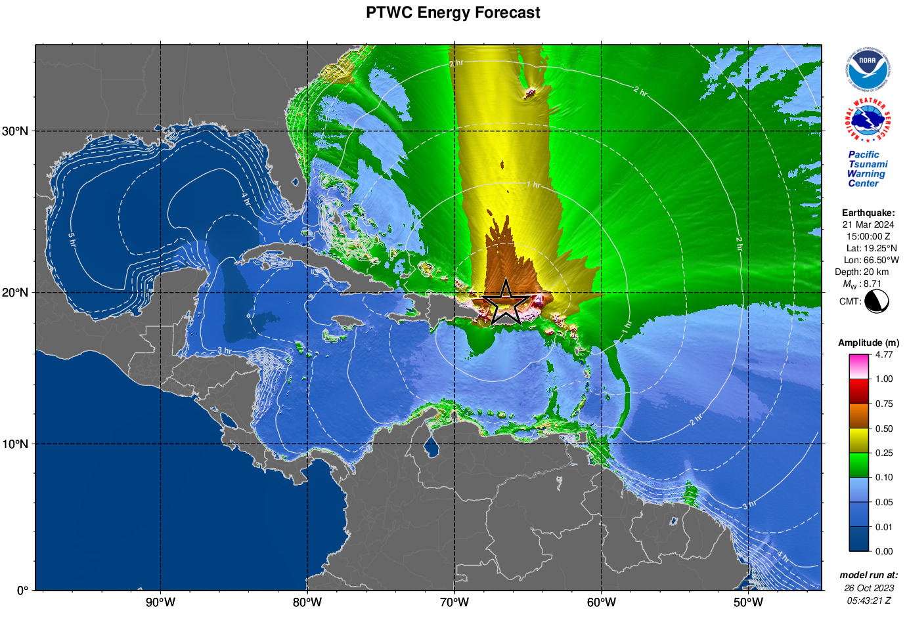

### Coastal Forecast Map

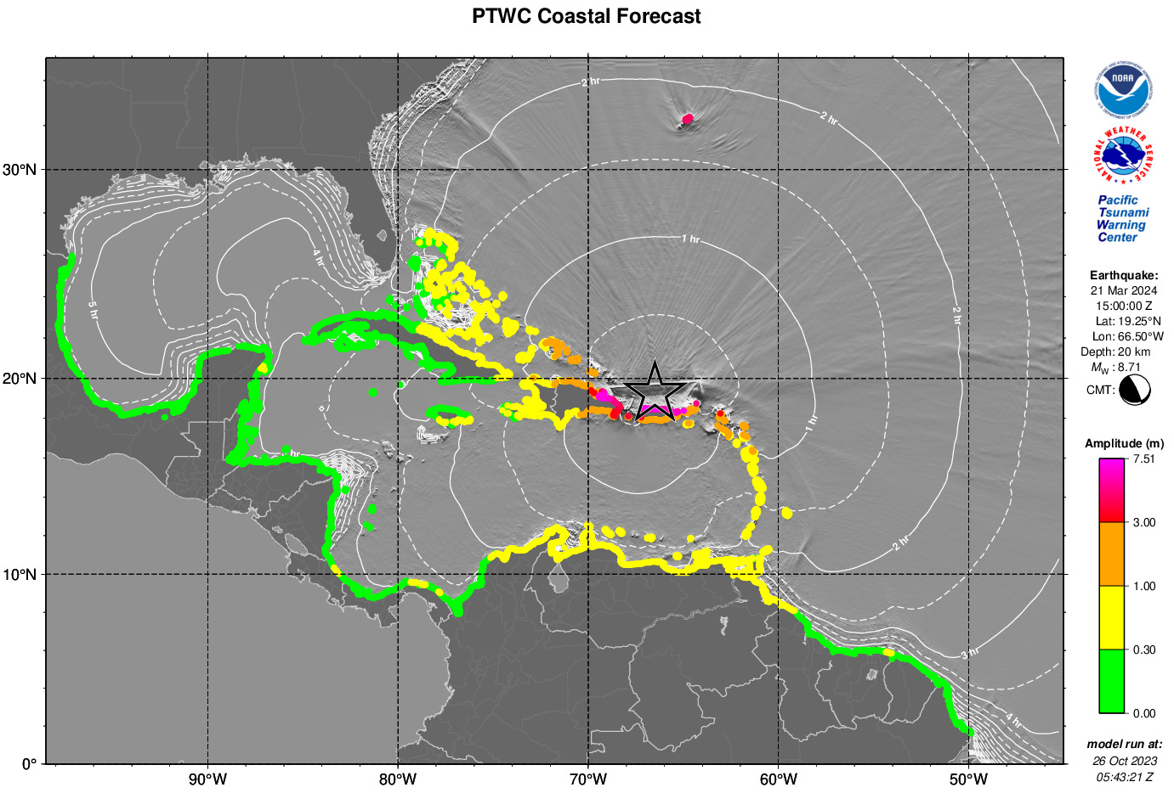

## Third or Later Threat Product with Sea Level Readings

### Text Product

ZCZC

WECA41 PHEB 211830

TSUCAX

Tsunami Message Number 5

NWS Pacific Tsunami Warning Center Honolulu HI

1830 UTC Thu Mar 21 2024

...TSUNAMI THREAT MESSAGE...

**** NOTICE **** NOTICE **** NOTICE **** NOTICE **** NOTICE *****

This message is issued for information only in support of the

UNESCO/IOC Tsunami and Other Coastal Hazards Warning System for

the Caribbean and Adjacent Regions and is meant for national

authorities in each country of that system.

National authorities will determine the appropriate level of

alert for each country and may issue additional or more refined

information.

**** NOTICE **** NOTICE **** NOTICE **** NOTICE **** NOTICE *****

PRELIMINARY EARTHQUAKE PARAMETERS

---------------------------------

* Magnitude 8.7

* Origin Time 1500 UTC Mar 21 2024

* Coordinates 19.3 North 66.5 West

* Depth 20 km / 12 miles

* Location Puerto Rico Region

EVALUATION

----------

* An earthquake with a preliminary magnitude of 8.7 occurred in

the Puerto Rico region at 1500 UTC on Thursday March 21

2024.

* Tsunami waves have been observed.

* Based on all available data... hazardous tsunami waves are

forecast for some coasts of the Caribbean and adjacent

regions covered by this international product.

TSUNAMI THREAT FORECAST

-----------------------

The following forecast tsunami amplitudes apply to the entire

duration of the event. It is up to national authorities to

decide on the appropriate levels of alert for their coasts

throughout the event based upon all available information.

* Tsunami waves reaching more than 3 meters above the tide

level are possible along some coasts of

ANGUILLA... BERMUDA... DOMINICAN REPUBLIC... and PUERTO

RICO AND VIRGIN ISLANDS.

* Tsunami waves reaching 1 to 3 meters above the tide level are

possible along some coasts of

ANTIGUA AND BARBUDA... GUADELOUPE... HAITI... SABA AND

SAINT EUSTATIUS... SAINT BARTHELEMY... SAINT KITTS AND

NEVIS... SINT MAARTEN... SAINT MARTIN... and TURKS AND

CAICOS ISLANDS.

* Tsunami waves reaching 0.3 to 1 meters above the tide level

are possible for some coasts of

ARUBA... BAHAMAS... BARBADOS... BONAIRE... COLOMBIA...

COSTA RICA... CUBA... CURACAO... DOMINICA... GRENADA...

GUYANA... JAMAICA... MARTINIQUE... MEXICO... MONTSERRAT...

PANAMA... SAINT LUCIA... SAINT VINCENT AND THE

GRENADINES... SURINAME... TRINIDAD AND TOBAGO... and

VENEZUELA.

* Actual amplitudes at the coast may vary from forecast

amplitudes due to uncertainties in the forecast and local

features. In particular maximum tsunami amplitudes on atolls

or small islands and at locations with fringing or barrier

reefs will likely be much smaller than the forecast

indicates.

* For all other areas covered by this message... there is no

tsunami threat although small sea level changes may occur.

RECOMMENDED ACTIONS

-------------------

* Government agencies responsible for threatened coastal areas

should take action to inform and instruct any coastal

populations at risk in accordance with their own

evaluation... procedures and the level of threat.

* Persons located in threatened coastal areas should stay alert

for information and follow instructions from national and

local authorities.

ESTIMATED TIMES OF ARRIVAL

--------------------------

* Estimated times of arrival -ETA- of the initial tsunami wave

for places within threatened regions are given below. Actual

arrival times may differ and the initial wave may not be the

largest. A tsunami is a series of waves and the time between

waves can be five minutes to one hour.

LOCATION COORDINATES ETA(UTC)

------------------------------------------------------

COLOMBIA

Barranquilla 11.1N 74.9W 1731 03/21

Riohacha 11.6N 72.9W 1735 03/21

Punta Caribana 8.6N 76.9W 1805 03/21

PANAMA

Aligandi 9.2N 78.0W 1743 03/21

Puerto Carreto 8.8N 77.6W 1750 03/21

Puerto Obaldia 8.7N 77.4W 1802 03/21

Colon 9.4N 79.9W 1823 03/21

Bocas Del Toro 9.4N 82.2W 1835 03/21

MEXICO

Cozumel 20.5N 87.0W 1810 03/21

COSTA RICA

Puerto Limon 10.0N 83.0W 1821 03/21

TRINIDAD TOBAGO

Port Of Spain 10.6N 61.5W 1823 03/21

VENEZUELA

Punto Fijo 11.7N 70.2W 1853 03/21

Golfo Venezuela 11.4N 71.2W 1953 03/21

Porlamar 10.9N 63.8W 2033 03/21

CUBA

Santa Crz D Sur 20.7N 78.0W 1943 03/21

Nueva Gerona 21.9N 82.8W 2120 03/21

GUYANA

Georgetown 6.8N 58.2W 2035 03/21

SURINAME

Paramaribo 5.9N 55.2W 2052 03/21

POTENTIAL IMPACTS

-----------------

* A tsunami is a series of waves. The time between wave crests

can vary from 5 minutes to an hour. The hazard may persist

for many hours or longer after the initial wave.

* Impacts can vary significantly from one section of coast to

the next due to local bathymetry and the shape and elevation

of the shoreline.

* Impacts can also vary depending upon the state of the tide at

the time of the maximum tsunami waves.

* Persons caught in the water of a tsunami may drown... be

crushed by debris in the water... or be swept out to sea.

TSUNAMI OBSERVATIONS

--------------------

* The following are tsunami wave observations from coastal

and/or deep-ocean sea level gauges at the indicated

locations. Tsunami amplitudes are measured with respect to

the normal tide level.

COORDINATES TIME TSUNAMI MS PER

GAUGE LOCATION LAT LON UTC AMPLITUDE TP MIN

---------------------------------------------------------------

HONDURAS

Puerto Cortes 15.8N 88.0W 1829 0.23M/ 0.7FT H 8

MEXICO

Sian Kaan 19.3N 87.4W 1823 0.18M/ 0.6FT T 10

Puerto Morelos 20.9N 86.9W 1819 0.30M/ 1.0FT H 10

COLOMBIA

Sapzurro 8.7N 77.4W 1815 0.30M/ 1.0FT H 11

Isla Fuerte 9.4N 76.2W 1805 0.50M/ 1.6FT H 14

San Andres 12.6N 81.7W 1803 0.26M/ 0.9FT C 7

Covenas 9.4N 76.2W 1757 0.50M/ 1.6FT H 14

Isla Naval 10.2N 75.8W 1739 0.39M/ 1.3FT H 8

Cartegena 10.4N 75.5W 1734 0.57M/ 1.9FT H 14

Ballenas 11.7N 72.7W 1723 0.80M/ 2.6FT H 13

Santa Marta 11.2N 74.2W 1720 0.76M/ 2.5FT H 8

PANAMA

El Porvenir 9.6N 78.9W 1805 0.59M/ 1.9FT H 12

BAHAMA

Settlement Pt 26.7N 79.0W 1749 0.53M/ 1.7FT H 14

USA-FLORIDA

Lake Worth Beach 26.6N 80.0W 1742 0.56M/ 1.8FT H 14

JAMAICA

Port Royal 17.9N 76.8W 1738 0.72M/ 2.4FT H 9

HAITI

Port Au Prince 18.5N 72.4W 1725 1.59M/ 5.2FT T 14

St Louis Du Sud 18.2N 73.6W 1650 1.02M/ 3.4FT H 11

Jeremie 18.6N 74.1W 1629 0.58M/ 1.9FT H 12

Cap Haitien 19.8N 72.2W 1605 1.62M/ 5.3FT H 14

CAYMAN_ISLANDS

Gun Bay 19.3N 81.1W 1723 0.16M/ 0.5FT H 14

George Town 19.3N 81.4W 1718 0.16M/ 0.5FT H 10

ANGUILLA

Prickley Bay 12.0N 61.8W 1715 1.37M/ 4.5FT C 10

Blowing Point 18.2N 63.1W 1617 3.57M/11.7FT H 9

SAINT_LUCIA

Soufriere St Lucia 13.9N 61.1W 1710 1.05M/ 3.4FT C 10

Ganters Bay St Lucia 14.0N 61.0W 1657 1.06M/ 3.5FT H 12

Vieux Fort St Lucia 13.7N 61.0W 1652 1.08M/ 3.5FT H 10

Dennery St Lucia 13.9N 60.9W 1636 0.74M/ 2.4FT H 7

UNITED_KINGDOM

Tortola Vi 18.4N 64.6W 1709 2.78M/ 9.1FT H 10

Bermuda Bio Sta 32.4N 64.7W 1704 9.23M/30.3FT H 9

Bermuda St George 32.4N 64.7W 1706 9.23M/30.3FT T 9

Bermuda Somerset 32.3N 64.9W 1656 7.70M/25.3FT H 9

Sapodilla Bay 21.7N 72.3W 1635 2.37M/ 7.8FT H 14

Grand Turk 21.4N 71.1W 1557 1.96M/ 6.4FT H 13

SAINT_VINCENT_AND_THE_GRENADINES

Calliaqua 13.1N 61.2W 1653 1.16M/ 3.8FT H 14

Chateaubelair 13.3N 61.2W 1649 1.23M/ 4.0FT H 9

BARBADOS

Port St Charles 13.3N 59.6W 1645 0.89M/ 2.9FT H 13

MARTINIQUE

Fort De France 14.6N 61.1W 1638 1.12M/ 3.7FT H 11

Le Robert 14.7N 60.9W 1629 0.90M/ 3.0FT H 9

Le Precheur 14.8N 61.2W 1630 0.92M/ 3.0FT H 11

ARUBA

Orangestad 12.5N 70.0W 1634 1.52M/ 5.0FT C 12

DOMINICA

Roseau 15.3N 61.4W 1633 1.27M/ 4.2FT H 13

Portsmouth 15.6N 61.5W 1627 1.11M/ 3.7FT H 8

ANTIGUA_AND_BARBUDA

Barbuda 17.6N 61.8W 1634 3.17M/10.4FT H 11

Parham 17.1N 61.8W 1606 2.16M/ 7.1FT H 14

US_VIRGIN_ISLANDS

Charlotte-amalie 18.3N 64.9W 1630 2.02M/ 6.6FT H 13

Limetree 17.7N 64.8W 1556 1.66M/ 5.4FT C 13

St Croix 17.7N 64.7W 1556 2.38M/ 7.8FT H 13

DOMINICAN_REPUBLIC

Port San Andres 18.4N 69.6W 1626 2.09M/ 6.9FT H 11

Barahona 18.2N 71.1W 1619 1.38M/ 4.5FT H 13

Puerto Plata 19.8N 70.7W 1546 3.55M/11.6FT H 11

Punta Cana 18.5N 68.4W 1541 7.40M/24.3FT H 12

DART

Bermuda 41425 28.7N 65.6W 1623 0.77M/ 2.5FT H 13

Caribbean 42407 15.3N 68.2W 1559 0.16M/ 0.5FT C 8

San Juan 41421 23.4N 63.8W 1548 0.66M/ 2.2FT H 10

Miami 41420 23.4N 67.3W 1541 1.01M/ 3.3FT H 8

GUADELOUPE

Point A Pitre 16.2N 61.5W 1624 1.64M/ 5.4FT T 11

PUERTO_RICO

Salinas 17.9N 66.2W 1621 2.19M/ 7.2FT H 14

Isabelii Vieques 18.2N 65.4W 1610 1.91M/ 6.3FT H 14

Culebra Is 18.3N 65.3W 1607 2.79M/ 9.1FT T 11

Esperanza Vieques 18.1N 65.5W 1600 2.20M/ 7.2FT H 9

Fajardo 18.3N 65.6W 1556 12.40M/40.7FT H 10

Yabucoa 18.1N 65.8W 1553 2.40M/ 7.9FT H 12

Magueyes Island 18.0N 67.0W 1549 1.99M/ 6.5FT H 13

Guayanilla 18.0N 66.8W 1550 2.58M/ 8.5FT C 11

Mona Island 18.1N 67.9W 1540 5.96M/19.5FT H 7

Aguadilla 18.5N 67.2W 1533 8.71M/28.6FT H 10

Mayaguez 18.2N 67.2W 1523 7.17M/23.5FT H 12

San Juan 18.5N 66.1W 1520 11.06M/36.3FT C 11

Arecibo 18.5N 66.7W 1514 12.10M/39.7FT H 8

FRANCE

Deshaies Guadeloupe 16.3N 61.8W 1622 1.35M/ 4.4FT H 12

Saint Martin 18.1N 63.1W 1615 2.56M/ 8.4FT T 14

Desirade Guadeloupe 16.3N 61.1W 1612 1.70M/ 5.6FT H 11

SAINT_KITTS_AND_NEVIS

Basseterre 17.3N 62.7W 1606 2.95M/ 9.7FT H 8

TURKS_AND_CAICOS

Grand Turk Island 21.4N 71.1W 1554 1.96M/ 6.4FT H 9

TIME UTC - Time of the reported observation

MS TP - Measurement Type

C is the maximum crest

T is the maximum trough

H is half maximum crest-to-trough

PER MIN - Tsunami wave period in minutes

NEXT UPDATE AND ADDITIONAL INFORMATION

--------------------------------------

* The next message will be issued in one hour... or sooner if

the situation warrants.

* Authoritative information about the earthquake from the U.S.

Geological Survey can be found on the internet at

earthquake.usgs.gov.

* Further information about this event may be found at

www.tsunami.gov.

* Coastal regions of the US Gulf Coast... US East Coast... and

the Maritime Provinces of Canada should refer to U.S.

National Tsunami Warning Center messages that can be found

at www.tsunami.gov.

$$

NNNN

## Final Threat Product - Threat Ended

### Text Product

ZCZC

WECA41 PHEB 220330

TSUCAX

Tsunami Message Number 14

NWS Pacific Tsunami Warning Center Honolulu HI

0330 UTC Fri Mar 22 2024

...FINAL TSUNAMI THREAT MESSAGE...

**** NOTICE **** NOTICE **** NOTICE **** NOTICE **** NOTICE *****

This message is issued for information only in support of the

UNESCO/IOC Tsunami and Other Coastal Hazards Warning System for

the Caribbean and Adjacent Regions and is meant for national

authorities in each country of that system.

National authorities will determine the appropriate level of

alert for each country and may issue additional or more refined

information.

**** NOTICE **** NOTICE **** NOTICE **** NOTICE **** NOTICE *****

PRELIMINARY EARTHQUAKE PARAMETERS

---------------------------------

* Magnitude 8.7

* Origin Time 1500 UTC Mar 21 2024

* Coordinates 19.3 North 66.5 West

* Depth 20 km / 12 miles

* Location Puerto Rico Region

EVALUATION

----------

* An earthquake with a preliminary magnitude of 8.7 occurred in

the Puerto Rico region at 1500 UTC on Thursday March 21

2024.

* Based on all available data... the tsunami threat from this

earthquake has passed and there is no further threat to

coasts of the Caribbean and adjacent regions covered by this

international product.

TSUNAMI THREAT FORECAST...UPDATED

---------------------------------

* The tsunami threat has now largely passed.

RECOMMENDED ACTIONS

-------------------

* Government agencies responsible for any impacted coastal

areas should monitor conditions at the coast to determine if

and when it is safe to resume normal activities.

* Persons located near impacted coastal areas should stay alert

for information and follow instructions from local

authorities.

* Remain observant and exercise normal caution near the sea.

POTENTIAL IMPACTS

-----------------

* Minor sea level fluctuations up to 30 cm above and below the

normal tide may occur in coastal areas near the earthquake

over the next few hours... and continuing for up to several

hours.

NEXT UPDATE AND ADDITIONAL INFORMATION

--------------------------------------

* This will be the final statement issued for this event unless

new information is received or the situation changes.

* Authoritative information about the earthquake from the U.S.

Geological Survey can be found on the internet at

earthquake.usgs.gov.

* Further information about this event may be found at

www.tsunami.gov.

* Coastal regions of the US Gulf Coast... US East Coast... and

the Maritime Provinces of Canada should refer to U.S.

National Tsunami Warning Center messages that can be found

at www.tsunami.gov.

$$

NNNN

# APPENDIX II. EXAMPLE PTWC PRODUCTS FOR ATLANTIC EARTHQUAKES

## Tsunami Information Statement – No Tsunami Threat

### Text Product Only

ZCZC

WECA43 PHEB 080135

TIBCAX

Tsunami Information Statement Number 1

NWS Pacific Tsunami Warning Center Honolulu HI

0135 UTC Mon Jul 8 2024

...TSUNAMI INFORMATION STATEMENT...

**** NOTICE **** NOTICE **** NOTICE **** NOTICE **** NOTICE *****

This statement is issued for information only in support of the

UNESCO/IOC Tsunami and Other Coastal Hazards Warning System for

the Caribbean and Adjacent Regions and is meant for national

authorities in each country of that system.

National authorities will determine the appropriate level of

alert for each country and may issue additional or more refined

information.

**** NOTICE **** NOTICE **** NOTICE **** NOTICE **** NOTICE *****

PRELIMINARY EARTHQUAKE PARAMETERS

---------------------------------

* Magnitude 6.8

* Origin Time 0127 UTC Jul 8 2024

* Coordinates 25.5 SOUTH 13.4 WEST

* Depth 10 KM / 6 MILES

* Location Southern Mid-atlantic Ridge

EVALUATION

----------

* An earthquake with a preliminary magnitude of 6.8 occurred

near the southern Mid-Atlantic Ridge at 0127 UTC on Monday

July 8 2024.

* Based on all available data... there is no tsunami threat to

coasts of the Caribbean and adjacent regions covered by this

international product.

RECOMMENDED ACTIONS

-------------------

* No action is required.

NEXT UPDATE AND ADDITIONAL INFORMATION

--------------------------------------

* This will be the only statement issued for this event unless

additional data are received or the situation changes.

* Authoritative information about the earthquake from the U.S.

Geological Survey can be found on the internet at

earthquake.usgs.gov.

* Further information about this event may be found at

www.tsunami.gov.

* Coastal regions of the US Gulf Coast... US East Coast... and

the Maritime Provinces of Canada should refer to U.S.

National Tsunami Warning Center messages that can be found

at www.tsunami.gov.

$$

NNNN

## First Product - Tsunami Information Statement – Still Evaluating

### Text Product

ZCZC

WECA43 PHEB 191407

TIBCAX

Tsunami Information Statement Number 1

NWS Pacific Tsunami Warning Center Honolulu HI

1407 UTC Thu Mar 19 2020

...TSUNAMI INFORMATION STATEMENT...

**** NOTICE **** NOTICE **** NOTICE **** NOTICE **** NOTICE *****

This statement is issued for information only in support of the

UNESCO/IOC Tsunami and Other Coastal Hazards Warning System for

the Caribbean and Adjacent Regions and is meant for national

authorities in each country of that system.

National authorities will determine the appropriate level of

alert for each country and may issue additional or more refined

information.

**** NOTICE **** NOTICE **** NOTICE **** NOTICE **** NOTICE *****

PRELIMINARY EARTHQUAKE PARAMETERS

---------------------------------

* Magnitude 8.5

* Origin Time 1400 UTC Mar 19 2020

* Coordinates 36.0 NORTH 10.8 WEST

* Depth 5 KM / 3 MILES

* Location Azores-cape St. Vincent Ridge

EVALUATION

----------

* An earthquake with a preliminary magnitude of 8.5 occurred

near the Azores-Cape Saint Vincent Ridge at 1400 UTC on

Thursday March 19 2020.

* The tsunami threat from this earthquake to coasts of the

Caribbean and adjacent regions covered by this international

Product is still under investigation. Further information

on the threat will be issued as soon as possible.

RECOMMENDED ACTIONS

-------------------

* Consider and prepare for the possibility of a tsunami threat

to the Caribbean region from this earthquake.

NEXT UPDATE AND ADDITIONAL INFORMATION

--------------------------------------

* Further statements on the tsunami threat to the Caribbean

region from this earthquake will be issued as soon as

information becomes available or in no more than one hour.

* Authoritative information about the earthquake from the U.S.

Geological Survey can be found on the internet at

earthquake.usgs.gov.

* Further information about this event may be found at

www.tsunami.gov.

* Coastal regions of the US Gulf Coast... US East Coast... and

the Maritime Provinces of Canada should refer to U.S.

National Tsunami Warning Center messages that can be found

at www.tsunami.gov.

$$

NNNN

## Later Product - Initial Tsunami Threat with Tsunami Forecast

### Text Product

ZCZC

WECA41 PHEB 191425

TSUCAX

Tsunami Message Number 3

NWS Pacific Tsunami Warning Center Honolulu HI

1425 UTC Thu Mar 19 2020

...TSUNAMI THREAT MESSAGE...

**** NOTICE **** NOTICE **** NOTICE **** NOTICE **** NOTICE *****

This message is issued for information only in support of the

UNESCO/IOC Tsunami and Other Coastal Hazards Warning System for

the Caribbean and Adjacent Regions and is meant for national

authorities in each country of that system.

National authorities will determine the appropriate level of

alert for each country and may issue additional or more refined

information.

**** NOTICE **** NOTICE **** NOTICE **** NOTICE **** NOTICE *****

PRELIMINARY EARTHQUAKE PARAMETERS

---------------------------------

* Magnitude 8.5

* Origin Time 1400 UTC Mar 19 2020

* Coordinates 36.0 NORTH 10.8 WEST

* Depth 5 KM / 3 MILES

* Location Azores-cape St. Vincent Ridge

EVALUATION

----------

* An earthquake with a preliminary magnitude of 8.5 occurred

near the Azores-Cape Saint Vincent Ridge at 1400 UTC on

Thursday March 19 2020.

* Based on all available data... hazardous tsunami waves are

forecast for some coasts of the Caribbean and adjacent

regions covered by this international product.

TSUNAMI THREAT FORECAST...UPDATED

---------------------------------

The following forecast tsunami amplitudes apply to the entire

duration of the event. It is up to national authorities to

decide on the appropriate levels of alert for their coasts

throughout the event based upon all available information.

* Tsunami waves reaching more than 3 meters above the tide

level are possible along some coasts of

BAHAMAS.

* Tsunami waves reaching 1 to 3 meters above the tide level are

possible along some coasts of

ANGUILLA... ANTIGUA AND BARBUDA... BARBADOS... BERMUDA...

BRAZIL... CUBA... DOMINICA... DOMINICAN REPUBLIC... FRENCH

GUYANE... GRENADA... GUADELOUPE... GUYANA... HAITI...

MARTINIQUE... PUERTO RICO AND VIRGIN ISLANDS... SAINT

BARTHELEMY... SAINT LUCIA... SAINT VINCENT AND THE

GRENADINES... SURINAME... TRINIDAD AND TOBAGO... TURKS AND

CAICOS ISLANDS... and VENEZUELA.

* Tsunami waves reaching 0.3 to 1 meters above the tide level

are possible for some coasts of

ARUBA... BONAIRE... COLOMBIA... CURACAO... JAMAICA...

MONTSERRAT... SABA AND SAINT EUSTATIUS... SAINT KITTS AND

NEVIS... SINT MAARTEN... and SAINT MARTIN.

* Actual amplitudes at the coast may vary from forecast

amplitudes due to uncertainties in the forecast and local

features. In particular maximum tsunami amplitudes on atolls

or small islands and at locations with fringing or barrier

reefs will likely be much smaller than the forecast

indicates.

* For all other areas covered by this message... there is no

tsunami threat although small sea level changes may occur.

RECOMMENDED ACTIONS

-------------------

* Government agencies responsible for threatened coastal areas

should take action to inform and instruct any coastal

populations at risk in accordance with their own

evaluation... procedures and the level of threat.

* Persons located in threatened coastal areas should stay alert

for information and follow instructions from national and

local authorities.

ESTIMATED TIMES OF ARRIVAL

--------------------------

* Estimated times of arrival -ETA- of the initial tsunami wave

for places within threatened regions are given below. Actual

arrival times may differ and the initial wave may not be the

largest. A tsunami is a series of waves and the time between

waves can be five minutes to one hour.

LOCATION COORDINATES ETA(UTC)

------------------------------------------------------

BERMUDA

Esso Pier 32.4N 64.7W 2054 03/19

DOMINICA

Roseau 15.3N 61.4W 2118 03/19

BARBADOS

Bridgetown 13.1N 59.6W 2119 03/19

MARTINIQUE

Fort De France 14.6N 61.1W 2121 03/19

SAINT LUCIA

Castries 14.0N 61.0W 2121 03/19

GUADELOUPE

Basse Terre 16.0N 61.7W 2123 03/19

SABA

Saba 17.6N 63.2W 2125 03/19

MONTSERRAT

Plymouth 16.7N 62.2W 2125 03/19

BARBUDA

Palmetto Point 17.6N 61.9W 2125 03/19

SINT EUSTATIUS

Sint Eustatius 17.5N 63.0W 2126 03/19

US VIRGIN IS

Christiansted 17.7N 64.7W 2126 03/19

Charlotte Amalie 18.3N 64.9W 2216 03/19

SAINT KITTS

Basseterre 17.3N 62.7W 2127 03/19

PUERTO RICO

San Juan 18.5N 66.1W 2129 03/19

Mayaguez 18.2N 67.2W 2142 03/19

BR VIRGIN IS

Anegada 18.8N 64.3W 2133 03/19

Roadtown 18.4N 64.6W 2212 03/19

SINT MAARTEN

Simpson Baai 18.0N 63.1W 2133 03/19

SAINT VINCENT

Kingstown 13.1N 61.2W 2134 03/19

ANGUILLA

The Valley 18.3N 63.1W 2136 03/19

ANTIGUA

Saint Johns 17.1N 61.9W 2137 03/19

TRINIDAD TOBAGO

Pirates Bay 11.3N 60.6W 2140 03/19

Port Of Spain 10.6N 61.5W 2314 03/19

SAINT BARTHELEMY

Saint Barthelemy 17.9N 62.8W 2145 03/19

DOMINICAN REP

Cabo Engano 18.6N 68.3W 2146 03/19

Puerto Plata 19.8N 70.7W 2156 03/19

Santo Domingo 18.5N 69.9W 2215 03/19

SAINT MARTIN

Baie Grand Case 18.1N 63.1W 2148 03/19

Baie Lucas 18.1N 63.0W 2149 03/19

Baie Blanche 18.1N 63.0W 2200 03/19

GRENADA

Saint Georges 12.0N 61.8W 2155 03/19

TURKS N CAICOS

Grand Turk 21.5N 71.1W 2157 03/19

West Caicos 21.7N 72.5W 2207 03/19

BAHAMAS

Mayaguana 22.3N 73.0W 2204 03/19

San Salvador 24.1N 74.5W 2208 03/19

Crooked Island 22.7N 74.1W 2210 03/19

Long Island 23.3N 75.1W 2215 03/19

Great Inagua 20.9N 73.7W 2222 03/19

Exuma 23.6N 75.9W 2223 03/19

Abaco Island 26.6N 77.1W 2226 03/19

Cat Island 24.4N 75.5W 2227 03/19

Andros Island 25.0N 77.9W 2236 03/19

Eleuthera Island 25.2N 76.1W 2251 03/19

Nassau 25.1N 77.4W 2253 03/19

Freeport 26.5N 78.8W 2256 03/19

Bimini 25.8N 79.3W 2328 03/19

HAITI

Cap Haiten 19.8N 72.2W 2212 03/19

Jacamel 18.1N 72.5W 2240 03/19

Jeremie 18.6N 74.1W 2331 03/19

Port Au Prince 18.5N 72.4W 0019 03/20

CUBA

Baracoa 20.4N 74.5W 2226 03/19

Santiago D Cuba 19.9N 75.8W 2245 03/19

Gibara 21.1N 76.1W 2325 03/19

Cienfuegos 22.0N 80.5W 2340 03/19

Santa Crz D Sur 20.7N 78.0W 0146 03/20

Nueva Gerona 21.9N 82.8W 0310 03/20

BONAIRE

Onima 12.3N 68.3W 2228 03/19

CURACAO

Willemstad 12.1N 68.9W 2235 03/19

ARUBA

Oranjestad 12.5N 70.0W 2241 03/19

VENEZUELA

Maiquetia 10.6N 67.0W 2254 03/19

Cumana 10.5N 64.2W 2258 03/19

Punto Fijo 11.7N 70.2W 0036 03/20

Golfo Venezuela 11.4N 71.2W 0214 03/20

Porlamar 10.9N 63.8W 0246 03/20

FRENCH GUYANE

Cayenne 4.9N 52.3W 2254 03/19

JAMAICA

Montego Bay 18.5N 77.9W 2306 03/19

Kingston 17.9N 76.9W 2321 03/19

COLOMBIA

Riohacha 11.6N 72.9W 2320 03/19

Barranquilla 11.1N 74.9W 2326 03/19

Cartagena 10.4N 75.6W 2343 03/19

Santa Marta 11.2N 74.2W 0006 03/20

Punta Caribana 8.6N 76.9W 0019 03/20

SURINAME

Paramaribo 5.9N 55.2W 0007 03/20

GUYANA

Georgetown 6.8N 58.2W 0046 03/20

BRAZIL

Ilha De Maraca 2.2N 50.5W 0137 03/20

POTENTIAL IMPACTS

-----------------

* A tsunami is a series of waves. The time between wave crests

can vary from 5 minutes to an hour. The hazard may persist

for many hours or longer after the initial wave.

* Impacts can vary significantly from one section of coast to

the next due to local bathymetry and the shape and elevation

of the shoreline.

* Impacts can also vary depending upon the state of the tide at

the time of the maximum tsunami waves.

* Persons caught in the water of a tsunami may drown... be

crushed by debris in the water... or be swept out to sea.

NEXT UPDATE AND ADDITIONAL INFORMATION

--------------------------------------

* The next message will be issued in one hour... or sooner if

the situation warrants.

* Authoritative information about the earthquake from the U.S.

Geological Survey can be found on the internet at

earthquake.usgs.gov.

* Further information about this event may be found at

www.tsunami.gov.

* Coastal regions of the US Gulf Coast... US East Coast... and

the Maritime Provinces of Canada should refer to U.S.

National Tsunami Warning Center messages that can be found

at www.tsunami.gov.

$$

NNNN

### Forecast Polygons Map

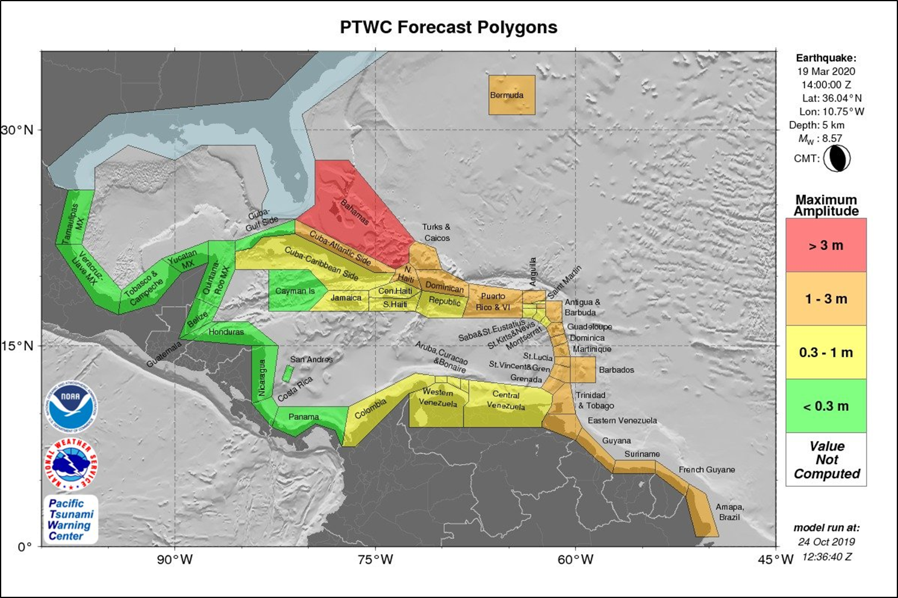

### Table of Forecast Statistics

PTWC TABLE OF FORECAST STATISTICS FOR REGIONAL POLYGONS - RUN ID 20191024123640

(for internal use only - not for distribution)

Earthquake - Origin: 03/19/2020 14:00:00 UTC Coordinates: 36.0N 10.8W Depth: 005km Magnitude: ***

This table is issued for information only in support the UNESCO/IOC Tsunami and Other Coastal Hazards

Warning System for the Caribbean and Adjacent Regions and is meant for national authorities in each

country of that system. National authorities will determine the appropriate level of alert for each

country and may issue additional or more refined information.

Actual amplitudes at the coast may vary from forecast amplitudes due to uncertainties in the forecast and

local features. In particular, maximum tsunami amplitudes on small islands will likely be much smaller

than the forecast indicates.

Coastal Forecast (meters) Offshore Forecast (meters) Total

Region_Name Maximum Mean Median STD Maximum Mean Median STD Points

Bahamas 3.5 1.40 1.10 0.70 2.0 0.60 0.53 0.33 115

Bermuda 2.1 1.90 1.90 0.11 1.0 1.00 1.00 0.00 2

Puerto_Rico_and_Virgin_Islands 1.8 0.92 0.73 0.37 0.94 0.42 0.43 0.17 83

Barbados 1.8 1.50 1.60 0.27 0.85 0.54 0.49 0.15 9

Anguilla 1.7 1.70 1.70 0.00 0.80 0.80 0.80 0.00 1

Saint_Lucia 1.6 0.99 0.89 0.37 0.64 0.40 0.41 0.15 13

Atlantic_Coast_of_Dominican_Republic 1.6 1.10 1.10 0.14 1.0 0.50 0.51 0.18 64

Amapa_Brazil 1.6 1.30 1.30 0.10 0.63 0.38 0.37 0.09 59

French_Guyane 1.6 1.40 1.30 0.11 0.68 0.38 0.37 0.08 41

Suriname 1.5 1.10 1.10 0.08 0.69 0.36 0.34 0.11 48

Saint_Barthelemy 1.5 1.50 1.50 0.00 0.67 0.67 0.67 0.00 1

Martinique 1.4 0.96 0.84 0.29 0.80 0.43 0.41 0.21 18

Trinidad_and_Tobago 1.4 1.10 1.10 0.15 0.70 0.47 0.47 0.10 35

Guadeloupe 1.3 0.99 0.87 0.22 0.79 0.40 0.39 0.15 19

Atlantic_Coast_of_Venezuela 1.3 1.10 1.00 0.11 0.68 0.41 0.40 0.08 33

Guyana 1.3 1.20 1.10 0.12 0.47 0.32 0.32 0.06 52

Antigua_and_Barbuda 1.3 1.20 1.20 0.11 1.1 0.74 0.73 0.17 10

Dominica 1.2 0.86 0.82 0.18 0.46 0.26 0.25 0.09 14

Atlantic_Coast_of_Cuba 1.1 0.57 0.55 0.28 0.79 0.23 0.21 0.15 100

Grenada 1.1 0.69 0.59 0.20 0.76 0.33 0.32 0.20 11

Saint_Vincent_and_the_Grenadines 1.1 0.75 0.61 0.23 0.80 0.36 0.27 0.21 12

Turks_and_Caicos_Islands 1.1 1.00 1.00 0.09 0.36 0.28 0.28 0.08 2

Atlantic_Coast_of_Haiti 1.0 0.84 0.85 0.15 0.64 0.35 0.36 0.12 28

Caribbean_Coast_of_Dominican_Republic 0.96 0.46 0.41 0.18 0.65 0.25 0.21 0.14 63

Montserrat 0.93 0.88 0.93 0.09 0.73 0.34 0.22 0.23 4

Sint_Maarten 0.93 0.93 0.93 0.00 0.82 0.72 0.72 0.10 2

Saint_Martin 0.93 0.93 0.93 0.00 0.84 0.84 0.84 0.00 1

Caribbean_Coast_of_Cuba 0.89 0.18 0.12 0.14 0.41 0.06 0.04 0.06 201

Saint_Kitts_and_Nevis 0.89 0.86 0.84 0.03 0.70 0.38 0.35 0.13 8

Saba_and_Saint_Eustatius 0.88 0.88 0.88 0.00 0.32 0.25 0.25 0.07 2

Gulf_of_Gonave_Coast_of_Haiti 0.66 0.46 0.44 0.09 0.38 0.15 0.14 0.06 74

Central_Coast_of_Venezuela 0.64 0.41 0.39 0.12 0.43 0.25 0.25 0.09 123

Bonaire 0.61 0.53 0.50 0.05 0.23 0.20 0.19 0.02 4

Western_Coast_of_Venezuela 0.54 0.42 0.41 0.04 0.31 0.19 0.20 0.07 62

Jamaica 0.48 0.27 0.24 0.10 0.27 0.11 0.10 0.05 73

Curacao 0.48 0.48 0.48 0.00 0.20 0.20 0.20 0.00 1

Aruba 0.45 0.45 0.45 0.00 0.16 0.16 0.16 0.00 1

Caribbean_Coast_of_Haiti 0.38 0.29 0.28 0.04 0.23 0.11 0.11 0.04 43

Caribbean_Coast_of_Colombia 0.37 0.26 0.26 0.06 0.28 0.10 0.10 0.05 131

Caribbean_Coast_of_Costa_Rica 0.28 0.22 0.22 0.04 0.11 0.06 0.06 0.02 23

Caribbean_Coast_of_Nicaragua 0.24 0.18 0.20 0.03 0.07 0.05 0.04 0.01 60

Caribbean_Coast_of_Panama 0.23 0.19 0.18 0.03 0.14 0.07 0.07 0.03 87

San_Andres_and_Providencia 0.20 0.19 0.19 0.02 0.09 0.07 0.07 0.02 4

Gulf_Coast_of_Cuba 0.14 0.09 0.08 0.03 0.10 0.04 0.04 0.02 60

Cayman_Islands 0.11 0.09 0.09 0.01 0.04 0.03 0.03 0.00 2

Belize 0.09 0.07 0.07 0.01 0.03 0.02 0.02 0.00 37

Quintana_Roo_Mexico 0.08 0.07 0.06 0.01 0.05 0.03 0.03 0.01 64

Caribbean_Coast_of_Honduras 0.07 0.06 0.06 0.01 0.09 0.03 0.03 0.01 87

Yucatan_Mexico 0.07 0.02 0.01 0.02 0.03 0.01 0.01 0.00 31

Caribbean_Coast_of_Guatemala 0.06 0.06 0.06 0.00 0.03 0.02 0.02 0.00 7

Tamaulipas_Mexico 0.02 0.01 0.02 0.00 0.01 0.00 0.00 0.00 64

Tabasco_and_Campeche_Mexico 0.02 0.02 0.02 0.00 0.01 0.00 0.00 0.00 86

Veracruz_Mexico 0.02 0.02 0.02 0.00 0.01 0.00 0.00 0.00 86

### Energy Forecast Map

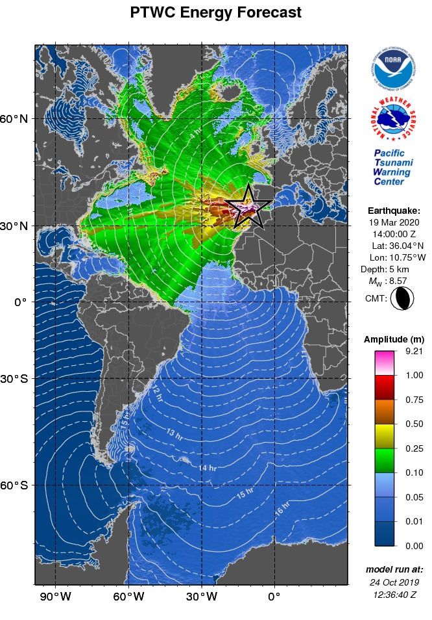

### Coastal Forecast Map - Atlantic

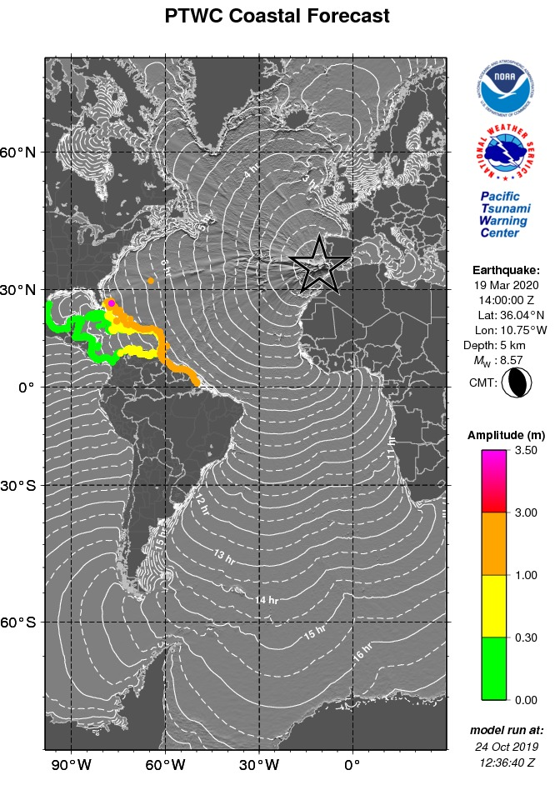

### Coastal Forecast Map – Caribbean

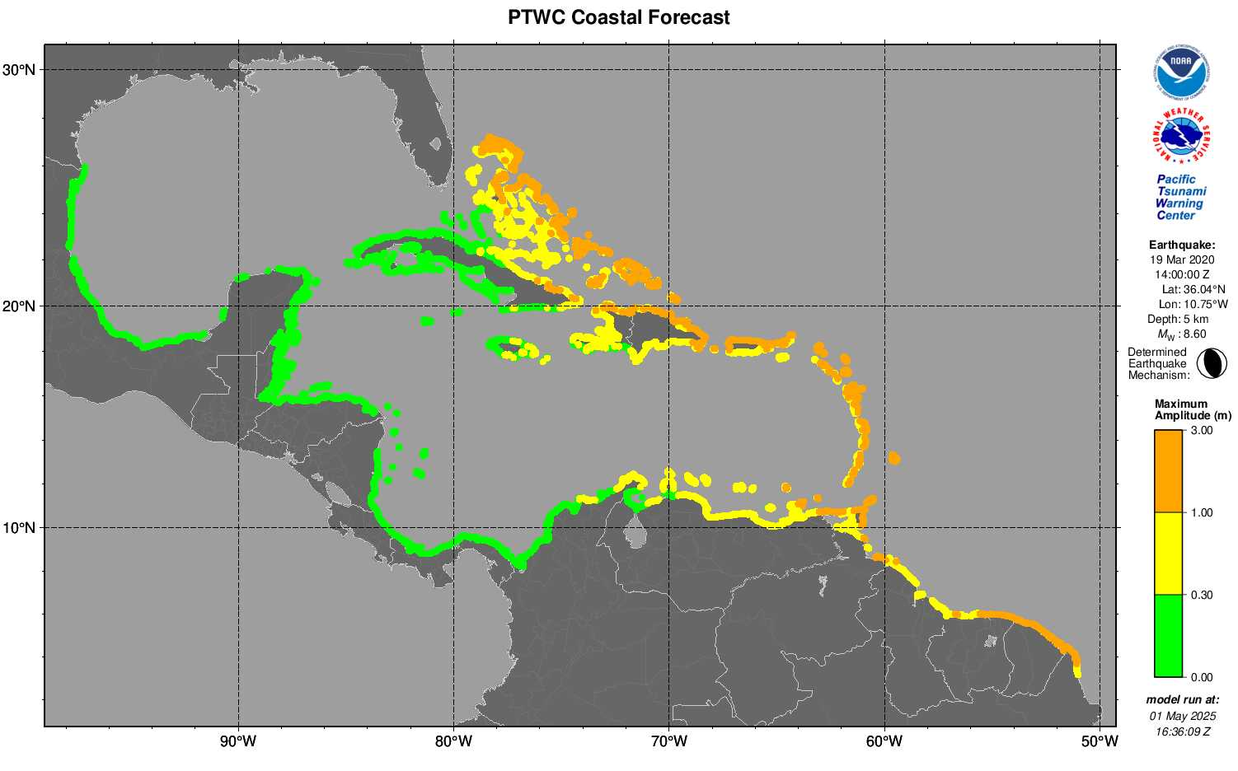

## Later Threat Product with Gauge Readings

### Text Product

ZCZC

WECA41 PHEB 200000

TSUCAX

Tsunami Message Number 14

NWS Pacific Tsunami Warning Center Honolulu HI

0000 UTC Fri Mar 20 2020

...TSUNAMI THREAT MESSAGE...

**** NOTICE **** NOTICE **** NOTICE **** NOTICE **** NOTICE *****

This message is issued for information only in support of the

UNESCO/IOC Tsunami and Other Coastal Hazards Warning System for

the Caribbean and Adjacent Regions and is meant for national

authorities in each country of that system.

National authorities will determine the appropriate level of

alert for each country and may issue additional or more refined

information.

**** NOTICE **** NOTICE **** NOTICE **** NOTICE **** NOTICE *****

PRELIMINARY EARTHQUAKE PARAMETERS

---------------------------------

* Magnitude 8.5

* Origin Time 1400 UTC Mar 19 2020

* Coordinates 36.0 NORTH 10.8 WEST

* Depth 5 KM / 3 MILES

* Location Azores-cape St. Vincent Ridge

EVALUATION

----------

* An earthquake with a preliminary magnitude of 8.5 occurred

near the Azores-Cape Saint Vincent Ridge at 1400 UTC on

Thursday March 19 2020.

* Tsunami waves have been observed.

* Based on all available data... hazardous tsunami waves are

forecast for some coasts of the Caribbean and adjacent

regions covered by this international product.

TSUNAMI THREAT FORECAST

-----------------------

The following forecast tsunami amplitudes apply to the entire

duration of the event. It is up to national authorities to

decide on the appropriate levels of alert for their coasts

throughout the event based upon all available information.

* Tsunami waves reaching more than 3 meters above the tide

level are possible along some coasts of

BAHAMAS.

* Tsunami waves reaching 1 to 3 meters above the tide level are

possible along some coasts of

ANGUILLA... ANTIGUA AND BARBUDA... BARBADOS... BERMUDA...

BRAZIL... CUBA... DOMINICA... DOMINICAN REPUBLIC... FRENCH

GUYANE... GRENADA... GUADELOUPE... GUYANA... HAITI...

MARTINIQUE... PUERTO RICO AND VIRGIN ISLANDS... SAINT

BARTHELEMY... SAINT LUCIA... SAINT VINCENT AND THE

GRENADINES... SURINAME... TRINIDAD AND TOBAGO... TURKS AND

CAICOS ISLANDS... and VENEZUELA.

* Tsunami waves reaching 0.3 to 1 meters above the tide level

are possible for some coasts of

ARUBA... BONAIRE... COLOMBIA... CURACAO... JAMAICA...

MONTSERRAT... SABA AND SAINT EUSTATIUS... SAINT KITTS AND

NEVIS... SINT MAARTEN... and SAINT MARTIN.

* Actual amplitudes at the coast may vary from forecast

amplitudes due to uncertainties in the forecast and local

features. In particular maximum tsunami amplitudes on atolls

or small islands and at locations with fringing or barrier

reefs will likely be much smaller than the forecast

indicates.

* For all other areas covered by this message... there is no

tsunami threat although small sea level changes may occur.

RECOMMENDED ACTIONS

-------------------

* Government agencies responsible for threatened coastal areas

should take action to inform and instruct any coastal

populations at risk in accordance with their own

evaluation... procedures and the level of threat.

* Persons located in threatened coastal areas should stay alert

for information and follow instructions from national and

local authorities.

ESTIMATED TIMES OF ARRIVAL

--------------------------

* Estimated times of arrival -ETA- of the initial tsunami wave

for places within threatened regions are given below. Actual

arrival times may differ and the initial wave may not be the

largest. A tsunami is a series of waves and the time between

waves can be five minutes to one hour.

LOCATION COORDINATES ETA(UTC)

------------------------------------------------------

JAMAICA

Montego Bay 18.5N 77.9W 2306 03/19

Kingston 17.9N 76.9W 2321 03/19

TRINIDAD TOBAGO

Port Of Spain 10.6N 61.5W 2314 03/19

COLOMBIA

Riohacha 11.6N 72.9W 2320 03/19

Barranquilla 11.1N 74.9W 2326 03/19

Cartagena 10.4N 75.6W 2343 03/19

Santa Marta 11.2N 74.2W 0006 03/20

Punta Caribana 8.6N 76.9W 0019 03/20

CUBA

Gibara 21.1N 76.1W 2325 03/19

Cienfuegos 22.0N 80.5W 2340 03/19

Santa Crz D Sur 20.7N 78.0W 0146 03/20

Nueva Gerona 21.9N 82.8W 0310 03/20

BAHAMAS

Bimini 25.8N 79.3W 2328 03/19

HAITI

Jeremie 18.6N 74.1W 2331 03/19

Port Au Prince 18.5N 72.4W 0019 03/20

SURINAME

Paramaribo 5.9N 55.2W 0007 03/20

VENEZUELA

Punto Fijo 11.7N 70.2W 0036 03/20

Golfo Venezuela 11.4N 71.2W 0214 03/20

Porlamar 10.9N 63.8W 0246 03/20

GUYANA

Georgetown 6.8N 58.2W 0046 03/20

BRAZIL

Ilha De Maraca 2.2N 50.5W 0137 03/20

POTENTIAL IMPACTS

-----------------

* A tsunami is a series of waves. The time between wave crests

can vary from 5 minutes to an hour. The hazard may persist

for many hours or longer after the initial wave.

* Impacts can vary significantly from one section of coast to

the next due to local bathymetry and the shape and elevation

of the shoreline.

* Impacts can also vary depending upon the state of the tide at

the time of the maximum tsunami waves.

* Persons caught in the water of a tsunami may drown... be

crushed by debris in the water... or be swept out to sea.

TSUNAMI OBSERVATIONS

--------------------

* The following are tsunami wave observations from coastal

and/or deep-ocean sea level gauges at the indicated

locations. Tsunami amplitudes are measured with respect to

the normal tide level.

COORDINATES TIME TSUNAMI MS PER

GAUGE LOCATION LAT LON UTC AMPLITUDE TP MIN

---------------------------------------------------------------

COLOMBIA

Isla Naval 10.2N 75.8W 2351 0.34M/ 1.1FT H 11

Santa Marta 11.2N 74.2W 2334 0.53M/ 1.7FT H 8

JAMAICA

Port Royal 17.9N 76.8W 2353 0.92M/ 3.0FT C 13

BRAZIL

Salvador 13.0S 38.5W 2331 0.65M/ 2.1FT H 11

TRINIDAD_AND_TOBAGO

Port Of Spain 10.6N 61.5W 2314 2.02M/ 6.6FT T 13

USA-MASSACHUSETTS

Nantucket Island 41.3N 70.1W 2305 1.62M/ 5.3FT H 9

UNITED_KINGDOM

Saint Helena Ruperts 15.9S 5.7W 2307 0.74M/ 2.4FT H 13

Tortola Vi 18.4N 64.6W 2251 1.40M/ 4.6FT H 12

USA-NORTH_CAROLINA

Hatteras 35.2N 75.7W 2247 2.21M/ 7.2FT H 8

ARUBA

Orangestad 12.5N 70.0W 2244 0.91M/ 3.0FT H 14

DOMINICAN_REPUBLIC

Barahona 18.2N 71.1W 2237 0.68M/ 2.2FT C 8

Puerto Plata 19.8N 70.7W 2200 1.94M/ 6.4FT C 8

Punta Cana 18.5N 68.4W 2159 1.71M/ 5.6FT H 12

FRANCE

Ile Royal Guiana 5.3N 52.6W 2229 2.70M/ 8.8FT H 14

Saint Martin 18.1N 63.1W 2158 1.86M/ 6.1FT H 7

Deshaies Guadeloupe 16.3N 61.8W 2128 1.46M/ 4.8FT H 11

Desirade Guadeloupe 16.3N 61.1W 2106 2.42M/ 8.0FT H 10

Sete 43.4N 3.7E 1901 0.22M/ 0.7FT C 14

Fos-sur-mer 43.4N 4.9E 1849 0.21M/ 0.7FT H 10

Port-vendres 43.0N 3.1E 1848 0.24M/ 0.8FT H 11

Nice 43.7N 7.3E 1823 0.26M/ 0.8FT H 9

Port Ferreol 43.4N 6.7E 1811 0.23M/ 0.8FT H 12

Ajaccio 41.9N 8.8E 1814 0.20M/ 0.6FT H 13

Lherbaudiere 47.0N 2.3W 1801 1.65M/ 5.4FT H 13

Les Sables Dolonne 46.5N 1.8W 1752 1.39M/ 4.6FT H 11

Concarmeau 47.9N 3.9W 1732 1.74M/ 5.7FT H 11

Le Conquet 48.4N 4.8W 1730 1.85M/ 6.1FT T 14

Mimizan 44.2N 1.3W 1702 1.38M/ 4.5FT H 12

Boucau Bayonne 43.5N 1.5W 1645 1.45M/ 4.8FT H 13

HAITI

Cap Haitien 19.8N 72.2W 2217 1.87M/ 6.1FT H 8

ANGUILLA

Prickley Bay 12.0N 61.8W 2216 1.17M/ 3.8FT H 13

Blowing Point 18.2N 63.1W 2157 1.86M/ 6.1FT H 13

DART

Caribbean 42407 15.3N 68.2W 2208 0.09M/ 0.3FT H 12

Miami 41420 23.4N 67.3W 2125 0.29M/ 0.9FT H 13

Montauk 44402 39.3N 70.7W 2127 0.19M/ 0.6FT C 12

Bermuda 41425 28.7N 65.6W 2110 0.50M/ 1.6FT H 8

San Juan 41421 23.4N 63.8W 2106 0.29M/ 0.9FT H 10

PUERTO_RICO

Magueyes Island 18.0N 67.0W 2213 1.12M/ 3.7FT H 14

Mona Island 18.1N 67.9W 2200 1.38M/ 4.5FT C 12

Isabelii Vieques 18.2N 65.4W 2201 1.39M/ 4.6FT H 8

Mayaguez 18.2N 67.2W 2151 2.42M/ 8.0FT H 10

Esperanza Vieques 18.1N 65.5W 2144 1.36M/ 4.5FT H 14

Yabucoa 18.1N 65.8W 2139 1.41M/ 4.6FT H 14

Arecibo 18.5N 66.7W 2139 3.13M/10.3FT H 7

San Juan 18.5N 66.1W 2136 2.57M/ 8.4FT H 14

TURKS_AND_CAICOS

Grand Turk Island 21.4N 71.1W 2205 2.90M/ 9.5FT H 12

SAINT_LUCIA

Ganters Bay St Lucia 14.0N 61.0W 2155 1.28M/ 4.2FT H 10

ANTIGUA_AND_BARBUDA

Barbuda 17.6N 61.8W 2146 2.09M/ 6.8FT H 9

Parham 17.1N 61.8W 2115 2.61M/ 8.6FT H 13

SAINT_VINCENT_AND_THE_GRENADINES

Calliaqua 13.1N 61.2W 2146 1.12M/ 3.7FT H 11

US_VIRGIN_ISLANDS

Limetree 17.7N 64.8W 2134 1.24M/ 4.1FT C 14

St Croix 17.7N 64.7W 2138 1.46M/ 4.8FT H 14

SAINT_KITTS_AND_NEVIS

Basseterre 17.3N 62.7W 2141 1.68M/ 5.5FT C 12

MARTINIQUE

Fort De France 14.6N 61.1W 2135 1.46M/ 4.8FT H 8

Le Robert 14.7N 60.9W 2125 2.68M/ 8.8FT H 14

Le Precheur 14.8N 61.2W 2126 1.32M/ 4.3FT H 13

DOMINICA

Roseau 15.3N 61.4W 2131 1.29M/ 4.2FT H 9

Portsmouth 15.6N 61.5W 2128 1.40M/ 4.6FT H 14

BARBADOS

Port St Charles 13.3N 59.6W 2125 3.21M/10.5FT H 14

ITALY

Salerno 40.7N 14.8E 1906 0.14M/ 0.5FT H 12

Genova 44.4N 8.9E 1837 0.31M/ 1.0FT H 13

Imperia 43.9N 8.0E 1820 0.27M/ 0.9FT H 12

Carloforte 39.1N 8.3E 1816 0.27M/ 0.9FT H 7

IRELAND

Malin Head 55.4N 7.3W 1854 1.41M/ 4.6FT H 9

MAURITANIA

Nouadhibou 20.8N 17.0W 1835 2.43M/ 8.0FT H 11

MONACO

Monaco 43.7N 7.4E 1820 0.22M/ 0.7FT H 14

CAPE_VERDE

Praia 14.9N 23.5W 1801 1.57M/ 5.1FT H 11

SPAIN

Barcelona 41.3N 2.2E 1754 0.23M/ 0.7FT T 8

Valencia 39.4N 0.3W 1728 0.39M/ 1.3FT H 9

Cartagena 37.6N 1.0W 1630 0.79M/ 2.6FT H 14

Ferrol 43.5N 8.3W 1600 2.91M/ 9.6FT H 8

Elhierro 27.8N 17.9W 1554 3.57M/11.7FT H 11

Fuerteventura 28.5N 13.9W 1551 4.79M/15.7FT H 14

Lagomera 28.1N 17.1W 1545 3.78M/12.4FT H 8

La Palma 28.7N 17.8W 1543 5.98M/19.6FT C 9

Tenerife 28.5N 16.2W 1540 6.00M/19.7FT H 10

Arrecife 29.0N 13.5W 1529 5.45M/17.9FT H 12

Laspalmas 28.1N 15.4W 1532 7.60M/24.9FT H 9

Algeciras 36.2N 5.4W 1534 2.55M/ 8.4FT H 13

Cadiz 36.5N 6.3W 1528 16.68M/54.7FT H 10

Huelva 37.1N 6.8W 1526 22.07M/72.4FT H 11

PORTUGAL

Ponta Delgada 37.7N 25.7W 1604 7.64M/25.1FT H 11

Albufeira 37.1N 8.3W 1505 30.86M/****FT H 8

Porto Santo 33.1N 16.3W 1503 20.47M/67.2FT H 7

TIME UTC - Time of the reported observation

MS TP - Measurement Type

C is the maximum crest

T is the maximum trough

H is half maximum crest-to-trough

PER MIN - Tsunami wave period in minutes

NEXT UPDATE AND ADDITIONAL INFORMATION

--------------------------------------

* The next message will be issued in one hour... or sooner if

the situation warrants.

* Authoritative information about the earthquake from the U.S.

Geological Survey can be found on the internet at

earthquake.usgs.gov.

* Further information about this event may be found at

www.tsunami.gov.

* Coastal regions of the US Gulf Coast... US East Coast... and

the Maritime Provinces of Canada should refer to U.S.

National Tsunami Warning Center messages that can be found

at www.tsunami.gov.

$$

NNNN

## Final Threat Product

### Text Message

ZCZC

WECA41 PHEB 200800

TSUCAX

Tsunami Message Number 22

NWS Pacific Tsunami Warning Center Honolulu HI

0800 UTC Fri Mar 20 2020

...FINAL TSUNAMI THREAT MESSAGE...

**** NOTICE **** NOTICE **** NOTICE **** NOTICE **** NOTICE *****

This message is issued for information only in support of the

UNESCO/IOC Tsunami and Other Coastal Hazards Warning System for

the Caribbean and Adjacent Regions and is meant for national

authorities in each country of that system.

National authorities will determine the appropriate level of

alert for each country and may issue additional or more refined

information.

**** NOTICE **** NOTICE **** NOTICE **** NOTICE **** NOTICE *****

PRELIMINARY EARTHQUAKE PARAMETERS

---------------------------------

* Magnitude 8.5

* Origin Time 1400 UTC Mar 19 2020

* Coordinates 36.0 NORTH 10.8 WEST

* Depth 5 KM / 3 MILES

* Location Azores-cape St. Vincent Ridge

EVALUATION

----------

* An earthquake with a preliminary magnitude of 8.5 occurred

near the Azores-Cape Saint Vincent Ridge at 1400 UTC on

Thursday March 19 2020.

* Based on all available data... the tsunami threat from this

earthquake has passed and there is no further threat.

TSUNAMI THREAT FORECAST...UPDATED

---------------------------------

* The tsunami threat to coasts of the Caribbean and adjacent

regions covered by this international product has now

largely passed.

RECOMMENDED ACTIONS

-------------------

* Government agencies responsible for any impacted coastal

areas should monitor conditions at the coast to determine if

and when it is safe to resume normal activities.

* Persons located near impacted coastal areas should stay alert

for information and follow instructions from local

authorities.

* Remain observant and exercise normal caution near the sea.

POTENTIAL IMPACTS

-----------------

* Minor sea level fluctuations up to 30 cm above and below the

normal tide may occur in coastal areas near the earthquake

over the next few hours.... and continuing for up to several

hours.

NEXT UPDATE AND ADDITIONAL INFORMATION

--------------------------------------

* This will be the final statement issued for this event unless

new information is received or the situation changes.

* Authoritative information about the earthquake from the U.S.

Geological Survey can be found on the internet at

earthquake.usgs.gov.

* Further information about this event may be found at

www.tsunami.gov.

* Coastal regions of the US Gulf Coast... US East Coast... and

the Maritime Provinces of Canada should refer to U.S.

National Tsunami Warning Center messages that can be found

at www.tsunami.gov.

$$

NNNN

# APPENDIX III. Countries and Territories as Named in PTWC CARIBE-EWS Products

1. ANGUILLA
2. ANTIGUA AND BARBUDA
3. ARUBA
4. BAHAMAS
5. BARBADOS
6. BELIZE
7. BERMUDA
8. BONAIRE
9. BRAZIL
10. CAYMAN ISLANDS
11. COLOMBIA
12. COSTA RICA
13. CUBA
14. CURACAO
15. DOMINICA
16. DOMINICAN REPUBLIC
17. FRENCH GUYANE
18. GRENADA
19. GUADELOUPE
20. GUATEMALA
21. GUYANA
22. HAITI
23. HONDURAS
24. JAMAICA
25. MARTINIQUE
26. MEXICO
27. MONTSERRAT
28. NICARAGUA
29. PANAMA
30. PUERTO RICO AND VIRGIN ISLANDS (*includes the U.S. and British Virgin Islands*)
31. SABA AND SAINT EUSTATIUS
32. SAINT BARTHELEMY
33. SAINT KITTS AND NEVIS
34. SAINT LUCIA
35. SAINT MARTIN
36. SAINT VINCENT AND THE GRENADINES
37. SAN ANDRES AND PROVIDENCIA
38. SINT MAARTEN
39. SURINAME
40. TRINIDAD AND TOBAGO
41. TURKS AND CAICOS ISLANDS
42. VENEZUELA

# APPENDIX IV. UNESCO CARIBE-EWS Member States

1. Antigua and Barbuda*
2. Bahamas
3. Barbados
4. Belize
5. Brazil**
6. Colombia
7. Costa Rica
8. Cuba
9. Dominica
10. Dominican Republic
11. France (Guadeloupe, Guyane, Martinique, Saint Martin, St Barthelemy)
12. Grenada
13. Guatemala
14. Guyana
15. Haiti
16. Honduras
17. Jamaica
18. Mexico
19. Netherlands (Aruba***, Bonaire, Curacao***, Saba, Sint Maarten***, Sint Eustaius).
20. Nicaragua
21. Panama
22. Saint Kitts and Nevis
23. Saint Lucia
24. Saint Vincent and the Grenadines
25. Suriname
26. Trinidad and Tobago
27. United Kingdom of Great Britain & Northern Ireland (Anguilla***, Bermuda, British Virgin Islands***, Cayman Islands***, Montserrat***, Turks and Caicos)
28. United States (Puerto Rico and US Virgin Islands)
29. Venezuela (Bolivarian Republic of)

CARIBE-EWS Member States located outside the CARIBE-EWS coastal service area

1. Canada
2. Peru

*not an IOC Member State

**Designation of Tsunami National Contact and Tsunami Warning Focal Point pending

***UNESCO Associate Member State participating as IOC CARIBE-EWS Observer Member State

# APPENDIX V. List of Forecast Polygons

1. Anguilla
2. Antigua and Barbuda
3. Aruba
4. Bahamas
5. Barbados
6. Belize
7. Bermuda
8. Bonaire
9. Brazil-Amapa Brazil
10. Cayman Islands
11. Colombia-Caribbean Coast of Colombia
12. Costa Rica-Caribbean Coast of Costa Rica
13. Cuba-Atlantic Coast of Cuba
14. Cuba-Caribbean Coast of Cuba
15. Cuba-Gulf Coast of Cuba
16. Curacao
17. Dominica
18. Dominican Republic-Atlantic Coast of Dominican Republic
19. Dominican Republic-Caribbean Coast of Dominican Republic
20. French Guyane
21. Grenada
22. Guadeloupe
23. Guatemala-Caribbean Coast of Guatemala
24. Guyana
25. Haiti-Atlantic Coast of Haiti
26. Haiti-Caribbean Coast of Haiti
27. Haiti-Gulf of Gonave Coast of Haiti
28. Honduras-Caribbean Coast of Honduras
29. Jamaica
30. Martinique
31. Mexico-Quintana Roo Mexico
32. Mexico-Tabasco and Campeche Mexico
33. Mexico-Tamaulipas Mexico
34. Mexico-Veracruz Mexico
35. Mexico-Yucatan Mexico
36. Montserrat
37. Nicaragua-Caribbean Coast of Nicaragua
38. Panama-Caribbean Coast of Panama
39. Puerto Rico and Virgin Islands
40. Saba and Saint Eustatius
41. Saint Barthelemy
42. Saint Kitts and Nevis
43. Saint Lucia
44. Saint Martin
45. Saint Vincent and the Grenadines
46. San Andres and Providencia
47. Sint Maarten
48. Suriname
49. Trinidad and Tobago
50. Turks and Caicos Islands
51. Venezuela-Atlantic Coast of Venezuela
52. Venezuela-Central Coast of Venezuela
53. Venezuela-Western Coast of Venezuela

# APPENDIX VI. Estimated Tsunami Arrival Time Points Named in PTWC Products

|  |  |  |  |
| --- | --- | --- | --- |
| **COUNTRY / TERRITORY** | **PLACE** | **LATITUDE** | **LONGITUDE** |
| ANGUILLA | THE VALLEY | 18.252 N | 63.051 W |
| ANTIGUA | SAINT JOHNS | 17.131 N | 61.874 W |
| ARUBA | ORANJESTAD | 12.506 N | 70.042 W |
| BAHAMAS | ABACO ISLAND | 26.556 N | 77.079 W |
| BAHAMAS | FREEPORT | 26.514 N | 78.782 W |
| BAHAMAS | NASSAU | 25.094 N | 77.351 W |
| BAHAMAS | ELEUTHERA ISLAND | 25.157 N | 76.124 W |
| BAHAMAS | SAN SALVADOR | 24.066 N | 74.547 W |
| BAHAMAS | CROOKED ISLAND | 22.747 N | 74.141 W |
| BAHAMAS | LONG ISLAND | 23.272 N | 75.082 W |
| BAHAMAS | MAYAGUANA | 22.330 N | 72.999 W |
| BAHAMAS | EXUMA | 23.570 N | 75.851 W |
| BAHAMAS | CAT ISLAND | 24.401 N | 75.532 W |
| BAHAMAS | ANDROS ISLAND | 25.030 N | 77.901 W |
| BAHAMAS | BIMINI | 25.761 N | 79.287 W |
| BAHAMAS | GREAT INAGUA | 20.948 N | 73.684 W |
| BARBADOS | BRIDGETOWN | 13.091 N | 59.622 W |
| BARBUDA | PALMETTO POINT | 17.578 N | 61.863 W |
| BELIZE | BELIZE CITY | 17.503 N | 88.178 W |
| BERMUDA | ESSO PIER | 32.373 N | 64.703 W |
| BONAIRE | ONIMA | 12.256 N | 68.309 W |
| BR VIRGIN IS | ROADTOWN | 18.425 N | 64.608 W |
| BR VIRGIN IS | ANEGADA | 18.750 N | 64.300 W |
| BRAZIL | FORTALEZA | 3.707 S | 38.480 W |
| BRAZIL | SAO LUIS | 2.470 S | 44.309 W |
| BRAZIL | ILHA DE MARACA | 2.208 N | 50.488 W |
| CAYMAN ISLANDS | CAYMAN BRAC | 19.681 N | 79.883 W |
| CAYMAN ISLANDS | GRAND CAYMAN | 19.297 N | 81.342 W |
| COLOMBIA | RIOHACHA | 11.554 N | 72.920 W |
| COLOMBIA | SANTA MARTA | 11.247 N | 74.225 W |
| COLOMBIA | BARRANQUILLA | 11.070 N | 74.866 W |
| COLOMBIA | CARTAGENA | 10.412 N | 75.563 W |
| COLOMBIA | PUNTA CARIBANA | 8.624 N | 76.898 W |
| COSTA RICA | PUERTO LIMON | 10.001 N | 83.013 W |
| CUBA | NUEVA GERONA | 21.922 N | 82.797 W |
| CUBA | CIENFUEGOS | 22.007 N | 80.465 W |
| CUBA | SANTA CRZ D SUR | 20.682 N | 77.959 W |
| CUBA | LA HABANA | 23.151 N | 82.364 W |
| CUBA | GIBARA | 21.119 N | 76.122 W |
| CUBA | BARACOA | 20.356 N | 74.498 W |
| CUBA | SANTIAGO D CUBA | 19.947 N | 75.850 W |
| CURACAO | WILLEMSTAD | 12.094 N | 68.934 W |
| DOMINICA | ROSEAU | 15.297 N | 61.396 W |
| DOMINICAN REP | CABO ENGANO | 18.612 N | 68.290 W |
| DOMINICAN REP | PUERTO PLATA | 19.813 N | 70.692 W |
| DOMINICAN REP | SANTO DOMINGO | 18.455 N | 69.893 W |
| FRENCH GUYANE | CAYENNE | 4.931 N | 52.350 W |
| GRENADA | SAINT GEORGES | 12.046 N | 61.754 W |
| GUADELOUPE | BASSE TERRE | 15.982 N | 61.737 W |
| GUATEMALA | PUERTO BARRIOS | 15.745 N | 88.597 W |
| GUYANA | GEORGETOWN | 6.840 N | 58.196 W |
| HAITI | JEREMIE | 18.641 N | 74.107 W |
| HAITI | CAP HAITEN | 19.792 N | 72.188 W |
| HAITI | PORT AU PRINCE | 18.544 N | 72.369 W |
| HAITI | JACAMEL | 18.100 N | 72.500 W |
| HONDURAS | TRUJILLO | 15.931 N | 85.958 W |
| HONDURAS | PUERTO CORTES | 15.850 N | 87.973 W |
| JAMAICA | MONTEGO BAY | 18.471 N | 77.933 W |
| JAMAICA | KINGSTON | 17.913 N | 76.854 W |
| MARTINIQUE | FORT DE FRANCE | 14.598 N | 61.082 W |
| MEXICO | COZUMEL | 20.516 N | 86.955 W |
| MEXICO | CAMPECHE | 19.867 N | 90.539 W |
| MEXICO | VERACRUZ | 19.201 N | 96.116 W |
| MEXICO | MADERO | 22.291 N | 97.785 W |
| MEXICO | TEXAS BORDER | 25.972 N | 97.141 W |
| MEXICO | PROGRESO | 21.300 N | 89.660 W |
| MONTSERRAT | PLYMOUTH | 16.706 N | 62.234 W |
| NICARAGUA | PUNTA GORDA | 11.437 N | 83.793 W |
| NICARAGUA | PUERTO CABEZAS | 14.019 N | 83.374 W |
| PANAMA | PUERTO OBALDIA | 8.667 N | 77.417 W |
| PANAMA | PUERTO CARRETO | 8.783 N | 77.573 W |
| PANAMA | ALIGANDI | 9.233 N | 78.017 W |
| PANAMA | COLON | 9.372 N | 79.914 W |
| PANAMA | BOCAS DEL TORO | 9.351 N | 82.242 W |
| PUERTO RICO | SAN JUAN | 18.459 N | 66.116 W |
| PUERTO RICO | MAYAGUEZ | 18.220 N | 67.160 W |
| SABA | SABA | 17.640 N | 63.220 W |
| SAINT BARTHELEMY | SAINT BARTHELEMY | 17.910 N | 62.825 W |
| SAINT KITTS | BASSETERRE | 17.290 N | 62.718 W |
| SAINT LUCIA | CASTRIES | 14.017 N | 61.031 W |
| SAINT MARTIN | BAIE BLANCHE | 18.115 N | 62.992 W |
| SAINT MARTIN | BAIE GRAND CASE | 18.110 N | 63.060 W |
| SAINT MARTIN | BAIE LUCAS | 18.060 N | 63.008 W |
| SAINT VINCENT | KINGSTOWN | 13.136 N | 61.214 W |
| SAN ANDRES PROVID | SAN ANDRES | 13.380 N | 81.390 W |
| SAN ANDRES PROVID | PROVIDENCIA | 12.590 N | 81.680 W |
| SINT EUSTATIUS | SINT EUSTATIUS | 17.500 N | 62.975 W |
| SINT MAARTEN | SIMPSON BAAI | 18.034 N | 63.104 W |
| SURINAME | PARAMARIBO | 5.934 N | 55.198 W |
| TRINIDAD TOBAGO | PIRATES BAY | 11.327 N | 60.559 W |
| TRINIDAD TOBAGO | PORT OF SPAIN | 10.641 N | 61.528 W |
| TURKS N CAICOS | WEST CAICOS | 21.671 N | 72.487 W |
| TURKS N CAICOS | GRAND TURK | 21.468 N | 71.107 W |
| US VIRGIN IS | CHARLOTTE AMALIE | 18.336 N | 64.920 W |
| US VIRGIN IS | CHRISTIANSTED | 17.748 N | 64.698 W |
| VENEZUELA | PORLAMAR | 10.948 N | 63.842 W |
| VENEZUELA | CUMANA | 10.469 N | 64.197 W |
| VENEZUELA | MAIQUETIA | 10.608 N | 66.966 W |
| VENEZUELA | PUNTO FIJO | 11.707 N | 70.232 W |
| VENEZUELA | GOLFO VENEZUELA | 11.399 N | 71.245 W |

# APPENDIX VII. IOC Technical Series

|  |  |  |
| --- | --- | --- |
| No. | Title | Languages |
| 1 | Manual on International Oceanographic Data Exchange. 1965 | (out of stock) |
| 2 | Intergovernmental Oceanographic Commission (Five years of work). 1966 | (out of stock) |
| 3 | Radio Communication Requirements of Oceanography. 1967 | (out of stock) |
| 4 | Manual on International Oceanographic Data Exchange - Second revised edition. 1967 | (out of stock) |
| 5 | Legal Problems Associated with Ocean Data Acquisition Systems (ODAS). 1969 | (out of stock) |
| 6 | Perspectives in Oceanography, 1968 | (out of stock) |
| 7 | Comprehensive Outline of the Scope of the Long-term and Expanded Programme of Oceanic Exploration and Research. 1970 | (out of stock) |
| 8 | IGOSS (Integrated Global Ocean Station System) - General Plan Implementation Programme for Phase I. 1971 | (out of stock) |
| 9 | Manual on International Oceanographic Data Exchange - Third Revised Edition. 1973 | (out of stock) |
| 10 | Bruun Memorial Lectures, 1971 | E, F, S, R |
| 11 | Bruun Memorial Lectures, 1973 | (out of stock) |
| 12 | Oceanographic Products and Methods of Analysis and Prediction. 1977 | E only |
| 13 | International Decade of Ocean Exploration (IDOE), 1971-1980. 1974 | (out of stock) |
| 14 | A Comprehensive Plan for the Global Investigation of Pollution in the Marine Environment and Baseline Study Guidelines. 1976 | E, F, S, R |
| 15 | Bruun Memorial Lectures, 1975 - Co-operative Study of the Kuroshio and Adjacent Regions. 1976 | (out of stock) |
| 16 | Integrated Ocean Global Station System (IGOSS) General Plan and Implementation Programme 1977-1982. 1977 | E, F, S, R |
| 17 | Oceanographic Components of the Global Atmospheric Research Programme (GARP) . 1977 | (out of stock) |
| 18 | Global Ocean Pollution: An Overview. 1977 | (out of stock) |
| 19 | Bruun Memorial Lectures - The Importance and Application  of Satellite and Remotely Sensed Data to Oceanography. 1977 | (out of stock) |
| 20 | A Focus for Ocean Research: The Intergovernmental Oceanographic Commission - History, Functions, Achievements. 1979 | (out of stock) |
| 21 | Bruun Memorial Lectures, 1979: Marine Environment and Ocean Resources. 1986 | E, F, S, R |
| 22 | Scientific Report of the Interealibration Exercise of the  IOC-WMO-UNEP Pilot Project on Monitoring Background Levels of Selected Pollutants in Open Ocean Waters. 1982 | (out of stock) |
| 23 | Operational Sea-Level Stations. 1983 | E, F, S, R |
| 24 | Time-Series of Ocean Measurements. Vol.1. 1983 | E, F, S, R |
| 25 | A Framework for the Implementation of the Comprehensive Plan  for the Global Investigation of Pollution in the Marine Environment. 1984 | (out of stock) |
| 26 | The Determination of Polychlorinated Biphenyls in Open-ocean Waters. 1984 | E only |
| 27 | Ocean Observing System Development Programme. 1984 | E, F, S, R |
| 28 | Bruun Memorial Lectures, 1982: Ocean Science for the Year 2000. 1984 | E, F, S, R |
| 29 | Catalogue of Tide Gauges in the Pacific. 1985 | E only |
| 30 | Time-Series of Ocean Measurements. Vol. 2. 1984 | E only |
| 31 | Time-Series of Ocean Measurements. Vol. 3. 1986 | E only |
| 32 | Summary of Radiometric Ages from the Pacific. 1987 | E only |
| 33 | Time-Series of Ocean Measurements. Vol. 4. 1988 | E only |
| 34 | Bruun Memorial Lectures, 1987: Recent Advances in Selected Areas of Ocean Sciences in the Regions of the Caribbean, Indian Ocean and the Western Pacific. 1988 | Composite E, F, S |
| 35 | Global Sea-Level Observing System (GLOSS) Implementation Plan. 1990 | E only |
| 36 | Bruun Memorial Lectures 1989: Impact of New Technology on Marine Scientific Research. 1991 | Composite E, F, S |
| 37 | Tsunami Glossary - A Glossary of Terms and Acronyms Used in the Tsunami Literature. 1991 | E only |
| 38 | The Oceans and Climate: A Guide to Present Needs. 1991 | E only |
| 39 | Bruun Memorial Lectures, 1991: Modelling and Prediction in Marine Science. 1992 | E only |
| 40 | Oceanic Interdecadal Climate Variability. 1992 | E only |
| 41 | Marine Debris: Solid Waste Management Action for the Wider Caribbean. 1994 | E only |
| 42 | Calculation of New Depth Equations for Expendable Bathymerographs Using a Temperature-Error-Free Method (Application to Sippican/TSK T-7, T-6 and T-4 XBTS. 1994 | E only |
| 43 | IGOSS Plan and Implementation Programme 1996-2003. 1996 | E, F, S, R |
| 44 | Design and Implementation of some Harmful Algal Monitoring Systems. 1996 | E only |
| 45 | Use of Standards and Reference Materials in the Measurement of Chlorinated Hydrocarbon Residues. 1996 | E only |
| 46 | Equatorial Segment of the Mid-Atlantic Ridge. 1996 | E only |
| 47 | Peace in the Oceans: Ocean Governance and the Agenda for Peace; the Proceedings of *Pacem in Maribus* XXIII, Costa Rica, 1995. 1997 | E only |
| 48 | Neotectonics and fluid flow through seafloor sediments in the Eastern Mediterranean and Black Seas - Parts I and II. 1997 | E only |
| 49 | Global Temperature Salinity Profile Programme: Overview and Future. 1998 | E only |
| 50 | Global Sea-Level Observing System (GLOSS) Implementation Plan-1997. 1997 | E only |
| 51 | L'état actuel de 1'exploitation des pêcheries maritimes au Cameroun et leur gestion intégrée dans la sous-région du Golfe de Guinée *(cancelled)* | F only |
| 52 | Cold water carbonate mounds and sediment transport on the Northeast Atlantic Margin. 1998 | E only |
| 53 | The Baltic Floating University: Training Through Research in the Baltic, Barents and White Seas - 1997. 1998 | E only |
| 54 | Geological Processes on the Northeast Atlantic Margin (8th training-through- research cruise, June-August 1998). 1999 | E only |
| 55 | Bruun Memorial Lectures, 1999: Ocean Predictability. 2000 | E only |
| 56 | Multidisciplinary Study of Geological Processes on the North East Atlantic and Western Mediterranean Margins (9th training-through-research cruise, June- July 1999). 2000 | E only |
| 57 | Ad hoc Benthic Indicator Group - Results of Initial Planning Meeting, Paris, France, 6-9 December 1999. 2000 | E only |
| 58 | Bruun Memorial Lectures, 2001: Operational Oceanography – a perspective from the private sector. 2001 | E only |
| 59 | Monitoring and Management Strategies for Harmful Algal Blooms in Coastal Waters. 2001 | E only |
| 60 | Interdisciplinary Approaches to Geoscience on the North East Atlantic Margin and Mid-Atlantic Ridge (10th training-through-research cruise, July-August 2000). 2001 | E only |
| 61 | Forecasting Ocean Science? Pros and Cons, Potsdam Lecture, 1999. 2002 | E only |
| 62 | Geological Processes in the Mediterranean and Black Seas and North East Atlantic (11th training-through-research cruise, July- September 2001). 2002 | E only |
| 63 | Improved Global Bathymetry – Final Report of SCOR Working Group 107. 2002 | E only |
| 64 | R. Revelle Memorial Lecture, 2006: Global Sea Levels, Past, Present and Future. 2007 | E only |
| 65 | Bruun Memorial Lectures, 2003: Gas Hydrates – a potential source of energy from the oceans. 2003 | E only |
| 66 | Bruun Memorial Lectures, 2003: Energy from the Sea: the potential and realities of Ocean Thermal Energy Conversion (OTEC). 2003 | E only |
| 67 | Interdisciplinary Geoscience Research on the North East Atlantic Margin, Mediterranean Sea and Mid-Atlantic Ridge (12th training-through-research cruise, June-August 2002). 2003 | E only |
| 68 | Interdisciplinary Studies of North Atlantic and Labrador Sea Margin Architecture and Sedimentary Processes (13th training-through-research cruise, July-September 2003). 2004 | E only |
| 69 | Biodiversity and Distribution of the Megafauna / Biodiversité et distribution de la mégafaune. 2006  Vol.1 The polymetallic nodule ecosystem of the Eastern Equatorial Pacific Ocean / Ecosystème de nodules polymétalliques de l’océan Pacifique Est équatorial  Vol.2 Annotated photographic Atlas of the echinoderms of the Clarion- Clipperton fracture zone / Atlas photographique annoté des échinodermes de la zone de fractures de Clarion et de Clipperton  Vol.3 Options for the management and conservation of the biodiversity — The nodule ecosystem in the Clarion Clipperton fracture zone: scientific, legal and institutional aspects | E F |
| 70 | Interdisciplinary geoscience studies of the Gulf of Cadiz and Western Mediterranean Basin (14th training-through-research cruise, July-September 2004). 2006 | E only |
| 71 | Indian Ocean Tsunami Warning and Mitigation System, IOTWS. Implementation Plan, 7–9 April 2009 (2nd Revision). 2009 | E only |
| 72 | Deep-water Cold Seeps, Sedimentary Environments and Ecosystems of the Black and Tyrrhenian Seas and the Gulf of Cadiz (15th training-through- research cruise, June–August 2005). 2007 | E only |
| 73 | Implementation Plan for the Tsunami Early Warning and Mitigation System in the North-Eastern Atlantic, the Mediterranean and Connected Seas (NEAMTWS), 2007–2011. 2007 *(electronic only)* | E only |
| 74 | Bruun Memorial Lectures, 2005: The Ecology and Oceanography of Harmful Algal Blooms – Multidisciplinary approaches to research and management. 2007 | E only |
| 75 | National Ocean Policy. The Basic Texts from: Australia, Brazil, Canada, China, Colombia, Japan, Norway, Portugal, Russian Federation, United States of America. (Also Law of Sea Dossier 1). 2008 | E only |
| 76 | Deep-water Depositional Systems and Cold Seeps of the Western Mediterranean, Gulf of Cadiz and Norwegian Continental margins (16th training-through-research cruise, May–July 2006). 2008 | E only |
| 77 | Indian Ocean Tsunami Warning and Mitigation System (IOTWS) – 12 September 2007 Indian Ocean Tsunami Event. Post-Event Assessment of IOTWS Performance. 2008 | E only |
| 78 | Tsunami and Other Coastal Hazards Warning System for the Caribbean and Adjacent Regions (CARIBE EWS) – Implementation Plan 2013–2017 (Version 2.0). 2013 | E only |
| 79 | Filling Gaps in Large Marine Ecosystem Nitrogen Loadings Forecast for 64 LMEs – GEF/LME global project Promoting Ecosystem-based Approaches to Fisheries Conservation and Large Marine Ecosystems. 2008 | E only |
| 80 | Models of the World’s Large Marine Ecosystems. GEF/LME Global Project Promoting Ecosystem-based Approaches to Fisheries Conservation and Large Marine Ecosystems. 2008 | E only |
| 81 | Indian Ocean Tsunami Warning and Mitigation System (IOTWS) – Implementation Plan for Regional Tsunami Watch Providers (RTWP). 2008 | E only |
| 82 | Exercise Pacific Wave 08 – A Pacific-wide Tsunami Warning and Communication Exercise, 28–30 October 2008. 2008 | E only |
| 83. | Cancelled |  |
| 84. | Global Open Oceans and Deep Seabed (GOODS) Bio-geographic Classification. 2009 | E only |
| 85. | Tsunami Glossary | E, F, S |
| 86 | Pacific Tsunami Warning System (PTWS) Implementation Plan | Electronic publication |
| 87. | Operational Users Guide for the Pacific Tsunami Warning and Mitigation System (PTWS) – Second Edition. 2011 | E only |
| 88. | Exercise Indian Ocean Wave 2009 (IOWave09) – An Indian Ocean-wide Tsunami Warning and Communication Exercise – 14 October 2009. 2009 | E only |
| 89. | Ship-based Repeat Hydrography: A Strategy for a Sustained Global Programme. 2009 | E only |
| 90. | 12 January 2010 Haiti Earthquake and Tsunami Event Post-Event Assessment of CARIBE EWS Performance. 2010 | E only |
| 91. | Compendium of Definitions and Terminology on Hazards, Disasters, Vulnerability and Risks in a coastal context | Under preparation |
| 92. | 27 February 2010 Chile Earthquake and Tsunami Event – Post-Event Assessment of PTWS Performance (Pacific Tsunami Warning System). 2010 | E only |
| 93. | Exercise CARIBE WAVE 11 / LANTEX 11—A Caribbean Tsunami Warning Exercise, 23 March 2011  Vol. 1 Participant Handbook / Exercise CARIBE WAVE 11 —Exercice d’alerte au tsunami dans les Caraïbes, 23 mars 2011. Manuel du participant / Ejercicio Caribe Wave 11. Un ejercicio de alerta de tsunami en el Caribe, 23 de marzo de 2011. Manual del participante. 2010  Vol. 2 Report. 2011  Vol. 3 Supplement: Media Reports. 2011 | E/F/S  E only E/F/S |
| 94. | Cold seeps, coral mounds and deep-water depositional systems of the Alboran Sea, Gulf of Cadiz and Norwegian continental margin (17th training-through- research cruise, June–July 2008) | E only |
| 95. | International Post-Tsunami Survey for the 25 October 2010 Mentawai, Indonesia Tsunami | E only |
| 96. | Pacific Tsunami Warning System (PTWS) 11 March 2011 Off Pacific coast of Tohoku, Japan, Earthquake and Tsunami Event. Post-Event Assessment of PTWS Performance | E only |
| 97. | Exercise PACIFIC WAVE 11: A Pacific-wide Tsunami Warning and Communication Exercise, 9–10 November 2011  Vol. 1 Exercise Manual. 2011  Vol. 2 Report. 2013 | E only E only |
| 98. | Tsunami Early Warning and Mitigation System in the North-Eastern Atlantic, the Mediterranean and connected seas. First Enlarged Communication Test Exercise (ECTE1). Exercise Manual and Evaluation Report. 2011 | E only |
| 99. | Exercise INDIAN OCEAN WAVE 2011 – An Indian Ocean-wide Tsunami Warning and Communication Exercise, 12 October 2011  Vol. 1 Exercise Manual. 2011  Supplement: Bulletins from the Regional Tsunami Service Providers Vol. 2 Exercise Report. 2013 | E only |
| 100. | Global Sea Level Observing System (GLOSS) Implementation Plan – 2012. 2012 | E only |
| 101. | Exercise Caribe Wave/Lantex 13. A Caribbean Tsunami Warning Exercise, 20 March 2013. Volume 1: Participant Handbook. 2012 | E only |
| 102. | Tsunami Early Warning and Mitigation System in the North-Eastern Atlantic, the Mediterranean and Connected Seas — Second Enlarged Communication Test Exercise (CTE2), 22 May 2012.  Vol. 1 Exercise Manual. 2012  Vol. 2 Evaluation Report. 2014 | E only |
| 103. | Exercise NEAMWAVE 12. A Tsunami Warning and Communication Exercise for the North-eastern Atlantic, the Mediterranean, and Connected Seas Region, 27–28 November 2012.  Vol. 1: Exercise Manual. 2012  Vol. 2: Evaluation Report. 2013 | E only |
| 104. | Seísmo y tsunami del 27 de agosto de 2012 en la costa del Pacífico frente a El Salvador, y seísmo del 5 de septiembre de 2012 en la costa del Pacífico frente a Costa Rica. Evaluación subsiguiente sobre el funcionamiento del Sistema de Alerta contra los Tsunamis y Atenuación de sus Efectos en el Pacífico. 2012 | Español solamente (resumen en inglés y francés) |
| 105. | Users Guide for the Pacific Tsunami Warning Center Enhanced Products for the Pacific Tsunami Warning System, August 2014. Revised Edition. 2014 | E, S |
| 106. | Exercise Pacific Wave 13. A Pacific-wide Tsunami Warning and Enhanced Products Exercise, 1–14 May 2013.  Vol. 1 Exercise Manual. 2013  Vol. 2 Summary Report. 2013 | E only |
| 107. | Tsunami Public Awareness and Educations Strategy for the Caribbean and Adjacent Regions. 2013 | E only |
| 108. | Pacific Tsunami Warning and Mitigation System (PTWS) Medium-Term Strategy, 2014−2021. 2013 | E only |
| 109. | Exercise Caribe Wave/Lantex 14. A Caribbean and Northwestern Atlantic Tsunami Warning Exercise, 26 March 2014.  Vol. 1 Participant Handbook. 2014 | E/S |
| 110. | Directory of atmospheric, hydrographic and biological datasets for the Canary Current Large Marine Ecosystem, 2nd edition: revised and expanded. 2016 | E only |
| 111. | Integrated Regional Assessments in support of ICZM in the Mediterranean and Black Sea Basins. 2014 | E only |
| 112. | 11 April 2012 West of North Sumatra Earthquake and Tsunami Event - Post- event Assessment of IOTWS Performance | E only |
| 113. | Exercise Indian Ocean Wave 2014: An Indian Ocean-wide Tsunami Warning and Communication Exercise. | E only |
| 114. | Exercise NEAMWAVE 14. A Tsunami Warning and Communication Exercise for the North-Eastern Atlantic, the Mediterranean, and Connected Seas Region, 28–30 October 2014  Vol. 1 Manual  Vol. 2 Evaluation Report – Supplement: Evaluation by Message Providers and Civil Protection Authorities | E only |
| 115. | Oceanographic and Biological Features in the Canary Current Large Marine Ecosystem. 2015 *(revised in 2016)* | E only |
| 116. | Tsunami Early Warning and Mitigation System in the North-Eastern Atlantic, the Mediterranean and Connected Seas. Third Enlarged Communication Test Exercise (CTE3), 1st October 2013.  Vol. 1 Exercise Manual Vol. 2 Evaluation Report | E only |
| 117. | Exercise Pacific Wave 15. A Pacific-wide Tsunami Warning and Enhanced Products Exercise, 2–6 February 2015  Vol. 1: Exercise Manual; Vol. 2: Summary Report | E only |
| 118. | Exercise Caribe Wave/Lantex 15. A Caribbean and Northwestern Atlantic Tsunami Warning Exercise, 25 March 2015 (SW Caribbean Scenario) Vol. 1: Participant Handbook | E only |
| 119. | Transboundary Waters Assessment Programme (TWAP) Assessment of Governance Arrangements for the Ocean  Vol 1: Transboundary Large Marine Ecosystems; Supplement: Individual Governance Architecture Assessment for Fifty Transboundary Large Marine Ecosystems  Vol 2: Areas Beyond National Jurisdiction | E only |
| 120. | Status and Trends in Primary Productivity and Chlorophyll from 1996 to 2014 in Large Marine Ecosystems and the Western Pacific Warm Pool, Based on Data from Satellite Ocean Colour Sensors | In preparation |
| 121. | Exercise Indian Ocean Wave 14, an Indian Ocean wide Tsunami Warning and Communications Exercise, 9–10 September 2014 | In preparation |
| 122. | Tsunami Early Warning and Mitigation System in the North-Eastern Atlantic, the Mediterranean and Connected Seas. Sixth Communication Test Exercise (CTE6), 29 July 2015.  Vol. 1: Exercise Manual Vol. 2: Evaluation Report | E only |
| 123 | Preparing for the next tsunami in the North-Eastern Atlantic, the Mediterranean and Connected Seas – Ten years of the Tsunami Warning System (NEAMTWS) | In preparation |
| 124 | Indicadores Marino Costeros del Pacífico Sudeste / Coastal and Marine Indicators of the Southeast Pacific (SPINCAM) | E/S |
| 125 | Exercise CARIBE WAVE 2016: A Caribbean and Adjacent Regions Tsunami Warning Exercise, 17 March 2016 (Venezuela and Northern Hispaniola Scenarios)  Volume 1: Participant Handbook | E only |
| 126 | Exercise Pacific Wave 16. A Pacific-wide Tsunami Warning and Enhanced Products Exercise, 1-5 February 2016.  Volume 1: Exercise Manual. Volume 2: Summary Report | E only |
| 127 | How to reduce coastal hazard risk in your community – A step by step approach | E only |
| 128. | Exercise Indian Ocean Wave 2016: An Indian Ocean-wide Tsunami Warning and Communications Exercise, 7–8 September 2016  Vol 1: Participant Manual Vol. 2: Exercise Report | E only |
| 129 | What are Marine Ecological Time Series telling us about the Ocean – A status report | E only |
| 130 | Tsunami Watch Operations – Global Service Definition Document | E only |
| 131 | Exercise Pacific Wave 2017. A Pacific-wide Tsunami Warning and Enhanced Products Exercise, 15-17 February 2017. Volume 1: Exercise Manual | E only |
| 132. | 2nd March 2016 Southwest of Sumatra Earthquake and Tsunami Event Post- Event Assessment of the Performance of the Indian Ocean Tsunami Warning and Mitigation System; Supplement: Tsunami Service Provider Bulletins and Maps | E only |
| 133. | Exercise CARIBE WAVE 17. A Caribbean and Adjacent Regions Tsunami Warning Exercise, 21 March 2017 (Costa Rica, Cuba and Northeastern Antilles Scenarios).  Volume 1: Participant Handbook Volume 2: Final Report | E only |
| 134. | Tsunami Exercise NEAMWave17 – A Tsunami Warning and Communication Exercise for the North-eastern Atlantic, the Mediterranean, and Connected Seas Region, 31 October – 3 November 2017  Volume 1: Exercise Instructions. 2017 | E only |
| 135. | User’s Guide for the Pacific Tsunami Warning Center Enhanced Products for the Tsunami and other Coastal Hazards Warning System for the Caribbean and Adjacent Regions (CARIBE-EWS), October 2017 | E only |