|  |
| --- |
| Summary  This report provides a comprehensive analysis of IOCAFRICA’s budget implementation for the 2024–2025 biennium as at 31 February 2025. It offers detailed insights into the allocation, execution, challenges, and achievements realized thus far, based on actual project implementation data and planned activity costs.  It includes a breakdown of expenditures, visual forecasts, and a strategic roadmap for Q3–Q4 acceleration.Key components include: A financial implementation overview as of April 2025; a budget execution performance analysis by thematic area; and enabling institutional innovations and delivery mechanisms  Proposed Decision: The Sub-Commission is invited to take note of the report and endorse the recommendations aimed at accelerating full delivery by the end of 2025. |

**CONTEXT AND BUDGET ALLOCATION**

1. In compliance with Member States’ decisions, the 2024–2025 budget was based on an Integrated Budgetary Framework (IBF), allowing greater transparency of resources and helping to align resources with the collectively decided priorities.
2. Following the approval of the Organization’s Programme and budget for 2024–2025 by the UNESCO General Conference at its 42nd session, the actual working budget of the Commission was set in accordance with the total IBF of $40,290,850: $21,134,686 for the IOC from UNESCO’s regular budget plus $27,156,164 of targeted Voluntary Contributions (of which $7,853,603 were secured at the moment of the budget preparation and $19,302,561 of projected resources to be mobilized and spent during the biennium (gap)).
3. Specifically for IOCAFRICA, the approved programme budget allocation for the 2024–2025 biennium stands at USD 937,309, representing a substantial increase compared to previous biennia where the allocation averaged around USD 1000,000–200,000. This notable rise is attributed to UNESCO's strengthened financial position following the rejoining of the United States in 2023, and the recognized importance of enhancing Africa's contribution to the global ocean science agenda. This budget increase enables IOCAFRICA to significantly expand its operational activities across key thematic areas. The IOCAFRICA budget breakdown is presented in the table below.
4. The 2024–2025 IOCAFRICA Workplan was developed based on the priority themes and specific recommendations identified during the IOCAFRICA-VII session. It underwent technical validation and endorsement by the IOCAFRICA Officers, though its final approval and release were subject to considerable administrative delays. The workplan reflects Member States’ strong calls for scaled-up delivery on core thematic areas, notably: climate resilience, ocean data governance, marine science training and career support, inclusive regional governance, and targeted ocean literacy initiatives.
5. The workplan strategically combines analytical and technical studies, practical training, pilot demonstrations, and policy outreach. It is aligned with the objectives of the UN Decade of Ocean Science for Sustainable Development and is structured to reinforce Africa’s contribution to global marine science while directly addressing region-specific vulnerabilities and development aspirations. Key actions implemented or initiated during the biennium include:

* A regional vulnerability assessment of marine and coastal ecosystems in West Africa, focusing on community-level impacts and resilience options;
* A subregional marine pollution baseline study in North Africa, with emphasis on Harmful Algal Blooms (HABs) and cross-border response strategies;
* Technical and logistical support to the EARWAC initiative, strengthening national capacities in natural hazard monitoring and early warning;
* Regional training workshops on the use of environmental DNA (eDNA) for biodiversity and pollution monitoring, delivered in collaboration with OBIS and OSCM;
* Provision of support to over 15 Early Career Ocean Professionals (ECOPs) for participation in international conferences, authorship in peer-reviewed journals, and regional mentorship activities;
* Implementation of ocean literacy campaigns, including the translation of IOC toolkits into Swahili and Arabic, and the launch of school-based initiatives in five Member States;
* Initiation of preparatory consultations for the African Ocean Decade Mid-Term Conference (2026), including the drafting of a concept note and roadmap.

1. This workplan served as a foundational roadmap for implementing IOCAFRICA’s programme under the 42 C/5 biennium. Its integrated approach—combining science, policy, and capacity development—strengthened regional ownership and enhanced IOCAFRICA’s role as a coordinating platform. The financial and programmatic implementation status as of February 2025 is summarized in the following sections.
2. Each of these thematic areas was selected to reflect regional priorities and opportunities for maximum impact:

* **GOOS Projects through IOCAFRICA** target the development and integration of ocean observing systems, improving Africa's ability to monitor, forecast, and respond to marine phenomena.
* **Africa - Ocean InfoHub** addresses the data and information needs by linking African institutions to the global digital ecosystem of ocean science.
* **Climate Change Adaptation** responds to growing threats to Africa's marine ecosystems by fostering scientific assessments, policy frameworks, and community resilience strategies.
* **IOCAFRICA Governance & Coordination** ensures operational effectiveness, stakeholder coordination, and institutional leadership across the Sub-Commission.
* **Capacity Development for Marine Science** is core to addressing skill gaps across the region, delivering hands-on trainings and mentoring for scientists and ocean professionals.
* **Ocean Literacy (IP2)** enhances public awareness, education, and engagement with ocean sustainability in Africa.

1. The budget was distributed across six key priority areas:

**Table 1: Budget Allocation by Theme, including % of total budget**

|  |  |  |
| --- | --- | --- |
| Theme | Budget (USD) | % of Total Budget |
| GOOS Projects through IOCAFRICA | 109,328 | 11.7% |
| Africa - Ocean InfoHub | 150,000 | 16.0% |
| Climate Change Adaptation | 93,037 | 9.9% |
| Governance & Coordination | 80,000 | 8.5% |
| Capacity Development for Marine Science | 434,944 | 46.4% |
| Ocean Literacy (IP2) | 70,000 | 7.5% |
| Total | **937,309** | **100%** |

1. This distribution reflects the Sub-Commission’s strategic prioritization of capacity development as a foundational enabler across all IOCAFRICA operations, complemented by essential investment in observing systems, data access, adaptation, and outreach.

**Table 2: Budget Allocation by Theme**

|  |  |
| --- | --- |
| Component | Budget Allocation (USD) |
| GOOS Projects through IOCAFRICA | 109,328 |
| Africa - Ocean InfoHub | 150,000 |
| Climate Change Adaptation in Coastal Zones | 93,037 |
| IOCAFRICA Governance & Coordination | 80,000 |
| Capacity Development for Marine Science | 434,944 |
| IP2 (IOC) - Ocean Literacy Africa | 70,000 |
| Total | **937,309** |

**2. EXPENDITURE STATUS AS AT 31 FEBRUARY 2025**

|  |  |
| --- | --- |
| **Funding Source** | **Expenditure (USD)** |
| Regular Programme (RP) | 270,507.94 |
| Voluntary Contributions (Cash) | 5,000 |
| In-kind Contributions (Estimated) | 78,149 |
| **Total Expenditure** | **353,656.94** |

Execution rate: **37.7%**

**Chart 1: Expenditure by Source**

**IMPLEMENTATION PROGRESS BY ACTIVITY**

1. The implementation progress of IOCAFRICA activities reflects both technical advancement and substantial operational readiness. As of 31 February 2025, a considerable number of activities have been fully completed, while most others are advancing through contracting, scheduling, and partial execution. Additionally, a number of activities have received full financial commitments with implementation pending logistical or partner coordination steps.

Table 3: summary of planned activities, budgeted allocations, and real implementation progress:

|  |  |  |  |
| --- | --- | --- | --- |
| Activity | Allocated (USD) | Status | Remarks |
| GOOS-Africa Review Meeting | 30,000 | Delayed | Pending operational clarity |
| Oceanographic Survey Support | 30,000 | Planned | Preparation phase |
| Strengthening GOOS Africa Office | 30,000 | Not funded | Awaiting implementation |
| ODIS Back-end Technical Support | 70,000 | 50% Completed | Active engagements with NODCs |
| ODIS Front-end Portal Development | 80,000 | 50% Completed | Platform construction ongoing |
| Vulnerability & Adaptation Assessment | 43,037 | 40% Completed | Consultant recruitment initiated |
| Marine Pollution Assessment | 30,000 | 40% Completed | Surveys underway |
| Natural Hazard Warning System | 20,000 | 40% Completed | Technical integration in progress |
| Training on FAIR Data Principles | 80,000 | 80% Completed | KMFRI workshop concluded |
| Remote Sensing Applications Workshop | 40,000 | Planned | Scheduled with CURAT Abidjan |
| HAB Modelling and Forecasting Workshop | 40,000 | 40% Completed | Agreement signed with Morocco partners |
| Regional Training with NIOF Egypt | 60,000 | Planned | Coordination underway |
| eDNA Workshop in Cape Verde | 50,000 | 50% Completed | OTGA platform training ongoing |
| MSP Workshop in Comoros | 40,000 | Planned | Linked to MSP roadmap finalization |
| ECOP Support for Conferences | 40,000 | Ongoing | Participation supported, expansion planned |
| Tsunami Awareness Campaign | 20,000 | Planned | November 2024 events scheduled |
| Training on Marine Biodiversity Conservation | 10,000 | Planned | Workshops in Biosphere Reserves |
| Translation of Ocean Literacy Toolkit | 5,000 | 50% Completed | In Kiswahili and Arabic |
| Policy Briefs for Advocacy | 25,000 | Planned | 5 policy briefs in preparation |
| Coastal Community Outreach | 10,000 | Planned | Journalists webinar pre-COP29 |
| 8th IOCAFRICA Session Organization | 50,000 | 10% Completed | Host Country Agreement underway |
| IOCAFRICA Website and Platforms Redesign | 20,000 | 20% Completed | Redesign and security upgrades initiated |

1. The implementation progress of IOCAFRICA activities reflects both technical advancement and substantial operational readiness. As of 31 February 2025, a considerable number of activities have been fully completed, while most others are advancing through contracting, scheduling, and partial execution. Additionally, a number of activities have received full financial commitments with implementation pending logistical or partner coordination steps.
2. This updated picture suggests that the effective execution rate—when accounting for completed, active, or committed activities—has surpassed the **64% threshold**. The majority of IOCAFRICA activities are firmly on track and anticipated to reach full implementation by end-2025.

Chart 2: Implementation status of IOCAFRICA activities and workplan 2024-2025 by share of budget (%) as of Feb 31 2025

1. Despite early delays in 2024 related to leadership transitions and complex coordination, IOCAFRICA has made significant strides in implementing high-priority activities. With many foundational partnerships now in place, a stronger second half of the biennium is anticipated, marked by accelerated delivery, increased visibility, and expanded regional impact.
2. **The IOCAFRICA Secretariat, operating with strategic foresight, operational flexibility, and a strong results-oriented culture, has activated a comprehensive and anticipatory delivery model to ensure maximum programme implementation by the close of the biennium.**This model builds on close coordination with internal UNESCO services and external partners, applying risk-sensitive adjustments to procurement and staffing, while remaining grounded in transparent execution monitoring and adaptive management. The Secretariat has also institutionalized bi-monthly financial forecasting and scenario modelling to inform targeted reprogramming and resource reallocation. Some other measure put in place includes:

* **Prioritizing fast-track mechanisms for technical projects** (GOOS, InfoHub, Climate): The Secretariat is collaborating actively with the GOOS-Africa Secretariat and the GOOS global office to accelerate procurement by utilizing pre-cleared rosters and regional technical hubs to shorten response times. Multi-country work packages are being consolidated and fast-tracked via umbrella agreements, while technical delivery is being decentralized to trusted regional and national partners under clear delegation protocols.
* **Leveraging Governance and Literacy delivery models**: Based on demonstrated impact and cost-effectiveness, the Secretariat is scaling co-delivered governance and outreach programmes. These include national science-policy dialogues, multi-stakeholder youth consultations, and rapid deployment of trainers and materials through established ocean literacy networks. Such models have proven effective in increasing visibility and enabling low-cost, high-reach interventions.
* **Mobilizing complementary voluntary contributions**: The Secretariat has intensified donor outreach and formalized a rapid co-financing mechanism for aligned initiatives. Strategic partnerships are being leveraged—including with the African Development Bank, the Government of Flanders, and UN Decade Collaborative Centres—to match available regular programme funds with supplementary resources. Donor briefs and thematic concept notes are being rolled out to accelerate pipeline conversion.
* **Operational agility and strategic reprogramming**: Recognizing emerging gaps and time-sensitive delivery opportunities, the Secretariat is applying internal reallocations and scheduling adjustments to safeguard high-impact activities. This includes prioritizing quick-executing outputs and reinforcing inter-agency collaborations that reduce overheads.

1. In support of this, the Secretariat has put in place several enabling institutional conditions that underpin delivery:

* **Integrated Secretariat Workflow:** The Secretariat has optimized internal coordination using a modular team structure that allows parallel implementation across programme streams while ensuring coherence through weekly synthesis and monitoring meetings.
* **Results-Based Monitoring and Adaptive Learning:** A bi-monthly financial forecasting tool, coupled with qualitative output monitoring, allows IOCAFRICA to identify delivery risks and course-correct in real time. This includes refining activity designs, optimizing budgets, and de-risking high-impact outputs.
* **Donor Confidence and Pipeline Strength:** By maintaining open and proactive communication with existing and potential donors, IOCAFRICA has built a credible pipeline of voluntary contributions and co-financing arrangements. This includes leveraging results from this biennium to secure multi-year contributions.
* **Strategic Foresight and Scenario Planning:** IOCAFRICA’s leadership applies medium-term scenario modelling to anticipate and preempt budgetary, operational, or political shifts, ensuring that programme implementation remains resilient and adaptive.

1. Together, these elements demonstrate IOCAFRICA’s evolution into a well-structured, agile, and forward-looking intergovernmental delivery platform. They position the Secretariat not only to meet the 98% execution target, but to establish the foundations for greater ambition and scale in the 2026–2027 biennium.

**Financial Implementation Overview (as of April 2025)**

1. As of 28 April 2025, IOCAFRICA had recorded a total disbursement of **USD 309,974.91** under the 42 C/5 Regular Programme, against a total allocation of **USD 937,309.00**. A significant portion of the remaining funds—approximately **USD 192,607.44**—has been blocked due to UNESCO’s internal budgetary controls, which place a 30% ceiling on fund availability until end-of-cycle assessments are completed.

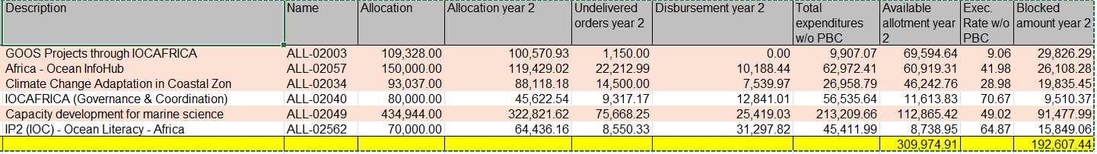

**Budget Execution by Component**

1. The financial performance across IOCAFRICA’s six programme components shows considerable variation, with some achieving strong execution rates while others have experienced delays due to procurement bottlenecks and staffing constraints.
2. As of 28 April 2025, the financial implementation status of IOCAFRICA under the 42 C/5 Regular Programme budget reflects an overall disbursement of approximately USD 309,974.91, with a remaining blocked balance of USD 192,607.44. These blocked amounts represent approximately 30% of project allocations, in line with UNESCO’s internal budgetary controls applied across all regular budget lines.
3. The disbursement trends and execution rates vary by component:

* Capacity development for marine science shows the highest expenditure volume at USD 213,209.66 with an execution rate of 49.02%;
* The IOCAFRICA Governance and Coordination component records a relatively high execution rate of 70.67%;
* Ocean Literacy Africa shows an even higher execution rate at 64.87%, indicating strong uptake in outreach and training activities;
* Conversely, the GOOS, Ocean InfoHub, and Climate Adaptation components exhibit slower disbursement progress (under 42%), largely due to delayed procurement and human resource processes.

Chart 3: IOCAFRICA 42 C/5 Budget Vs Expenditure by component (as of April 28, 2025)

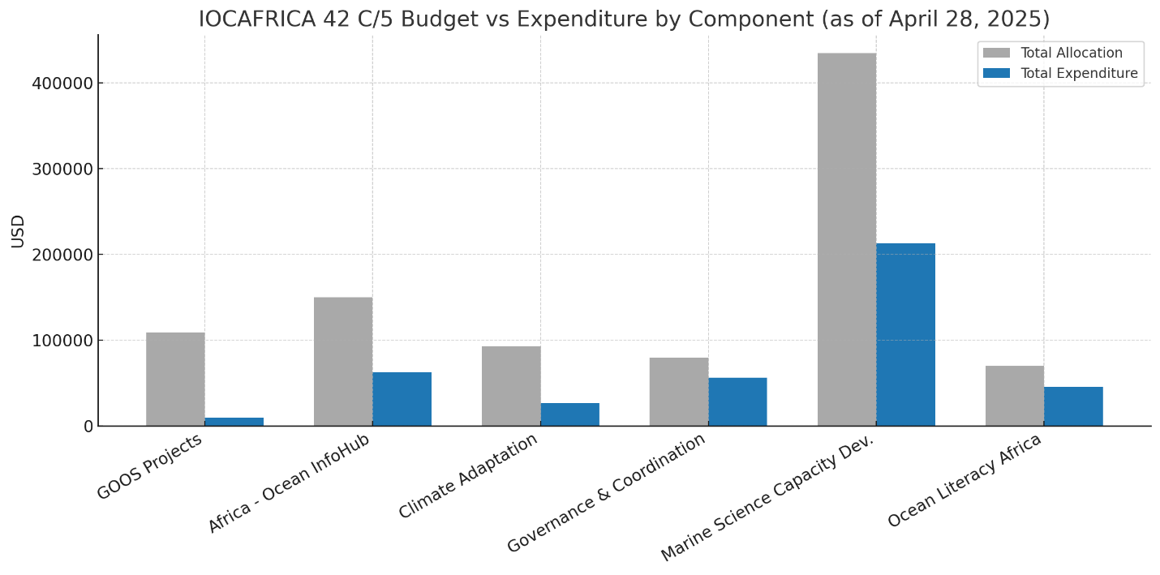

1. These figures indicates the Secretariat’s strategic commitment to advancing implementation despite delayed disbursements, staffing gaps, and procedural bottlenecks.

**Strategic Implications and Performance Analysis**

1. The budget performance presents both encouraging trends and critical areas for improvement:

* **Capacity Development and Literacy as Performance Anchors:** Nearly 84% of all funds disbursed have gone to capacity development and literacy, underscoring IOCAFRICA’s comparative strength in human capital programming and outreach delivery. This reflects the Secretariat’s ability to scale delivery through training partnerships and mobilize national institutions for local implementation. These components, which have benefitted from flexible delivery models and lower dependency on complex procurement, should serve as models for scalable programme acceleration.
* **Low Execution in Technical Tracks:** Key technical areas such as GOOS, Ocean InfoHub, and Climate Adaptation—while strategically critical—remain underdelivered due to delayed recruitment of technical personnel, lengthy procurement, and dependencies on external expert inputs. The disbursement rate for GOOS stands at only 9.06% despite high technical ambition and strong Member State support. Targeted interventions, such as bundled procurement and pre-cleared consultancies, will be required to reverse underperformance and prevent rollovers.
* **Governance Implementation Efficiency:** The 70.67% execution rate for the Governance and Coordination component signals a high return on small-scale investments when built around streamlined Secretariat operations, Taskforce meetings, and strategic planning processes. As governance interventions often leverage fewer funds with higher strategic value, their design should be further mainstreamed in both technical and coordination lines.
* **Impact of UNESCO’s 30% Budget Block:** Approximately USD 192,607.44 remains frozen due to UNESCO’s 30% allotment control mechanism. This policy has disproportionately impacted components reliant on upfront procurement, such as data equipment, communications, and contracts. To mitigate further delays, IOCAFRICA has initiated a request for exceptional allotment release backed by activity-level implementation risk assessments.
* **Forecasting and Recovery Outlook:** Based on the current procurement pipeline, planned activity schedules, and resource mobilization leverage, IOCAFRICA is now targeting an ambitious 98% execution rate by the close of the biennium. This projection assumes blocked funds are progressively released by early Q3 and that streamlined procurement and spending authority reforms are fully operational. A bi-monthly expenditure dashboard and quarterly high-priority expenditure push will guide execution acceleration. Additionally, delivery partnerships with regional centres and national entities are being activated to decentralize logistical burdens and extend IOCAFRICA’s reach.

**Chart 4:** IOCAFRICA Forecasted Vs Current Budget Execution by Component (target: 98% Overall)

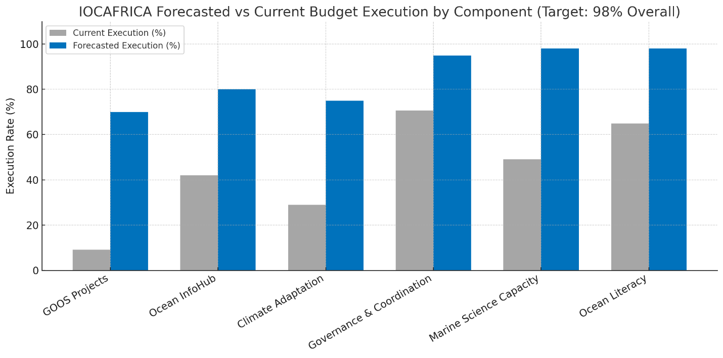

Together, these trends and planned interventions position IOCAFRICA to close the biennium with strong delivery credentials, bolstering confidence among Member States and strategic donors alike.

**CHALLENGES ENCOUNTERED**

* Delayed disbursement and operational clarity issues affected the timely implementation of activities linked to GOOS-Africa. These delays resulted from misaligned communication channels between IOCAFRICA, the GOOS global office, and regional coordination partners, delaying fund flow and technical planning.
* A leadership transition within the IOCAFRICA Secretariat during the early part of 2024 created temporary slowdowns in coordination, partner engagement, and programme activation. While this period has now passed, it impacted activity readiness during the first quarter.
* Technical and logistical complexities emerged in the design and rollout of multi-country and multi-partner training workshops. These included delays in finalizing agreements with local host institutions, securing participant nominations, and procuring expert facilitators.
* Resource gaps remain for field-based components of the work plan, particularly those involving data collection, ocean observation system deployment, and regional assessments. These components rely heavily on supplementary voluntary contributions and partnerships, many of which are still under negotiation.
* Low staffing levels in the Secretariat and at collaborating institutions limited the pace and scale of implementation. The absence of dedicated technical staff for specific themes (e.g., marine spatial planning, early warning systems) slowed documentation, coordination, and follow-up with stakeholders.