Summary

The report starts with an introduction by the IOC Executive Secretary.
It is followed by the highlights of programme implementation in the period and the assessment of progress under the IOC results framework for 2024–2025 at year end 2024, including extracts of documents prepared for the 221st session of the UNESCO Executive Board (April 2025). Assessment of progress/achievements against the 2022–2023 results framework can be found in document IOC/EC-57/3.1.Doc(1).
The Addendum to this document provides a detailed update of the work accomplished over the period from June 2023 to May 2025 by IOC functions and in English only.
In addition, the ‘Report on 2024–2024 (42 C/5) Budget Implementation as at 31 December 2024’ (IOC/A-33/3.2.Doc(2)) and the ‘Report on the Financial Situation of the IOC Special Account at year end 2024 and forecast for 2025’ (IOC/A-33/3.2.Doc(3)) complete the documentation in support of the oral presentation of the Executive Secretary to the plenary session of the Assembly.
Decision proposed: The Executive Council is invited to take note of this report and consider the draft decision referenced as Dec. IOC/A-33/3.2 in the Provisional Action Paper (document IOC/A-33/AP).

Introduction by the IOC Executive Secretary
- The statutory purpose of the IOC is twofold. Firstly, ‘to promote international cooperation and coordinate programmes research, services and capacity-building, in order to learn more about the nature and resources of the ocean and coastal areas’. Secondly, ‘to apply that knowledge for the improvement of management, sustainable development, the protection of marine environment, and the decision-making processes of its Member States’. (Art. 2.1 of the IOC Statutes)
- Learning comes first, and it needs to be continuous: in a changing ocean, what we knew yesterday may be different tomorrow. It follows that the application of learnings also needs to be continuous, faster and more dynamic than in the past.
- The learning process starts with sustained ocean observations that generate ocean data for research, analysis and modelling. The priorities set by IOC Governing Bodies for the current budget period reflect this and has been a critical focus of our work in the past year.
- With the IOC’s share of UNESCO’s regular budget for 2024–2025 (42 C/5) increased to 3% at the request of its Member States, two thirds (68%) of additional non-staff resources were allocated across the board to stabilise all IOC functions, and one third (32%) was used as additional targeted investment in the Global Ocean Observing System (GOOS), International Oceanographic Data and Information Exchange System (IODE) and Capacity Development through Regional Subsidiary Bodies.
- The graph below shows the comparison between non-staff (activity) budgets for these key priority areas in 2022–2023 (41 C/5) and 2024–2025 (42 C/5). The increased budget also allowed a modest staff reinforcement for GOOS, IODE, IOCAFRICA, IOCINDIO and the Pacific.

- The application of learning and knowledge, the second part of our mandate, is growing in importance in line with the strengthened global ocean governance landscape, and the increased relevance of regional policy and governance mechanisms. Strengthening IOC’s work in ocean observations and ocean data results in products and services supporting for example, marine monitoring for the Kunming-Montreal Global Biodiversity Framework, the BBNJ Treaty and pollution-related frameworks, as well as cementing IOC’s role as a global knowledge partner for sustainable ocean planning. At the same time, we are advancing with the important process of reforming GOOS, making it fit-for-purpose for a fast-changing ocean and the impact it will have for communities and economies on land. We are also seeking to build an integrated IOC data architecture (agenda item 3.4.3 at this session), which can better meet the needs of ocean decision-makers and managers.
- These dual objectives of learning and application are reflected in the IOC Medium-Term Strategy and align with the ethos of the United Nations Decade of Ocean Science for Sustainable Development (2021–2030), which seeks to generate the science needed for the decisions required for a sustainable ocean. The IOC-led programmes and projects that are being developed under the framework of the ‘Ocean Decade’ range from observations to research, to sustainable ocean planning. They are testbeds of transformative approaches to the generation of timely, relevant and co-designed knowledge that has direct applicability to decision-making. The diverse stakeholder communities evolving through Ocean Decade processes will be important networks for the IOC in a post-Decade era in the efforts to better deliver on generation of knowledge as well as its application. The Ocean Decade thus provides the framework for IOC programmes to work in new ways, with new partners focusing on emerging issues and thus build the foundation of the future IOC that will be our legacy after the end of the Decade. The consultation work that was requested by the Executive Council as part of the ‘IOC and Future of the Ocean’ process (agenda item 5.3 at this session) will ensure that the knowledge and experience generated through the Ocean Decade can be leveraged to meet the evolving needs and expectations of Member States.
- Since a key objective of our work is to achieve a better, faster, more dynamic interaction between ocean knowledge, decision-making and management, we need also to consider whether the way we work can also get better, faster and more dynamic. It was therefore welcome that the Executive Council last year requested an external assessment of IOC governance and management (agenda item 5.2 at this session), calling for “streamlining of operations and optimising the use of resources so as to be truly fit-for-purpose in response to the fast-evolving ocean agenda and increasing demands of Member States and multilateral processes.”
- This assessment and related deliberations have crystallised two broad opportunities for making our processes more streamlined and our resource use more optimal:
- Firstly, by complying with decision-making authority provisions and accountability relationships as established in the IOC Statutes;
- Secondly, by aligning the IOC work programme, its objectives and indicators with the IOC Medium-Term Strategy.
- Acting on these opportunities—anchored in the two most important documents governing the IOC—will enable the IOC to be simultaneously more strategic, more efficient and more responsive to demands of Member States and multilateral processes. The Assembly discussions and decisions on these matters will therefore be of high importance.
Highlights of Programme Implementation (June 2023–May 2025)
- Coordinated by IOC since 2021, the United Nations Decade of Ocean Science for Sustainable Development (2021–2030) has cemented its place as the largest coordinated global ocean science initiative ever undertaken. The ‘Ocean Decade’ has galvanised over 20,000 individuals working in multi-disciplinary, international teams to implement 59 endorsed global Decade programmes and over 500 regional and national Decade projects. These Decade Actions are led by research institutes, NGOs, private sector and government partners in 76 countries. Thirteen (13) regional and thematic decentralised coordination structures are hosted by partners including a newly launched Decade Collaborative Centre for sustainable ocean economy hosted by Barcelona City Council. Forty (40) countries have established National Decade Committees. The 2024 Ocean Decade Conference, hosted by Spain in April 2024 in Barcelona, convened over 2,600 in-person participants to discuss the science and knowledge needs that will guide the future priorities of the Ocean Decade, as well as opportunities related to partnerships and resources and the means of ensuring the full engagement of under-represented groups. This was achieved through an unprecedented mobilisation of the IOC Secretariat and its partners over the past three years. The recommendations of the Ocean Decade Conference have provided a foundation for IOC’s engagement in the preparation of the 2025 United Nations Ocean Conference. This Conference, which will also mark the mid-point of implementation of the Ocean Decade, will be a seminal moment in the global ocean governance agenda and a unique moment for IOC to advance action for solutions-based ocean science.
- As part of IOC’s core activities and with Member States’ support, the following key achievements were realised since the 32nd session of the IOC Assembly in 2023.
- The second IOC State of the Ocean Report, was published in June 2024. The StOR presents the results of ocean-related scientific activities and analyses to describe the current and future state of the ocean, addressing physical, chemical, ecological, socioeconomic and governance aspects, focusing on the seven Outcomes of the Ocean Decade. A call for members of the advisory board for the 2026 StOR was issued in March 2025, and a first meeting of the advisory board focused on initiating planning for the 2026 report was held in May 2025.
- During the United Nations Climate Conference (COP28) in December 2023, IOC championed the crucial role of ocean science as the basis for ocean and climate action. Ocean issues made important headway within the first-ever ‘Global Stocktake of the Paris Agreement’, with an unprecedented recognition of the need to consider the ocean when acting on climate change and strengthen ocean action based on the best available ocean science.
- IOC’s data submission towards SDG Indicator 14.3.1 ‘Average marine acidity (pH) measured at agreed suite of representative sampling stations’ collected inputs from an increased number of countries and stations (178 stations in 2021; 765 stations from 44 countries in 2025).
- The IOC-coordinated global expert network on ocean acidification now counts more than 1,500 members from 116 countries (26 in Africa, 23 SIDS) and continues to grow.
- Ocean deoxygenation continues to threaten ocean health with approaches focused on reoxygenation proposed as a means of reducing the extent of low oxygen areas. The GO2NE working group convened experts in September 2024 to discuss the potential of approaches to reoxygenation to stop further deoxygenation, with the results of the workshop to be published in Eos (Journal).
- The portfolio of IOC activities aimed to conserve, restore and sustainably manage coastal blue carbon ecosystems for climate, biodiversity and economy benefits continues to grow following the demand of Member States. The IOC helps to coordinate the Blue Carbon Initiative (BCI, since 2010), the International Partnership for Blue Carbon (IPBC, since 2020), an initiative of Australia, and the High-Level Ambition Group on blue carbon (HILAG, since 2022), an initiative of France. The IOC was one of the proponents of a Global Ocean Decade Programme for Blue Carbon (GO-BC) in late 2021 and has been one of its Steering Committee members ever since. These activities were showcased to Member States during a dedicated side event to the 57th session of the IOC Executive Council in June 2024.
- Recognizing that Joint programmes between IOC, United Nations and other international organizations are important ways to leverage and enhance IOC activities to best serve society and that these programmes must be underpinned by timely and relevant agreements, a revised four-year memorandum of understanding for the Global Climate Observing System (GCOS) was negotiated with the World Meteorological Organization (WMO), the United Nations Environment Programme (UNEP) and the International Science Council (ISC). In addition, a memorandum of understanding was signed in April 2024 between UNESCO-IOC and FAO to formalise joint sponsorship of the Intergovernmental Panel on Harmful Algal Blooms (IOC-FAO IPHAB). In the context of an updated World Climate Research Programme Science and Implementation Plan, discussions are underway between UNESCO-IOC, WMO and ISC to update the 1993 co-sponsors agreement to ensure that it reflects the plan and is adaptable in the future. IOC as a co-sponsor of the World Climate Research Programme will host a meeting of the joint scientific committee at UNESCO HQ in May 2025.
- The Global Ocean Observing System (GOOS) coordinates more than 8,700 ocean observing platforms across 13 global ocean observing networks, operated by 83 Member States (9 in Africa, 9 SIDS). Over 120,000 ocean observations are delivered to operational forecasting systems every day, as tracked through OceanOPS (GOOS IOC-WMO Operational Centre). The number of sustained biological and ecological observing programmes coordinated and tracked has risen to 638 across 71 Member States with 7 in Africa and 14 SIDS.
- GOOS has continued to build coordination, integration and advocacy on global ocean observing in combination with advancing stakeholder engagement, and the resilience and responsiveness of the global system. Recent key advances include: enhancing community use of the foundational Essential Ocean Variables (EOVs) concept through a new paper (submitted) and user driven revision of the EOV Specification sheets; development of a minimum metadata passport—with a unique identifier for data use and tracking; the first IODE/GOOS Data Workshop where a significant step forward was made in uniting IOC data elements towards a cutting-edge IOC Data Architecture (agenda item 3.4.3 at this session); building engagement and support with the 14 regional alliances and 77 GOOS National Focal Points, the latter through a second annual National Focal Point Forum and survey. GOOS/IOC office has coordinated across WMO and IOC to deliver the first Statement of Guidance (SOG) for ocean applications as part of the Rolling Review of Requirements process. This is a significant step forward in expressing the observational needs across operational ocean forecasting systems for a range of application areas.
- In order to ensure that GOOS governance is fit-for-purpose, a proposal for GOOS reform (agenda item 4.5.1 at this session) is being prepared, according to the mandates set out in Decision EC-57/4.1 and document IOC/EC-57/4.1.Doc(1).
- The Joint WMO-IOC Collaborative Board met in person in September 2024 and identified priority areas for its work using a multi-criteria analysis. These priority areas are: defining the Global Basic Observing Network (GBON) for oceans; improving data management and interoperability; strengthening coastal and maritime resilience; and enhancing capacity development through joint training and collaboration.
- The ad hoc intersessional Working Group on Ocean Observations in Areas under National Jurisdiction have been working according to the terms of reference outlined in Decision A-32/4.8.2 and have prepared a report of their work and recommendations for IOC Assembly at its 33rd session (Agenda item 4.5.3 at this session).
- The WMO/IOC OceanOPS centre partnered with the ‘Vendée Globe’ race, equipping 25 of the 40 boats with advanced instruments to gather critical meteorological and oceanographic data. This unique initiative transformed the race into a "floating scientific station," providing valuable insights, especially from under-sampled regions like the Southern Ocean. The Vendée Globe/IOC collaboration will continue for the 2028 edition, during which all skippers will be required to embark scientific instruments.
- The Ocean Data and Information System (ODIS) is a federation of independent data systems including continental-scale data systems, national data systems as well as those of small organizations. ODIS enables individuals and organizations to share their metadata with the world, and enable better findability, accessibility, interoperability and reusability (FAIR) of ocean data. ODIS currently links 55 data catalogues or nodes from 45 partner organizations, enabling a sustainable, interoperable, and inclusive digital ecosystem for all ocean stakeholders that will continue to grow in the future.
- As a joint effort between the Global Ocean Observing System (GOOS) and the IODE/Ocean Biodiversity Information System (OBIS), information was collected from 638 long-term active biological monitoring programmes and integrated into an online metadata platform (BioEco portal), which will be connected to ODIS, and become the infrastructure to monitor the status of the marine biological component of GOOS. OBIS continues to play a key role in this regard by hosting and providing an integrated, standardised and quality controlled access point to the actual biological and ecosystem observations required to feed into ecosystem models, early-warning systems and indicator and assessment frameworks. OBIS now holds 136 million species observations and continues to grow with over 1 million records per month collectively provided by over 1,000 institutions from 99 countries.
- The Environmental DNA Expeditions in Marine World Heritage Sites project, funded by the Government of Flanders (Kingdom of Belgium) and implemented jointly by the IOC (through OBIS) and the World Heritage Centre, was completed in December 2024 and demonstrated the transformative potential of environmental DNA (eDNA) for monitoring and conserving ocean biodiversity, by providing a cost-effective and accessible method, particularly in developing countries where traditional studies are difficult to carry out. By combining eDNA sampling with DNA metabarcoding, the initiative has engaged local communities, including students, in citizen science, thus promoting education and public participation in ocean conservation. Over a period of three years, sampling campaigns were conducted at 21 marine UNESCO World Heritage sites in 19 countries. More than 250 participants took part and 400 eDNA samples were taken, enabling the identification of around 4,400 marine species, including 28 marine mammals, 86 sharks and rays, three turtles, and 120 species on the IUCN Red List of Threatened Species. The data has been made accessible through OBIS by an interactive dashboard (https://dashboard.ednaexpeditions.org/) that includes climate change projections, and in a UNESCO publication titled Engaging communities to safeguard ocean life: UNESCO Environmental DNA Expeditions (https://doi.org/10.58337/CBXU3518).
- Through the Flanders-funded Pacific Islands Marine Bioinvasion Alert Network (PacMAN) project (2020–2024), which also concluded in December 2024, IOC (through the Ocean Biodiversity Information System) has built an end-to-end system for monitoring, sampling, and analysing marine invasive species using molecular technologies, with a primary focus on developing this scientific capacity in Fiji as a pilot. The PacMAN early-warning decision support tool can analyse species detections, assess risks, and display information in a user-friendly format and syncs with OBIS to retrieve data. Two high-risk invasive species were detected, the presence of which in Fiji was previously unknown. The project aligned with national and international biodiversity targets by its contributing to Target 6 of the Convention on Biological Diversity (CBD) in the Kunming-Montreal Global Biodiversity Framework and Fiji's National Biodiversity Strategic Action Plan 2020–2025.
- Tsunami programme kept its strong capacity development focus in all ocean basins. With active support by Member States as indicated by the renewal of agreements with:
- the Agency for Meteorology, Climatology, and Geophysics of the Republic of Indonesia hosting the Indian Ocean Tsunami Information Centre (IOTIC) 2023–2027,
- the Coastal Zone Management Unit (CZMU) of Barbados hosting the Caribbean Tsunami Information Centre (CTIC) 2024–2029, and
- the Bureau of Meteorology (Bureau) of Australia hosting the Indian Ocean Tsunami Warning and Mitigation (IOTWMS) Office in Perth, Australia 2023–2027.
- Advancing Tsunami Preparedness. The 2nd Global Tsunami Symposium in Banda Aceh (Indonesia) highlighted the importance of enhancing the Global Tsunami Warning and Mitigation System. In particular, it made an urgent appeal for investment to ensure that 100% of coastal community at risk are Tsunami Ready by 2030. In addition, a commemorative event at UNESCO headquarters marked the 20th anniversary of the 2004 Indian Ocean Tsunami, honouring the progress made and highlighting the work that remains to be done. There are now 100 recognized Tsunami Ready communities in 31 Member States, 15 of which are SIDS.
- Monitoring and Warning for Tsunamis Generated by Volcanoes was published as an IOC Technical Series issue (183) in 2024.
- The joint IOC-SCOR GlobalHAB science programme has developed a new decadal plan for an international HAB research programme focused on understanding HABs in the context of global sustainability. As part of the joint effort of GlobalHAB and GESAMP, a whitepaper on Sargassum was published in June 2023, and GlobalHAB published a white paper on Fish-killing marine algal blooms as IOC Manuals and Guides, 93.
- A new partnership between the IOC, the Nippon Foundation and UNEP is developing a decadal implementation plan for ‘A global ocean free from the harmful impacts of pollution by 2050’. The concept of this collaboration was presented at the World Ocean Summit in Tokyo in March 2025.
- In June 2023, the Assembly adopted the IOC Capacity Development Strategy, 2023–2030 and established a group of experts on capacity development to develop an implementation plan. The OceanTeacher Global Academy (OTGA) continues to grow with an increasing number of trainings (more than 50 courses per year) and approximately 14,000 beneficiaries worldwide. OTGA, a network of 17 Regional and Specialized Training Centres remains active, and dozens of additional partners have joined the training initiatives over the past two years. With its ISO 29993:2017 accreditation as a Learning Service Provider, the IOC, through OTGA, certifies hundreds of training participants every year and guarantees a high-quality standardized Learning Management System. OTGA continues to support training needs and priorities of all IOC programmes and regions, and those of the Ocean Decade, promoting expanded training and lifelong learning opportunities in the fields of ocean sciences, services, and management.
- With the IOC capacity development effort bolstered by NORAD funding, five activities were launched in 2024, designed jointly with regional and technical subsidiary bodies: (i) establishing Early Warning Systems for Harmful Algae Blooms in Africa; (ii) GLOSS-Africa (Phase 1–North Africa); (iii) support for strategic planning and capacity development for ocean observations under the auspices of GOOS-Africa; (iv) Biodiversity Data Hub for the High Seas; and (v) OceanTraining internships to enhance global human capacity related to the IOC mandate. The call for 2025 cohort is now underway, with a call for interested host institutions launched in February 2025. New funding received in December 2024 will support the expansion of establishing early warning systems for harmful algal blooms in Africa, including the updating of data management infrastructure to support such systems, enabling linkages between blooms and deoxygenation to be determined and ensuring that observations associated with the systems contribute to GOOS.
- The programmatic work of IOC in capacity development is complemented by the Ocean Decade Capacity Development Facility, which aims to develop and deliver priority capacity development initiatives in the framework of the Ocean Decade, with a focus on SIDS, Least Developed Countries and Early Career Ocean Professionals.
- Ensuring alignment with evolving national and regional priorities and strategies is paramount for the success of our action for Global Priority Africa. The Africa Ocean Decade Task Force oversees and promotes the implementation of the Ocean Decade Africa Roadmap, including the development and launch of a new Decade programme on sustainable ocean management in Africa. Similarly, the Tropical Americas and Caribbean Taskforce is overseeing the implementation of the Ocean Decade Africa Roadmap.
- In the WESTPAC region, immense efforts have been made to align ocean science with societal needs including through national and international agreements and policy frameworks. A milestone was reached with the organization of the 2nd UN Ocean Decade Regional Conference and the 11th WESTPAC International Marine Science Conference (22–25 April 2024) hosted by Thailand, which brought together more than 1,200 stakeholders from 40 countries in the region and beyond to discuss the current state of ocean knowledge, take stock of the first three years’ achievements of the Ocean Decade Actions in the region and identify future priorities, building on the outputs of the Vision 2030 process (The Ocean Decade’s strategic ambition setting process on the road to 2030). A regional framework for action to accelerate marine spatial planning was adopted to support the MSPglobal 2.0.
- As a contribution to the UNESCO operational strategy on SIDS, IOC is leading one of six intersectoral Accelerator programme–ACE#2: Strengthen Sustainable Ocean Knowledge, Spatial Planning and Water Management capacities of SIDS in support of the growth of their blue economies. Increased engagement with SIDS in the Ocean Decade was supported through the establishment of a decentralized coordination hub for the Pacific Islands Region, hosted by The Pacific Community, and the establishment of a taskforce for the Tropical Americas and Caribbean Region to oversee implementation of the Ocean Decade in the region.
- IOC stepped up its efforts in Marine Spatial Planning (MSP) and launched in 2022 an updated joint MSProadmap with the European Commission, then resumed the MSPglobal project (core of the MSPglobal programme and co-funded by EU) in July 2023 with a regional focus on Western Africa and Western Pacific. In addition, MSPglobal 2.0 has co-developed other knowledge, tools and new online training on OceanTeacher Global Academy to help all Member States advance their MSP processes. Two publications on the engagement of Indigenous Peoples and Local Communities in MSP were published in July 2024, while four other toolkits on biodiversity, climate, spatial data and offshore wind engagement will be launched by June 2025. These tools were developed through co-designed global workshops with key organizations and experts from all continents and sea-basins. In total, MSPglobal 2.0 activities had involved 1,000 participants from 116 countries by mid-March 2025. This engagement has been realized through the organisation of global and regional MSPfora, trainings and workshops for representatives of national authorities, as well as for G20 representatives. A new rapid assessment tool to facilitate national planning processes has been developed and piloted in seven countries in Africa, Western Pacific and Latin America and the Caribbean. Additional financial support from Government of Sweden (2024–2027) will continue to support this work, in addition to the renewed support of the European Commission’s DG MARE for another two years. The work of IOC on MSP provides a solid basis for advancing the development of the draft IOC-wide Strategy on Sustainable Ocean Planning and Management (SOPM), and the new Decade Programme on Sustainable Ocean Planning supported by a range of international partners, which was launched at the Barcelona Conference. The IOC Working Group on SOPM met three times in 2025 to finalise the Draft Strategy and related Implementation Plan, to be presented to the 33rd IOC Assembly under agenda item 4.1.
- Ocean literacy training has been delivered through dedicated programmes to a wide range of groups including students, early career ocean professionals, journalists, architects and urban planners, as well as finance experts, with training resources available in English, French and Spanish and e-learning modules delivered through the Ocean Teacher Global Academy. To facilitate students training, a new Ocean Literacy Centre, located on San Servolo Island in Venice was inaugurated in April 2025. More than 55 countries are now engaged in the blue schools regional or national network programme.
- In June 2024 the first Ocean Literacy World Conference was held in Venice, under the patronage of the Italian Ministry of Foreign Affairs. The event brought together more than 140 participants from 76 countries, and resulted in the Venice Declaration for Ocean Literacy in Action. An edition of the Ocean and Climate Village interactive exhibition was organized in Barcelona during the 37th America’s Cup in partnership with Luna Rossa PRADA Pirelli. As a contribution to the Ocean Decade, the sixth edition of the Ocean Literacy Dialogues, was organized in Mumbai (India) in collaboration with the Jane Goodall Institute and the UNESCO Office in New Delhi, and several webinars were set up to catalyse the new Decade Action on Challenge 10. The translation of the Ocean Literacy for All Toolkit from English to Swahili is now accessible to over 2,000,000 Kiswahili speakers in the East Africa sub-region, including the Democratic Republic of the Congo, Comoros, Kenya, Tanzania, and Somalia.

2024 Progress report (as presented to the 221st session of the UNESCO Executive Board)

(Excerpts from 221 EX/4 and 221 EX/4.INF) 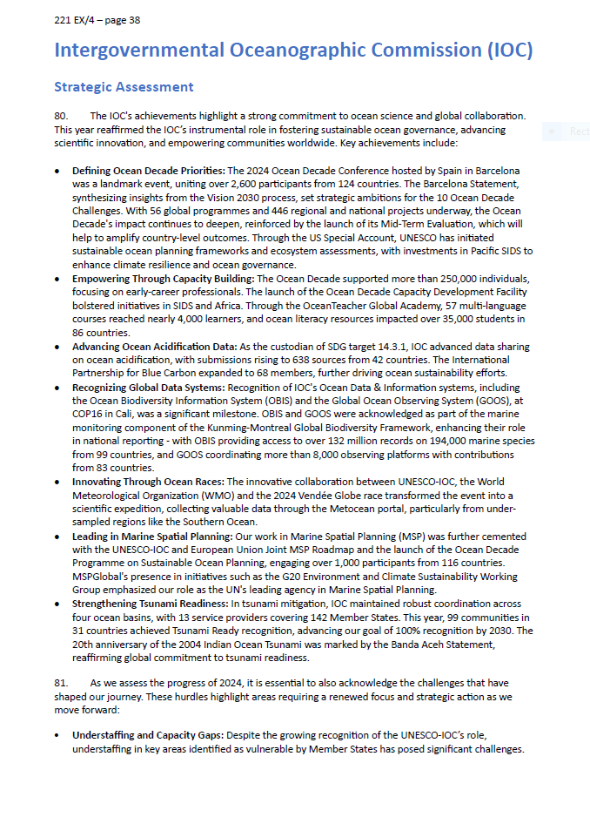
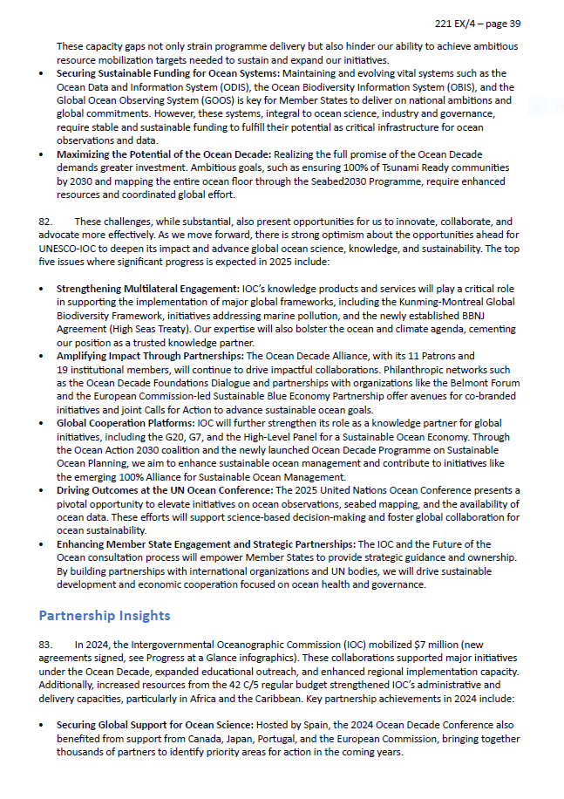
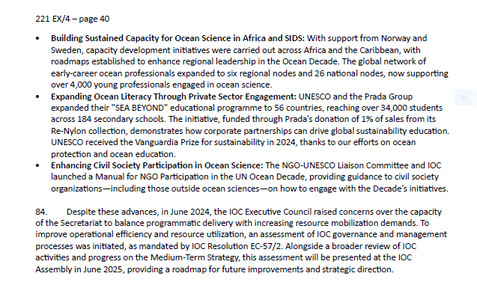

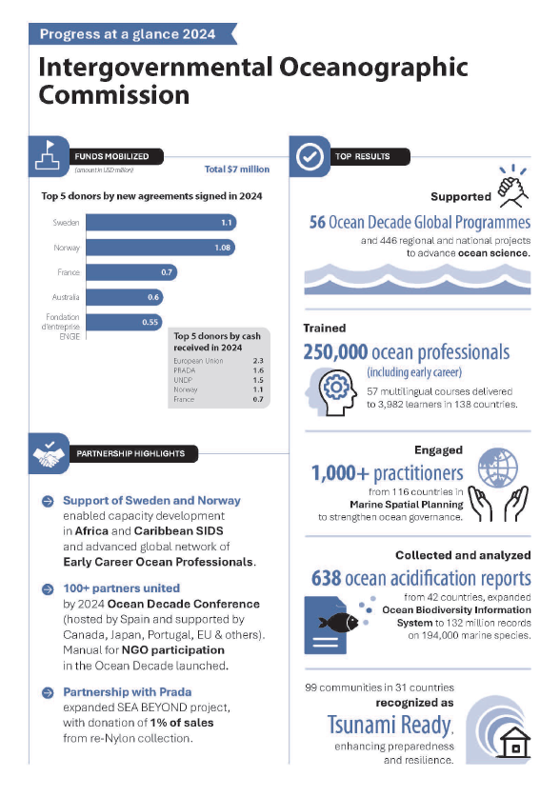

Progress assessment against the IOC Results Framework 2024–2025 at year end 2024

