TOWS-WG TT-DMP Agenda Item 4
PTWS Approach to Tsunami Ready Equivalency
INFORMATION DOCUMENT

- INTRODUCTION
UNESCO leads the UN Decade of Ocean Science for Sustainable Development from 2021 to 2030. In June 2022, the IOC Assembly approved the establishment of the IOC Ocean Decade Tsunami Programme, with an associated aim of making ‘100% of communities at risk of tsunami prepared for and resilient to tsunamis by 2030’.
The implementation of the UNESCO / IOC Tsunami Ready Recognition Programme (TRRP) is intended to be a key tool to achieving the societal outcome ‘A Safe Ocean’ of the Ocean Decade. Therefore, the programme is generally used as the framework and language to measure tsunami preparedness against this global goal.
A number of nations in ICG/PTWS and elsewhere globally have existing disaster management and tsunami risk management programmes, and may choose not to implement the voluntary programme. Inclusion of these countries in the context of the TRRP is critical to accurately capture and report progress towards the goal of 100% of communities being tsunami ready by 2030.
Approaches to this pose challenges, including:
- Existing national reporting on tsunami risk management is diverse, and utilizing this to assess progress in an ICG/PTWS-centralised manner would be resource intensive. When completed at this level (e.g., through the interpretation of a working group), this is also unlikely to accurately capture community preparedness that may be specific to cultural contexts.
- Adopting a structure to assess progress specific to ICG/PTWS, separate from the Tsunami Ready indicators, would limit engagement with and contribution to reporting against the global goal.
- Nations that choose to implement and monitor in parallel the indicators of their own tsunami risk management programmes and the TRRP for reporting to the ICG/PTWS may be involved in a dual effort in which financial and human resources are allocated for administrative tasks instead of directly supporting the preparedness of communities at risk.
Because of this, at the ICG/PTWS-XIX (2021), Working Group Three was requested to “explore […] ways to recognize communities that choose not to implement the UNESCO/IOC Tsunami Ready programme, as compliant with the Tsunami Ready indicators”.
At the ICG/PTWS-XXX the Working Group presented the following approach, and was recommended that this approach be “developed into formal guidance for ICG/PTWS, led by Task Team Tsunami Ready in consultation with regional working groups”.

- ABOUT THE UNESCO / IOC TSUNAMI READY RECOGNITION PROGRAMME

  - AIM
The Tsunami Ready Recognition Programme aims to build resilient communities through awareness and preparedness strategies that will protect life, livelihoods and property from tsunamis in different regions, and to ensure a structural and systematic approach to building community preparedness.
As a community performance-based programme, it promotes tsunami preparedness by actively collaborating with the community, community leaders, and national and local emergency management agencies.
A community is a group of people who live in the same area (city, town, village, neighborhood), including its social and economic dimensions, infrastructure, life-lines and supporting environmental systems. The scale of the community is important. Its size (area, population, density and distribution), national governance structure, as well as its vulnerability, exposure, resources and capacity required, will determine how Tsunami Ready is implemented.
“Tsunami Ready” recognition does not mean that a community is tsunami proof; rather, it is an acknowledgement and recognition that a community has adopted mitigation measures to cope with its tsunami risk.
  - APPROACH AND BENEFITS
The UNESCO/IOC Tsunami Ready approach is intended to:
- Bring the ownership of preparedness to the community.
- Ensure structural and systematic approach in building community preparedness.
- Be a collaborative effort to achieve a level of tsunami preparedness through the fulfilment of a set of established best practice guidelines and indicators.
- Be implemented on a voluntary basis that entails a “bottom-up” process with the community taking the initiative to build its own capacity. This approach ensures ownership of the process that strengthens its sustainability.
Among the benefits of implementing the UNESCO/IOC Tsunami Ready Recognition Programme are that it:
- Strengthens tsunami preparedness of coastal communities through:
  - Improved assessments of Hazards, Risk, Inundation, and Evacuation.
  - Improved early warning systems/warning chain.
  - Improved public awareness, understanding of tsunami threat and preparedness
  - Tested awareness and preparedness through regular exercises.
- Strengthens the relationship between tsunami scientists, warning officials and local communities.
- Strengthens preparedness for other hazards.
- Improves community planning.
- Encourages a consistent and sustainable approach to disaster risk reduction.
- Contributes to the aims of the Sendai Framework for Disaster Risk Reduction and Sustainable Development Goals.
- Provides international recognition from UNESCO IOC as Tsunami Ready Community.

  - STRATEGY, INDICATORS, AND IMPLEMENTATION
The Tsunami Ready Recognition Programme Guidelines list strategies that must be implemented for a community to be recognized as Tsunami Ready. These strategies are defined by 12 key indicators covering I. Assessment, II. Preparedness and III. Responses actions (Figure 1).
The Programme is facilitated by each region’s the UNESCO/IOC Tsunami Information Centres, e.g., the International Tsunami Information Centre for the PTWS. The formal recognition process follows standard guidelines (UNESCO/IOC Manual and Guides 74, 2022).
Successful implementation of the Programme requires inclusive oversight through governance at a national and local level, and confidence that the community will be able to sustain the established indicators for at least four years. Communities must have a voluntary interest to be recognized as ‘Tsunami Ready’ under the UNESCO / IOC programme, and recognition is renewed on a four-yearly basis.
It should be noted that many of these strategies, governance and renewal requirements are in place in communities around the Pacific as part of existing disaster risk management efforts.
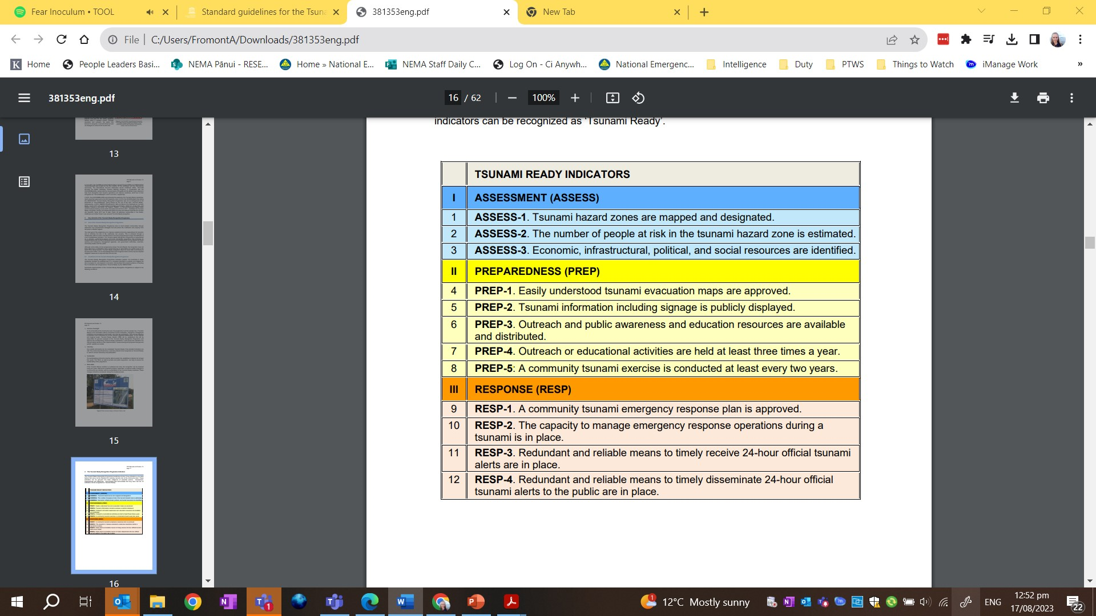
Figure 1: Tsunami Ready Recognition Programme Indicators

- PROPOSED APPROACH
Formal uptake and implementation of the recognition programme alongside existing tsunami DRR programmes is likely to result in additional cost, risks duplication of strategies, and requires alignment of the global framework with local, regional and national frameworks.
Therefore, recognising that not all communities will volunteer to undergo the recognition process, Working Group Three (WG3) proposes an approach that seeks to enable reporting for tsunami preparedness in a manner compatible with the UNESCO/IOC Tsunami Ready Recognition Programme, using existing national administrative frameworks and reporting requirements, and without needing formal UNESCO/IOC recognition.
  - APPROACH PRINCIPLES
This approach has the following principles:
- Countries have a strong motivation to ensure that their communities at risk of tsunami are prepared for and resilient to tsunamis.
- Existing national strategies are used to measure progress towards the “100% Tsunami Ready’ goal.
- Reporting on progress towards global preparedness targets is consistent with the Tsunami Ready Framework (12 indicators)
- Effort to track and report towards global targets is concentrated at the national level.
- Supports national reporting and ICG/PTWS KPI’s.
Communities would also be enabled to progress formal Tsunami Ready Recognition as an option, through the establishment of a National Tsunami Ready Board (NTRB) structure. This will also support reporting and maintain consistency within the ICG/PTWS.
  - APPROACH IMPLEMENTATION WORKFLOW
The implementation workflow of this approach would be as follows:
    - Define the most appropriate level of ‘community’
In order to be able to measure progress towards indicators, the most practical definition of ‘community’ must be considered. In the case of small countries and territories, this may be at the national/territorial level. In other cases, this may be the lowest level of governance that has legislative responsibilities (such as a city, state or region) or according to their own disaster management subdivision at the most fundamental level of organization.
It is likely that this will align closely with the existing reporting requirements of a National Disaster Management Office (NDMO) or similar.
    - Undertake a cross-reference process at the national level
A nation would undertake a review of existing resources that contribute to community preparedness outcomes for tsunami, for any alignment with the indicators of the Tsunami Ready Recognition Programme.
These resources may include national and regional frameworks, risk reduction strategies, response and warning plans and legislation.
The outcome of this is the identification of where Tsunami Ready indicators are already being met as a standard approach across all or most communities within a country or territory. For example, this may be the case where the capability to receive and disseminate tsunami warnings is provided through a national system. This review enables reporting against that indicator without separate assessment through the Tsunami Ready Recognition Programme.
    - Utilise existing community reporting
Some Tsunami Ready Recognition Programme indicators cannot be met through the application of national standards only, and must be assessed at the community level.
Where this is the case, existing reporting requirements and opportunities should be identified with consideration as to how such strategies are reported on at a national level or where certain reporting considerations could be added.
For example, a community may be required to maintain or submit a community response plan or may report on outreach and public education through separate channels to the NDMO, or NTRB. These can be compiled to assess an overall ‘preparedness’ relative to the Tsunami Ready indicators.
    - Empower community participation through governance
In many cases, national or regional bodies consisting of representation from scientists and disaster management offices exist to provide expertise and governance to disaster risk reduction programmes.
In order to enable local communities who, wish to apply for recognition under the TRRP, countries and territories are encouraged to identify such existing bodies that meet the requirements of a NTRB. These requirements are laid out in the Standard Guidelines for the Tsunami Ready Recognition Programme (IOC Manual and Guides 74, 2022).
These bodies, can then be tasked with responsibility for reviewing and approving Tsunami Ready recognition, should a community wish to participate formally in the programme.

