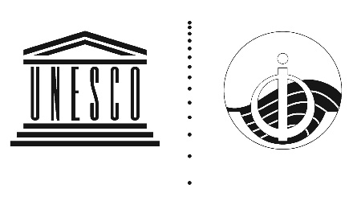
INTERGOVERNMENTAL OCEANOGRAPHIC COMMISSION
(of UNESCO)

Eight Session of the IOC Regional Committee for the Central Indian Ocean (IOCINDIO-VIII)
Online, 17-19 May 2021

Country Report/Presentation

Please, provide a brief description of the country programmes related to the IOCINDIO Work programme based on the IOC global functions.
NB: Feel free to provide additional programmes even if different of the below listed.

Country:
Presenter(s) full names and position:
Full contacts address of the presenter(s):
Names of members of national delegation attending IOCINDIO-VIII

IOC Function A : Ocean Science and Research
IOCINDIO Programme: Effects of human induced changes: Ocean acidification, eutrophication, hypoxia, harmful algal blooms (HABs) in coastal waters of the North-western Indian Ocean
Projects Titles | Activities |  |  |  |  |  | Geographical scope Regional/National  benefitting countries |  |  |  |  |  | Budget/funding sources  National/Regional/international |  |  |  |  |  | Results/impacts
IOC Function B: Observing Systems & Data
IOCINDIO Programme: Ocean observations, coastal zone management, circulations and fisheries.
Projects Titles |  | Activities |  |  |  |  |  | Geographical scope Regional/National  benefitting countries |  |  |  |  |  | Budget/funding sources  National/Regional/international |  |  |  |  |  | Results/impacts
IOC Function C: Ocean Hazards
IOCINDIO Programmes
- Coastal vulnerability assessment for sea level rise and storm surges.
- Monitoring with Responsible Response of Oil Spill in inner ROPME Sea.
Projects Titles |  |  | Activities |  |  |  |  |  | Geographical scope Regional/National  benefitting countries |  |  |  |  |  | Budget/funding sources  National/Regional/international |  |  |  |  |  | Results/impacts
IOC Function D: Assessments & information for Policy
IOCINDIO Programmes: 2050 Integrated Ocean Policy Advice for Proactive Planning and Management for IOCINDIO Member States.
Projects Titles |  |  |  | Activities |  |  |  |  |  | Geographical scope Regional/National  benefitting countries |  |  |  |  |  | Budget/funding sources  National/Regional/international |  |  |  |  |  |  |  | Results/impacts
IOC Function E: Governance
IOCINDIO Programme: Blue Economy Business opportunities in the context of climate change adaptation and Disaster Risk Reduction.
Projects Titles |  |  |  |  | Activities |  |  |  |  |  | Geographical scope Regional/National  benefitting countries |  |  |  |  |  | Budget/funding sources  National/Regional/international |  |  |  |  |  | Results/impacts
IOC Function F: Capacity Development
IOCINDIO Programme: IOCINDIO Networking Research Infrastructures, Facilities and Human Resources.

Projects Titles |  |  |  |  |  | Activities |  |  |  |  |  | Geographical scope Regional/National  benefitting countries |  |  |  |  |  | Budget/funding sources  National/Regional/international |  |  |  | Results/impacts
ANY OTHER PROGRAMMES/PROJECTS RELEVANT TO IOCINDIO

